# LIDL Modeling Tool developer manual

## Configure the development environment

### Download Java

If you have not installed java on the computer, or the Java version is no higher than 11, you need to download and install Java 11 or a higher version. Here we install Java 11. The details are as follows:

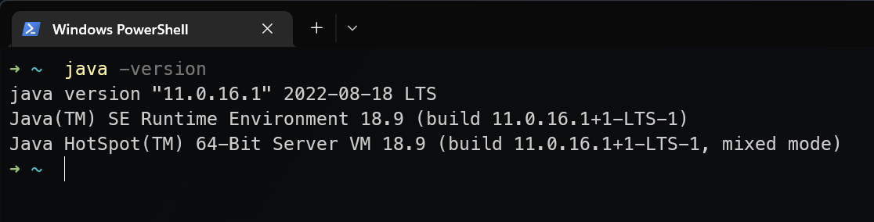

### Download Eclipse IDE

Download **Eclipse Modeling Tools version 20-09** at the following link:

<https://www.eclipse.org/downloads/packages/release/2020-09/r/eclipse-modeling-tools/>

Note: You must download this version, otherwise it will introduce unexpected problems.

Taking Windows as an example, the downloaded file is **eclipse-modeling-2020-09-R-win32-x86_64.zip**.

The link refers to the web page shown below. The download link provides Eclipse Modeling Tools version 2020-09 for Windows, macOS, and Linux operating systems.

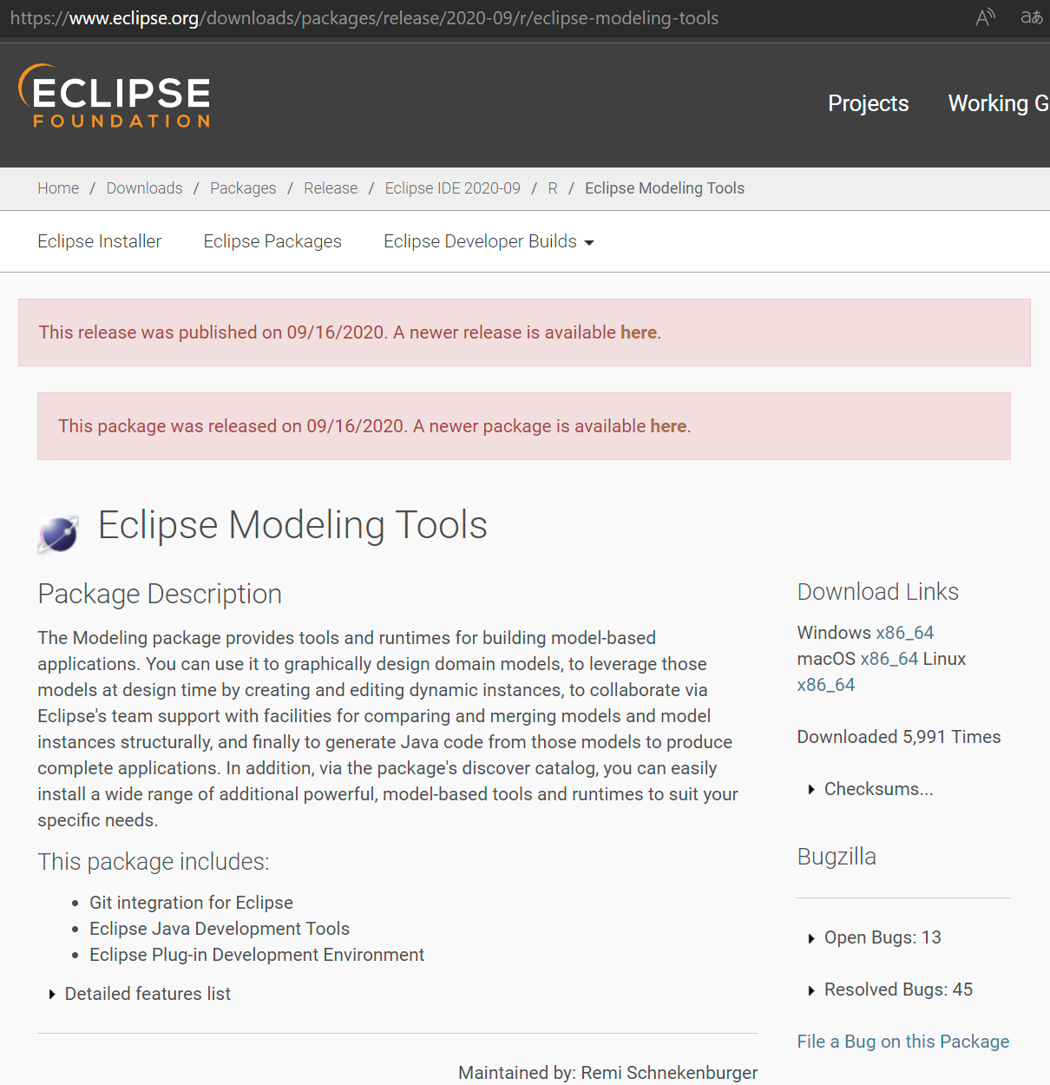

### Decompress src.zip

Package path：/LIDL MEC Toolkit/source code/Modeling tool/src.zip (in zenodo)

If you use our GitHub repository, the source code path is  
/LIDL-MEC-Toolkit/source code/Modeling tool/tool/

We use the 7z tool to pack the zip. If you encounter problems decompressing it directly, use the 7z tool to decompress it.

To avoid the tip of "the target path is too long" when decompressing, you can extract the files in the compressed package to the root directory of a disk.

This manual decompresses it to the root directory of Disk E and extracts a tool folder. In the folder, there is all the source code for the modeling tool.

There is only one tool folder in the root directory of the compressed package, which contains all the source codes of the modeling tool.

In the next step, select the tool folder as the Eclipse workspace.

### Run Eclipse IDE

Decompress the Eclipse IDE compressed package downloaded in step 2, and run the eclipse.exe in the folder eclipse under its root directory.

If you can not start Eclipse because the Java version on the computer is too low (as shown below),

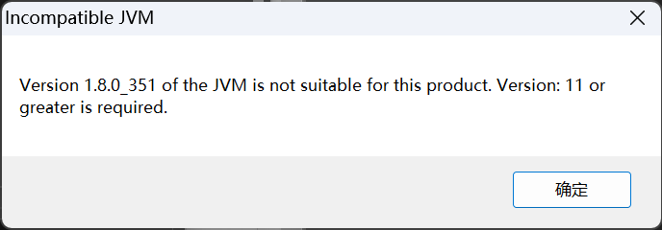

Edit the **eclipse.ini** file in the eclipse directory and add two lines before **- vmargs**:

-vm

<Path of Java executable file of Java 11 or higher version>

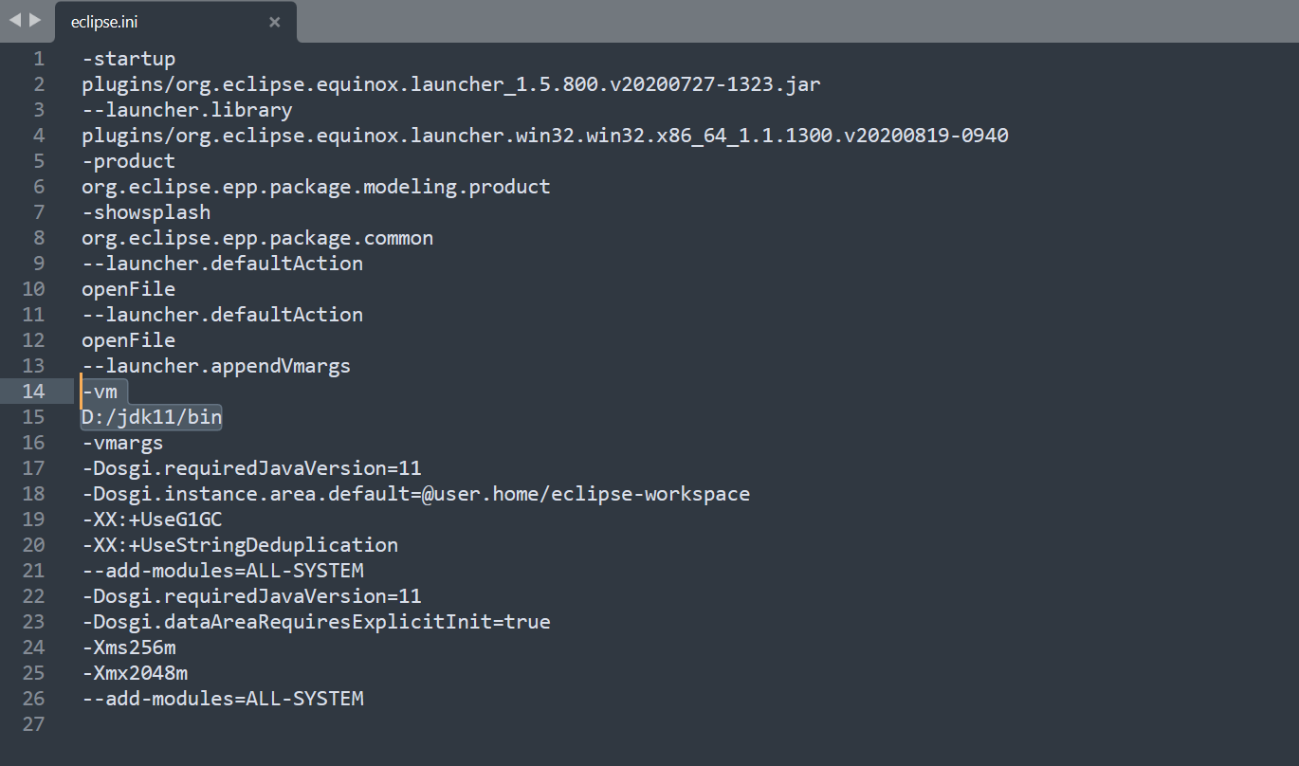

In the menu bar at the top of the Eclipse, click Window and click Preferences.

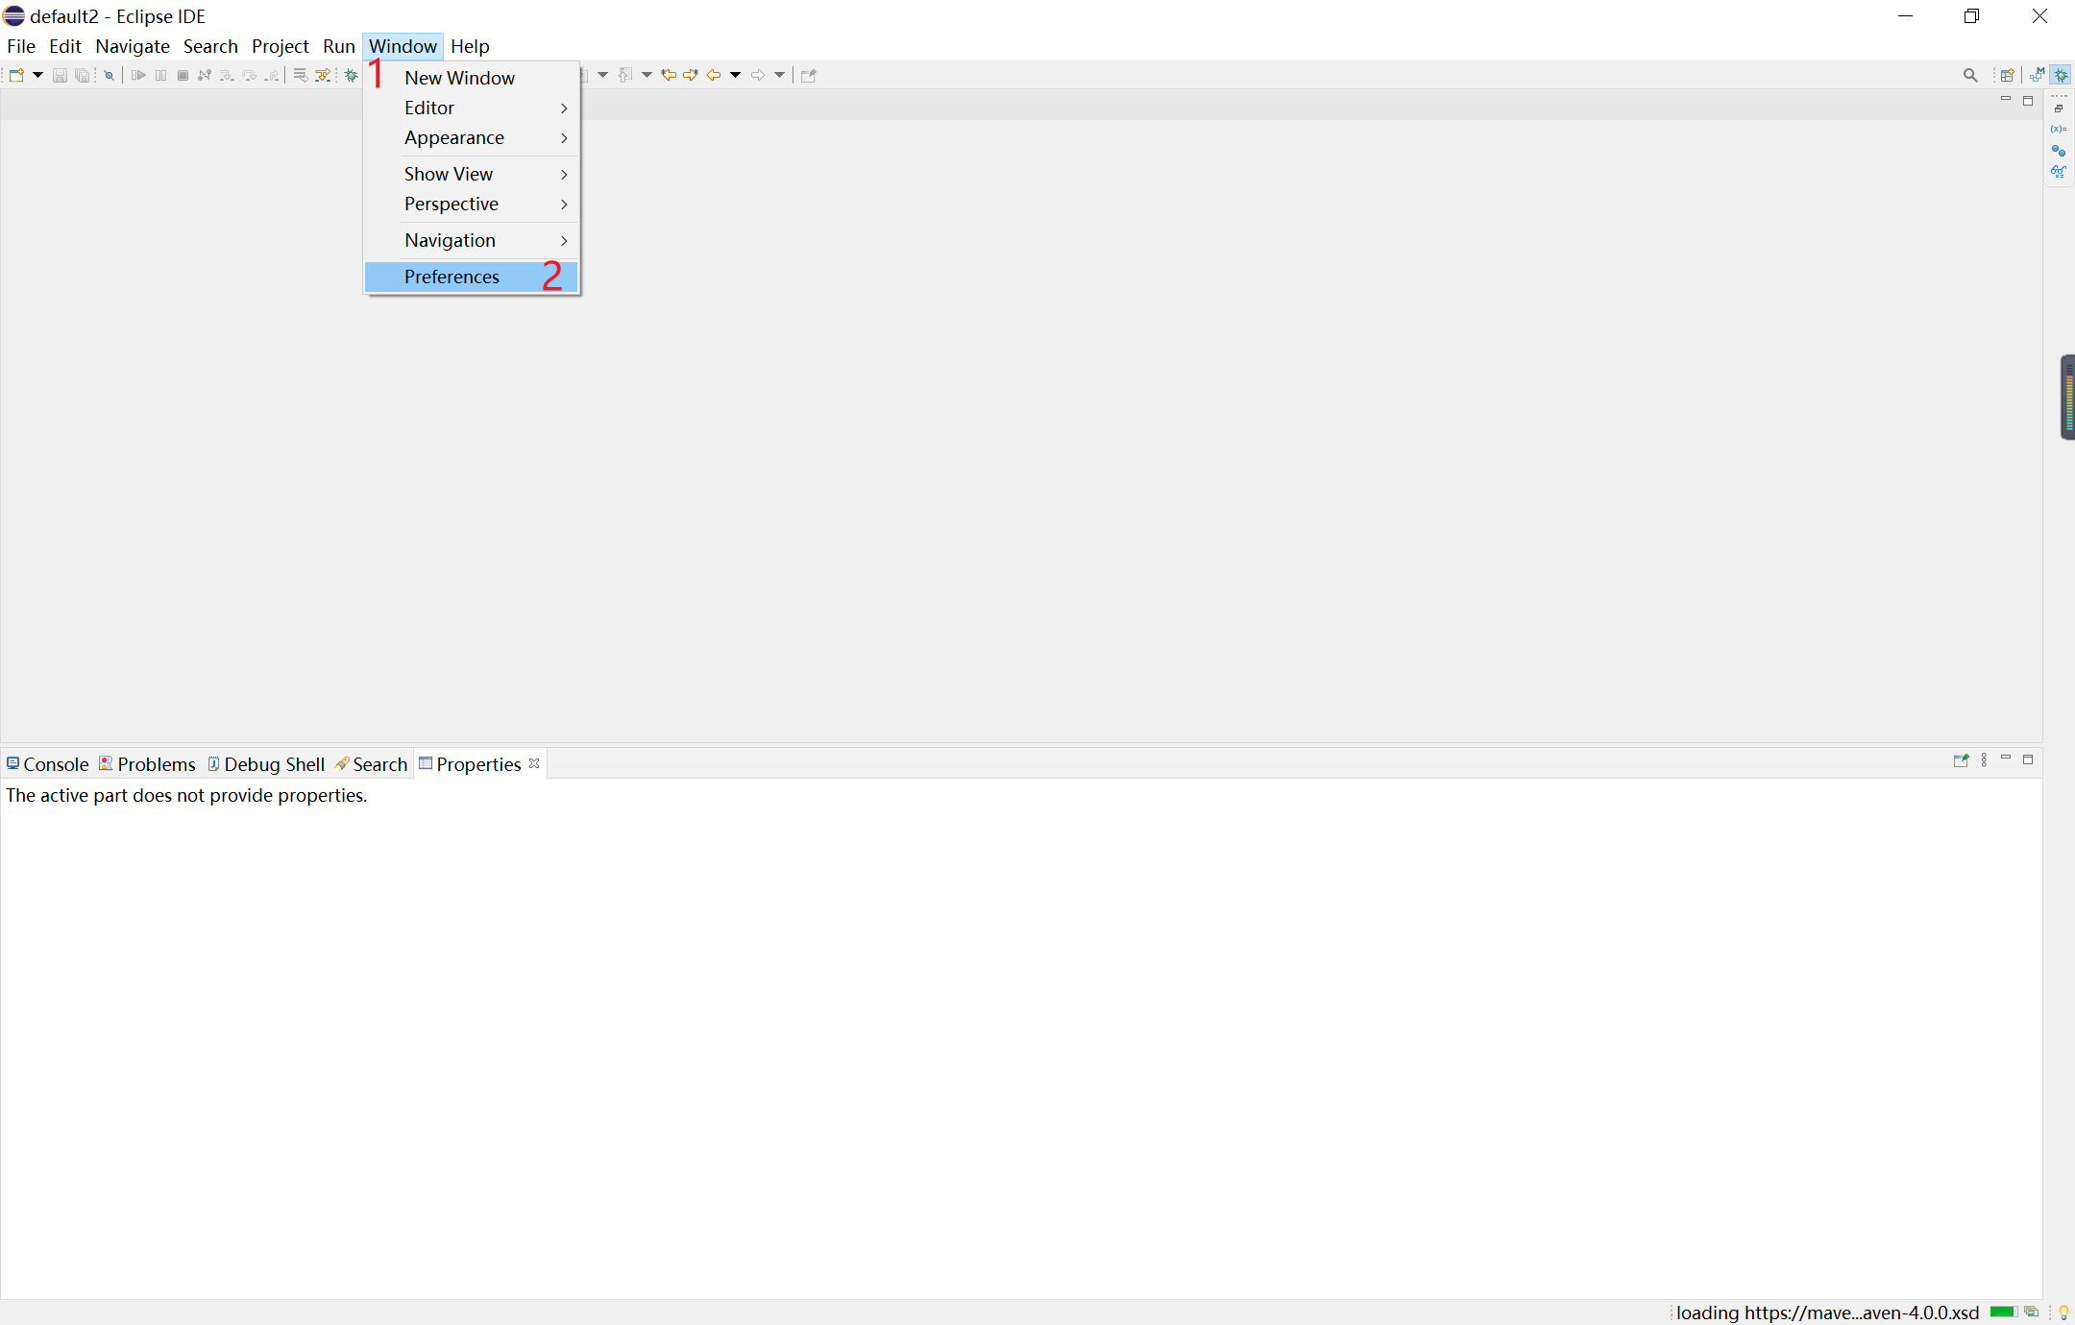

In the Preferences window, select Java -> Installed JREs, select the java version, and here we select java 11.

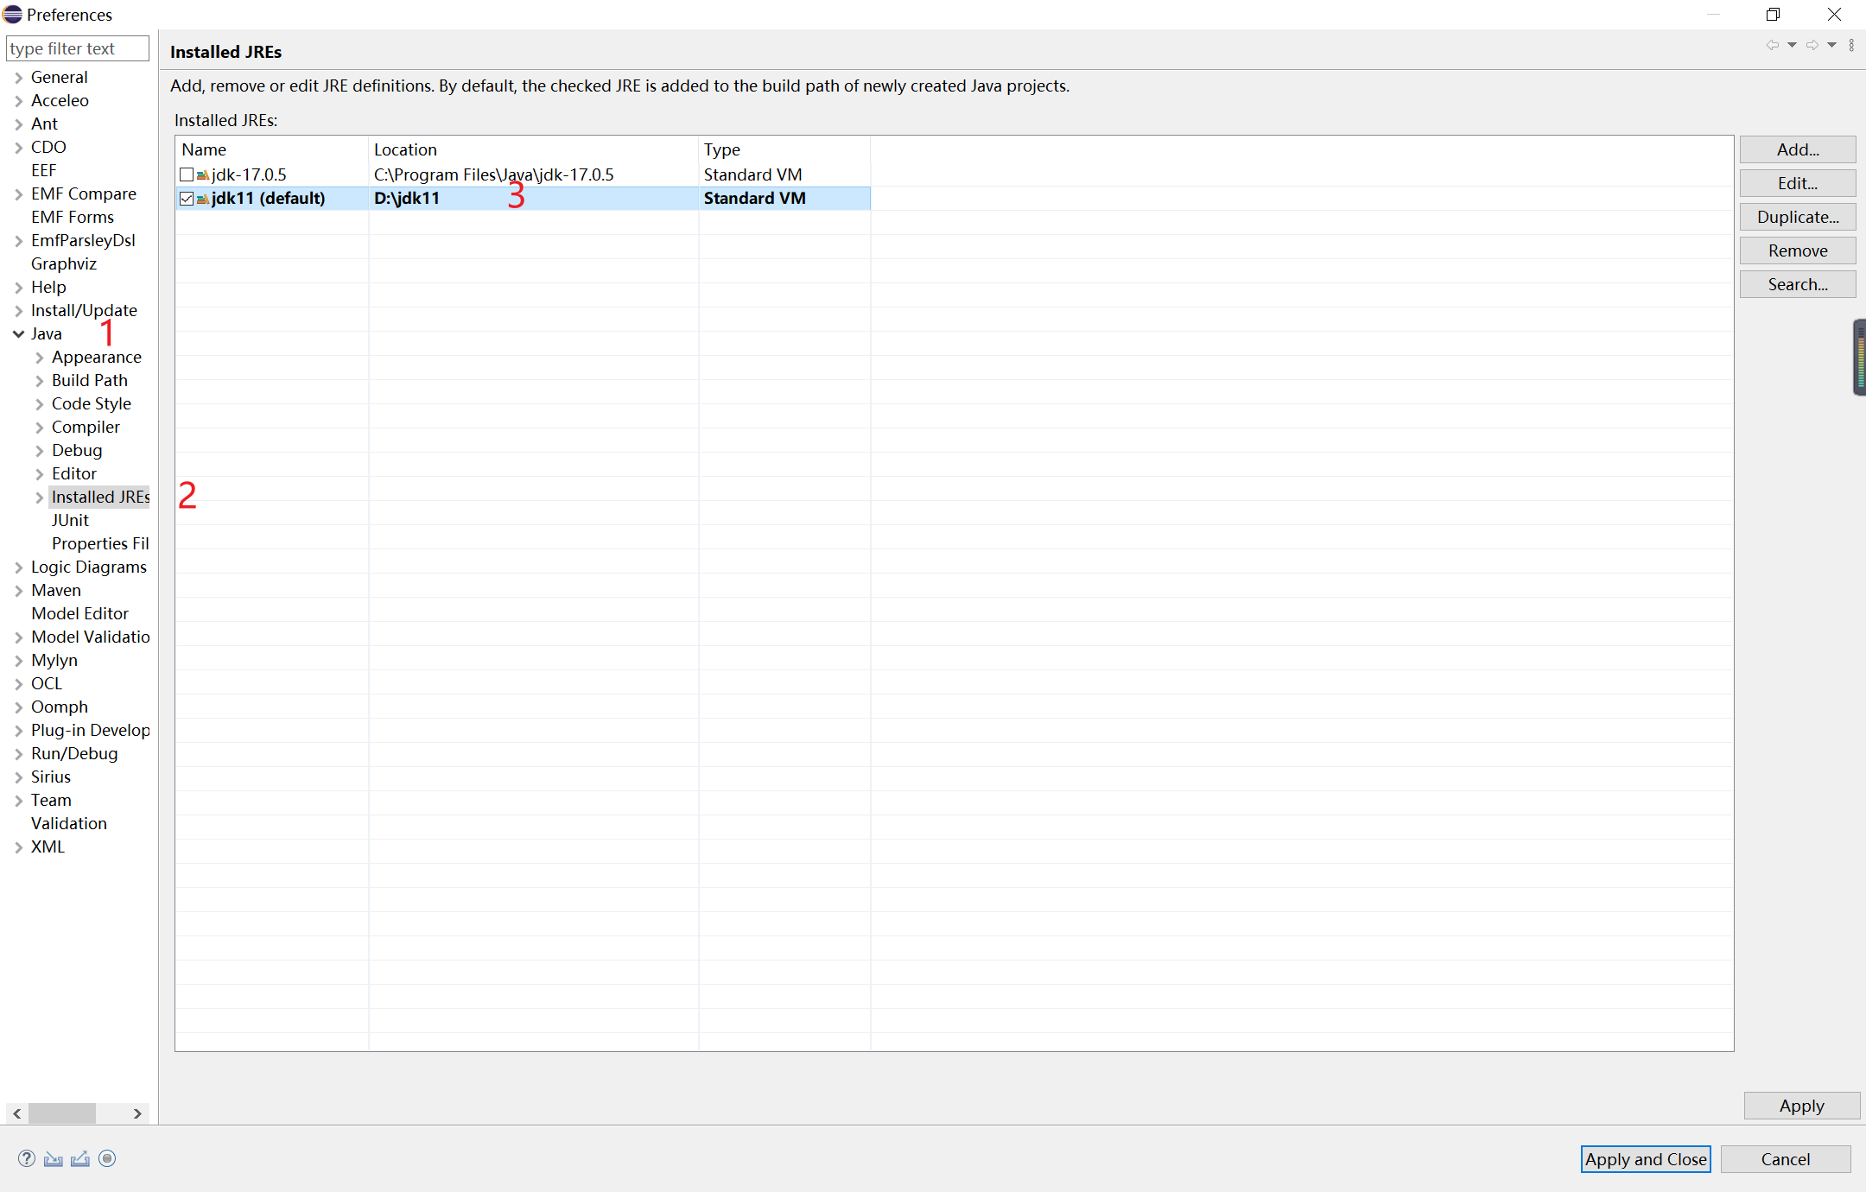

### Configure workspace

Configure Workspace as the tool folder, as follows:

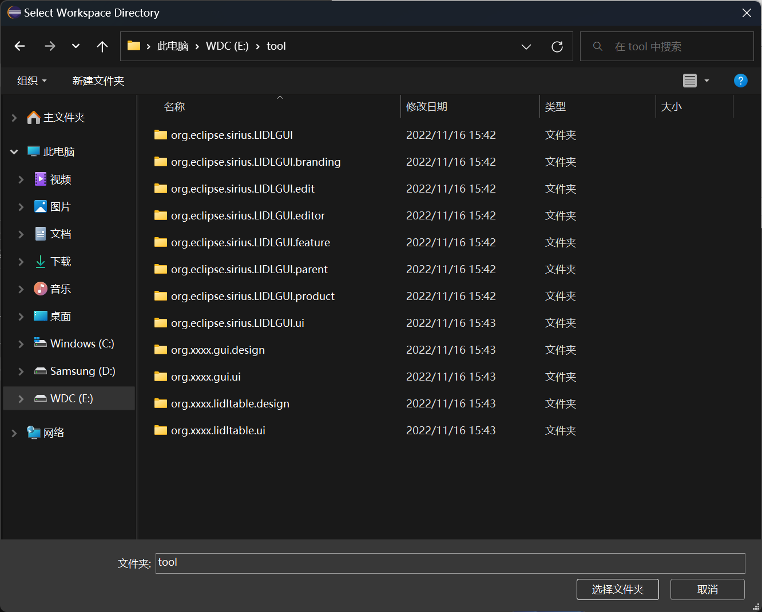

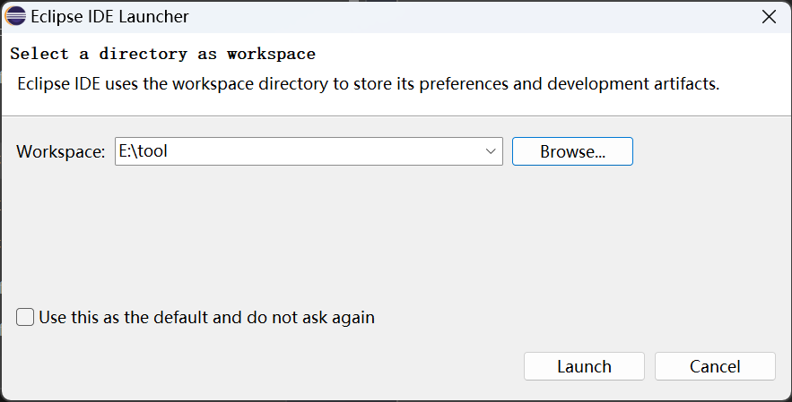

Click Launch to start the Eclipse IDE.

### Install plug-ins

Click Help>Eclipse Marketplace in the top menu bar of the IDE, and wait for the Eclipse Marketplace to finish loading.

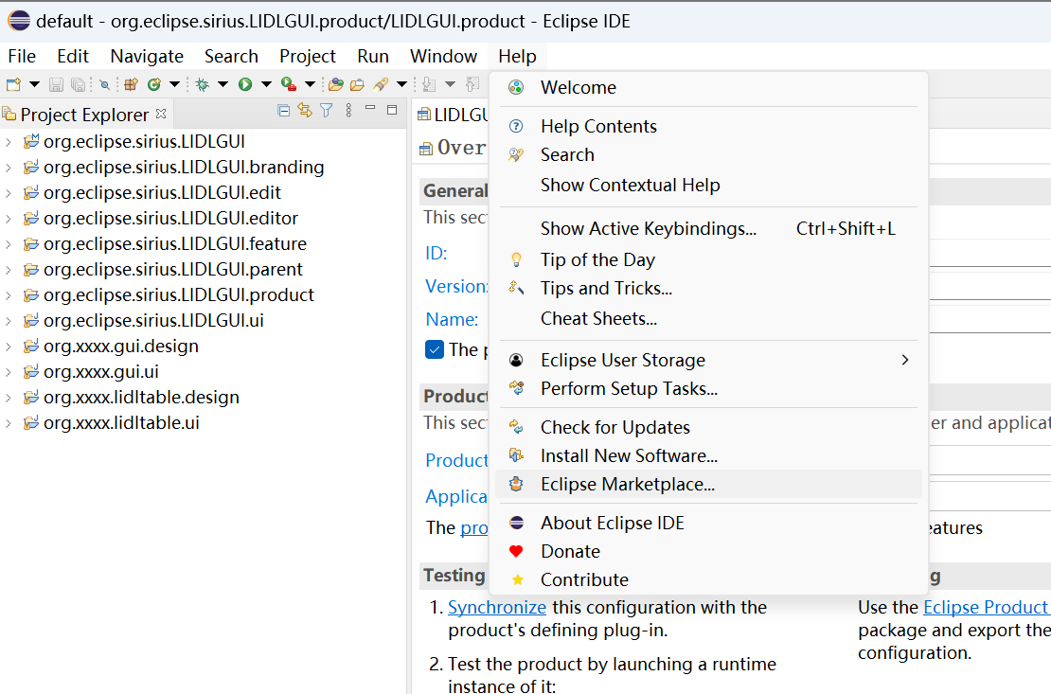

#### Verify the Eclipse IDE version

Now, you can check whether the Eclipse IDE is the Modeling Tools version, as follows:

Enter Ecore in the pop-up window and press Enter to search. When the search results are loaded, you can see EcoreTools: Ecore Diagram Editor 4.0, and it displays Installed.

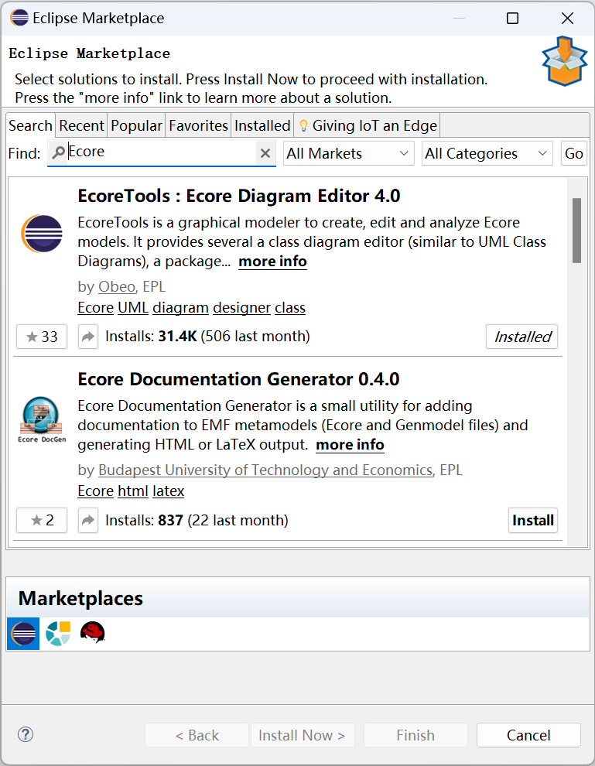

Or click the "Installed" tab in the window to see EcoreTools: Ecore Diagram Editor 4.0.

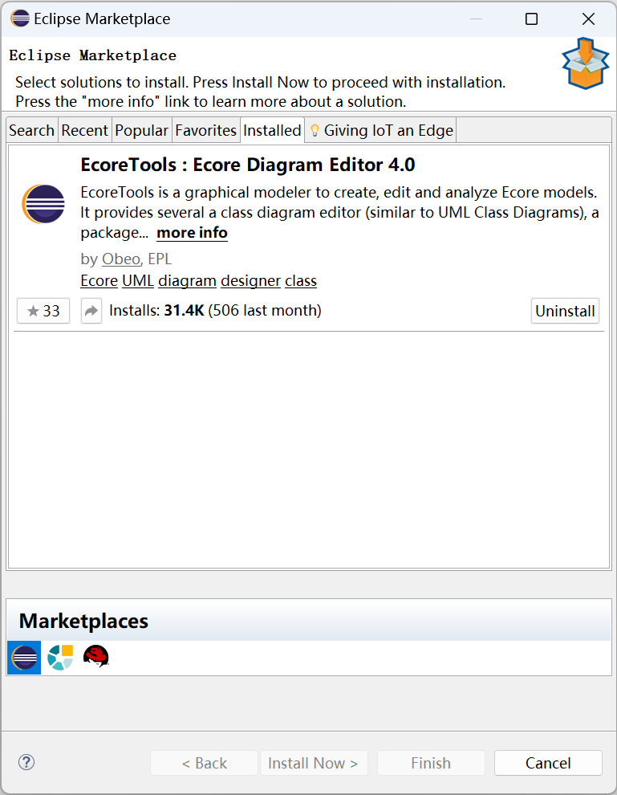

#### Install Sirius 6.5

Search Sirius in the Eclipse Marketplace, and click Install to install Sirius 6.5 in the search results.

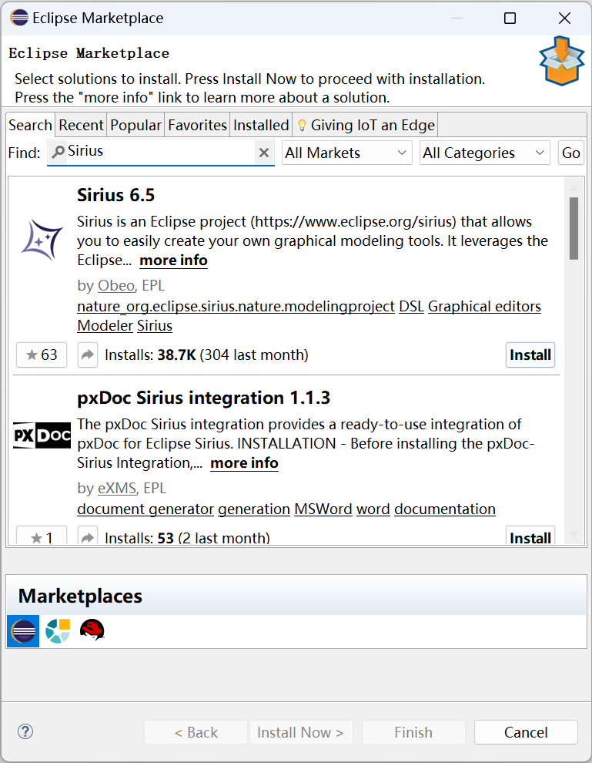

Click Confirm.

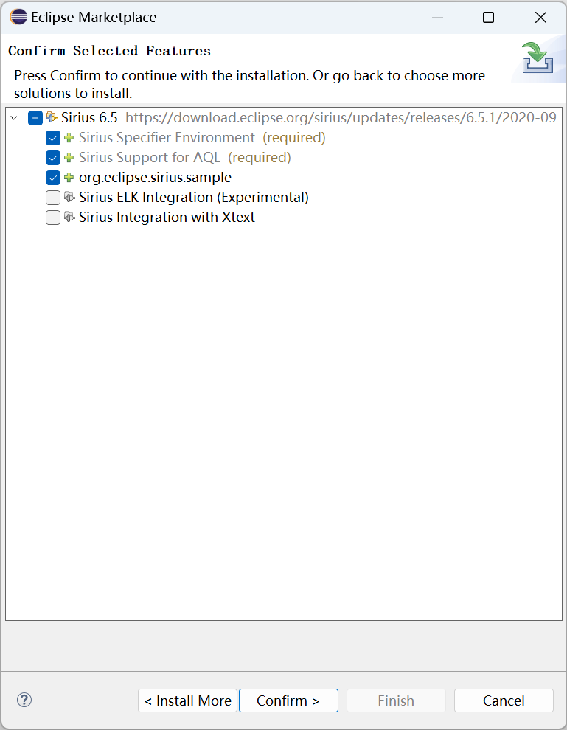

Click Yes and wait for the download.

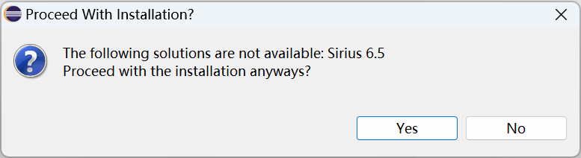

During the download process, click Progress in the lower right corner to open the Progress tab to view the download progress.

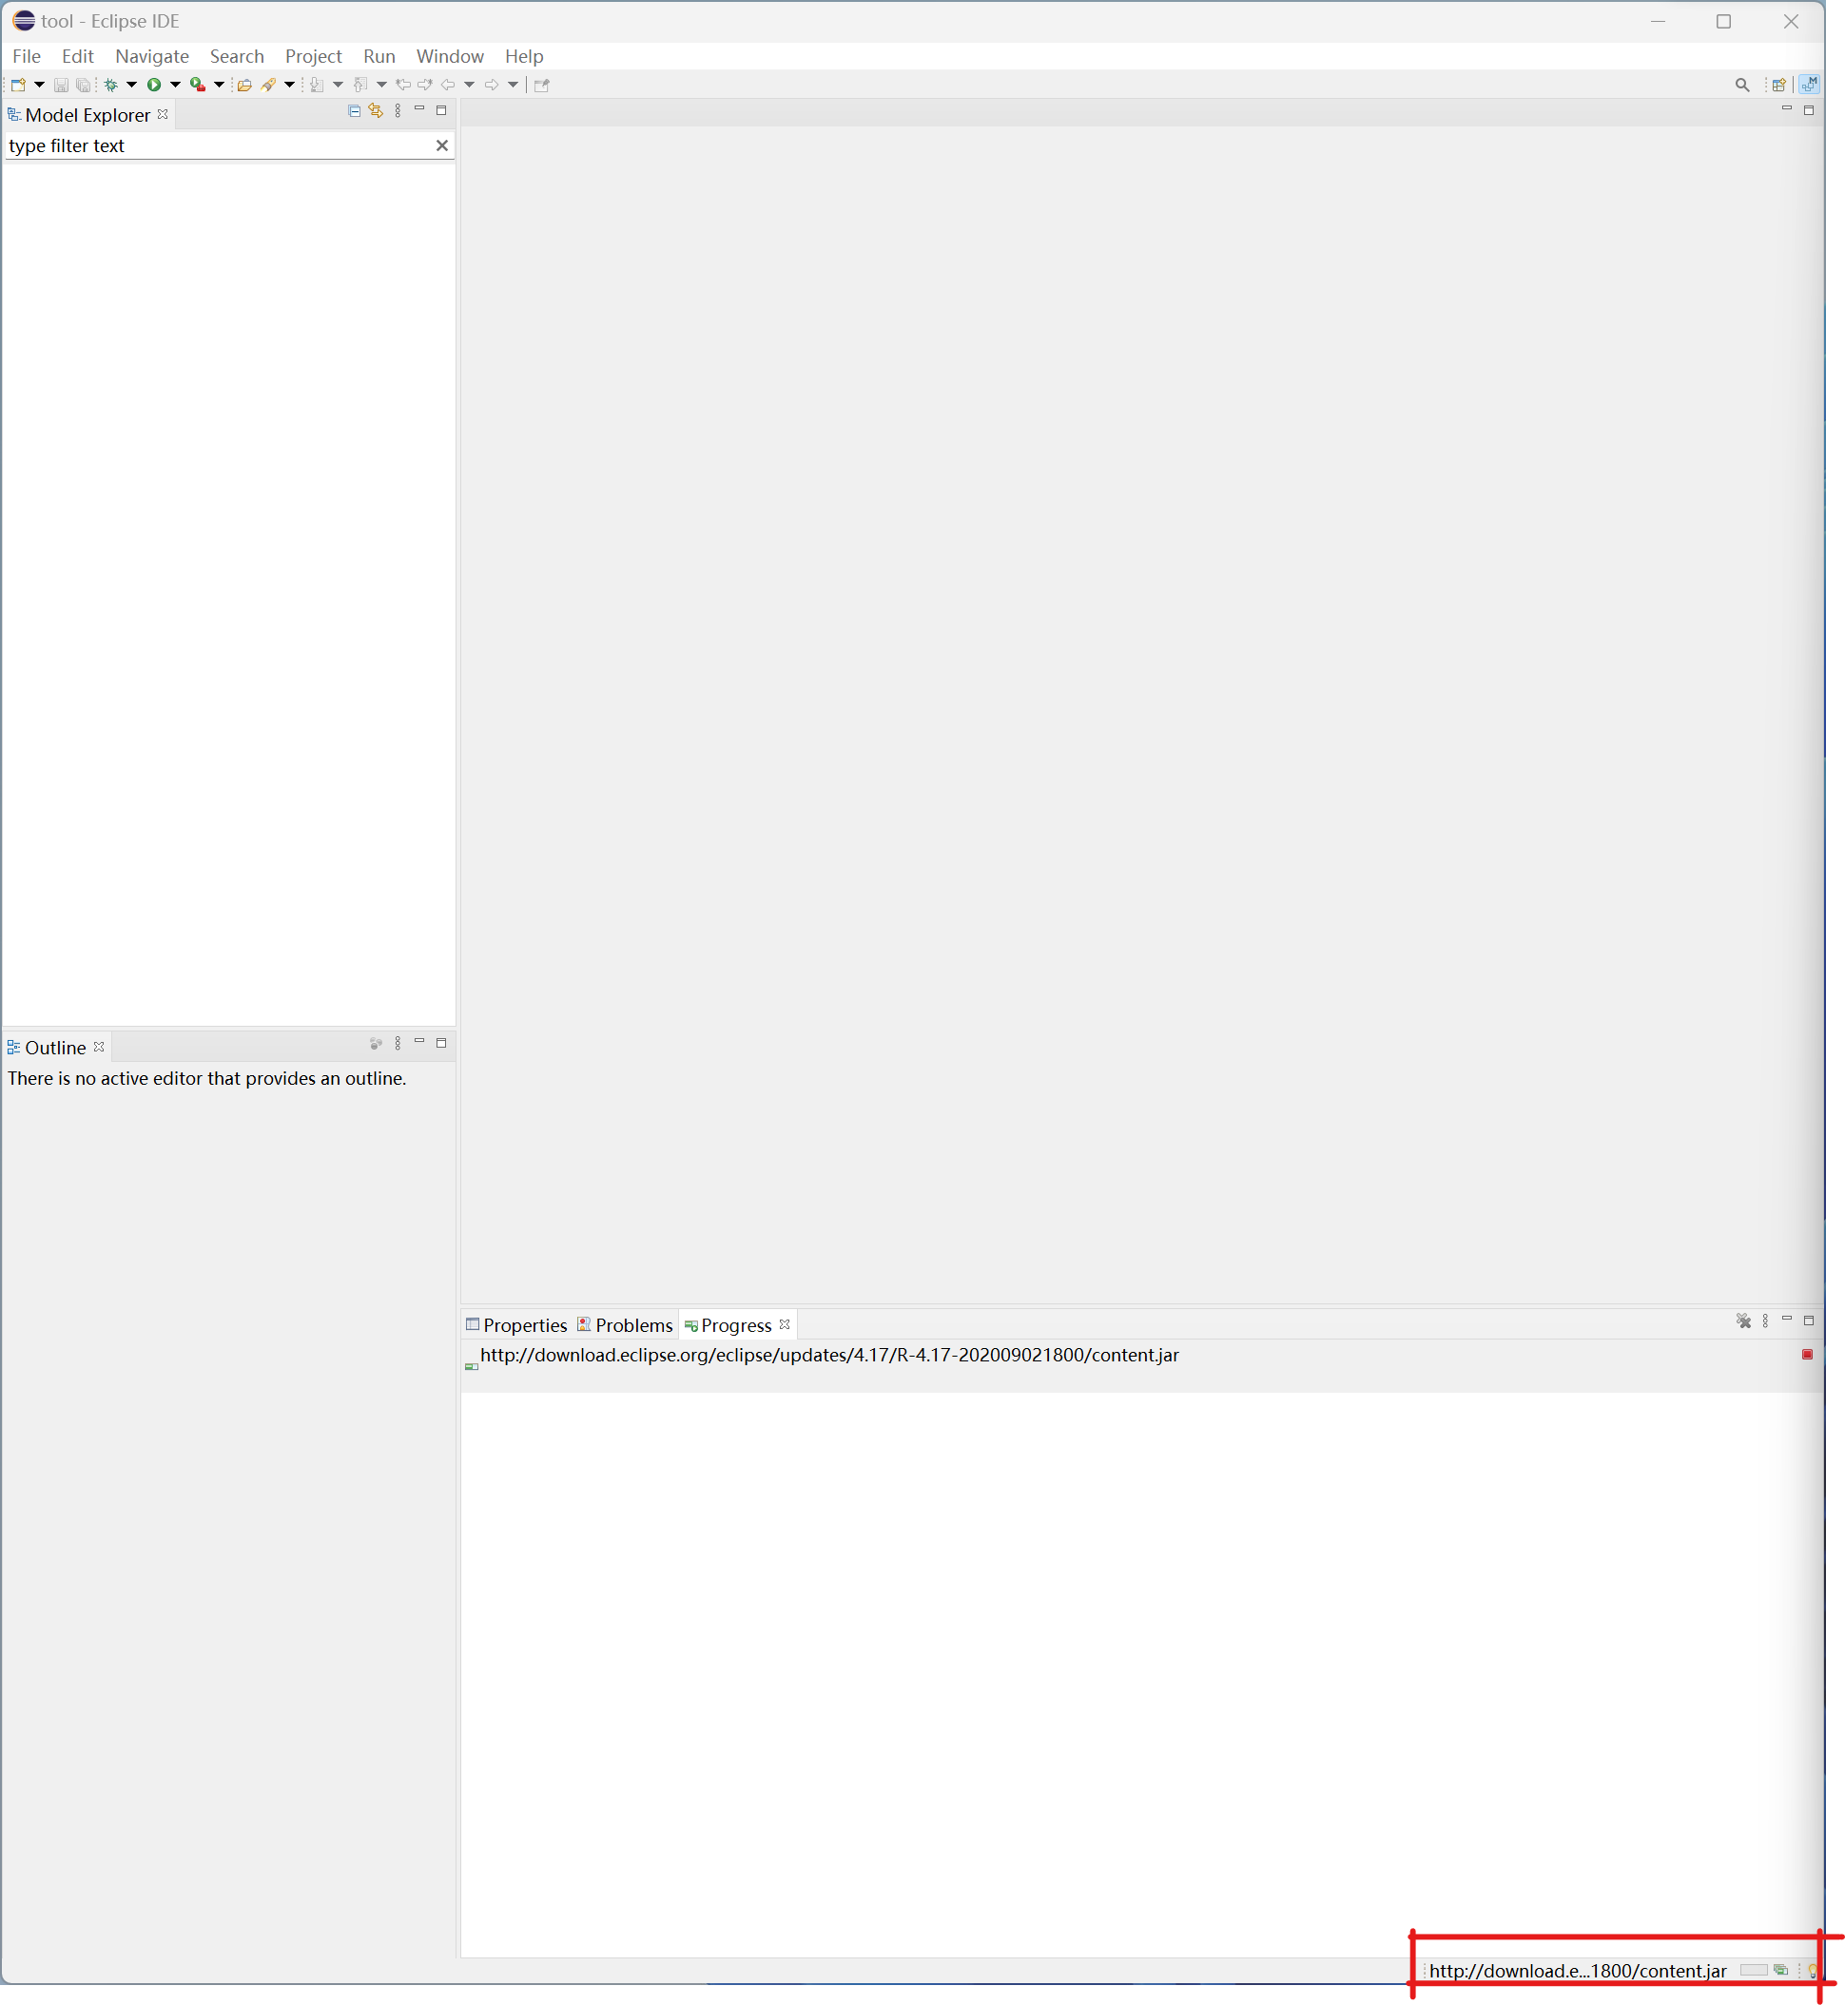

After downloading, select I accept in the pop-up Review Licenses window and then click Finish.

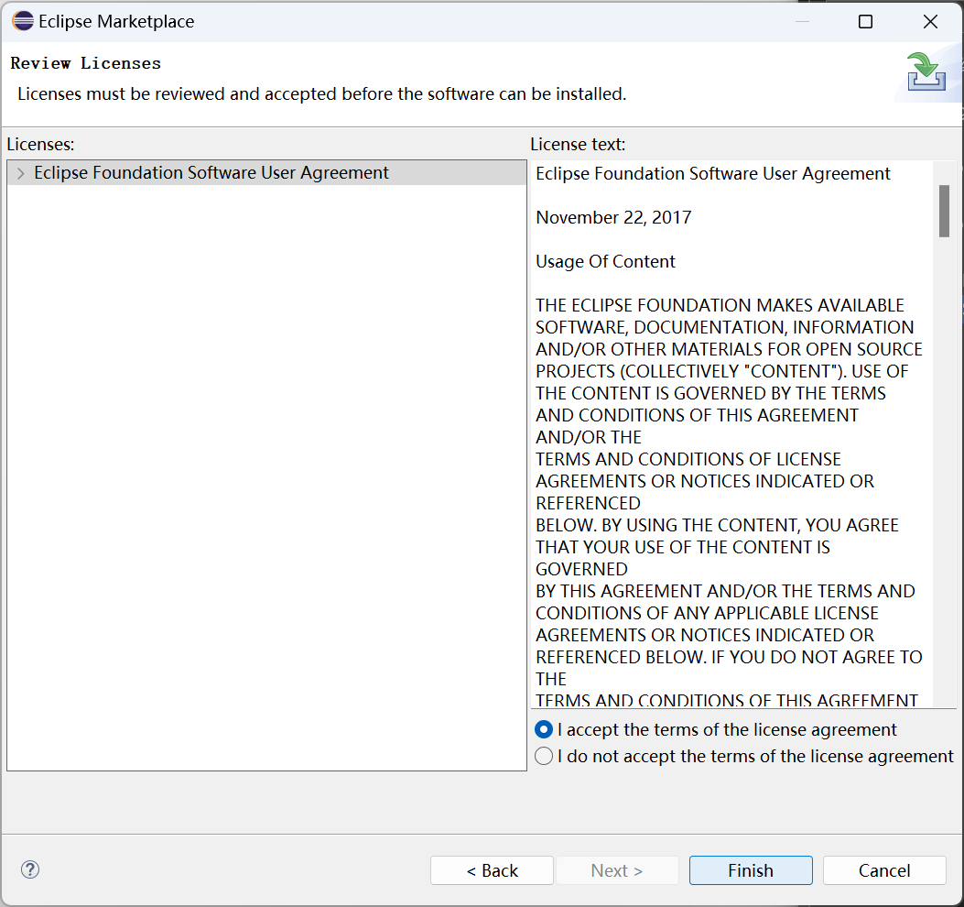

The Progress window will display the installation Progress and wait for the Sirius 6.5 download and installation to complete.

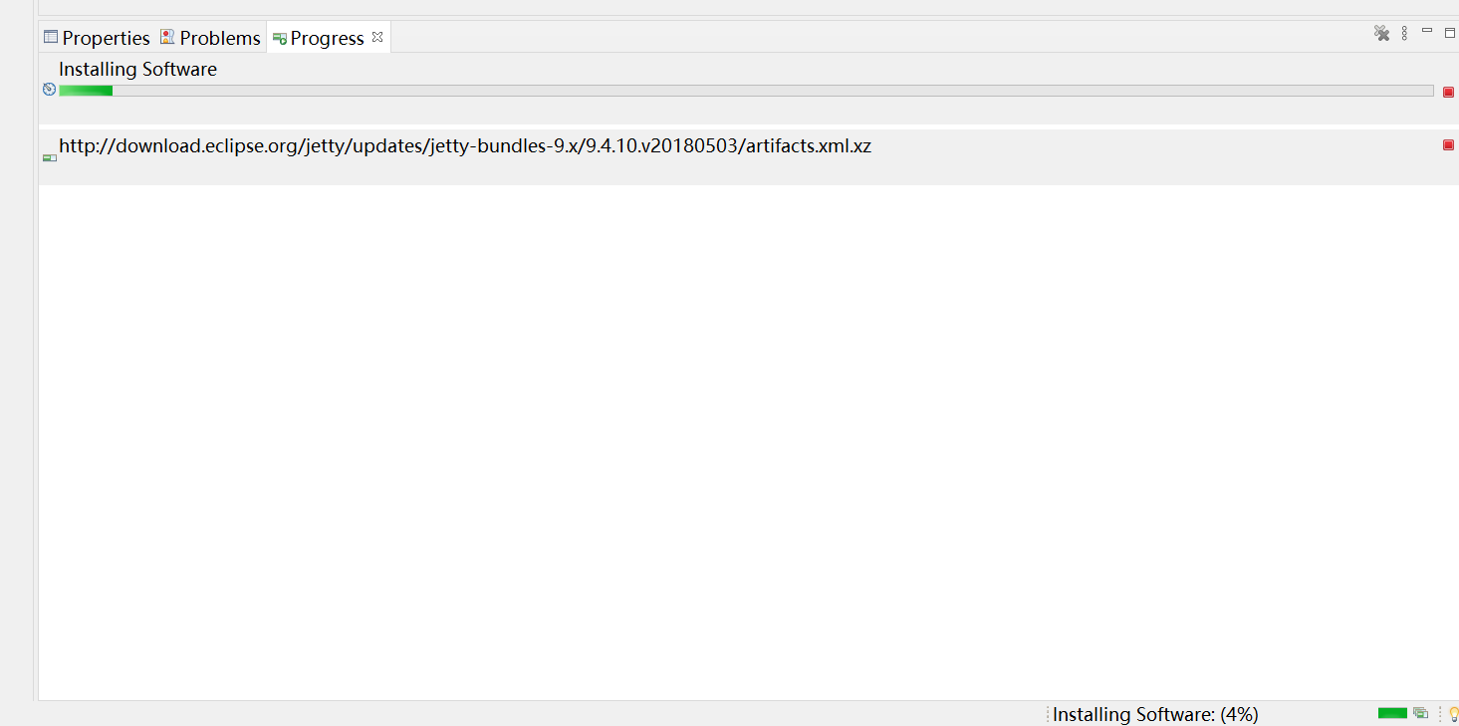

After installation, click Restart Now to restart the Eclipse IDE.

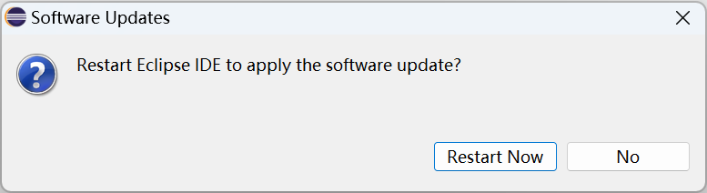

## Run the software project

### Import Software Project

Click File > Open Projects from File System...

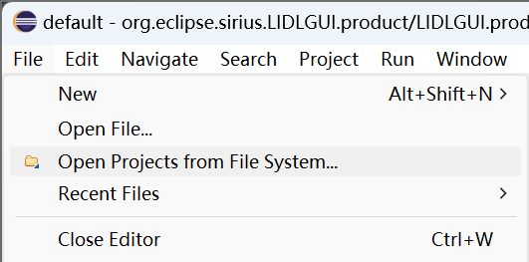

Click Directory in Import Projects from File System or Archive.

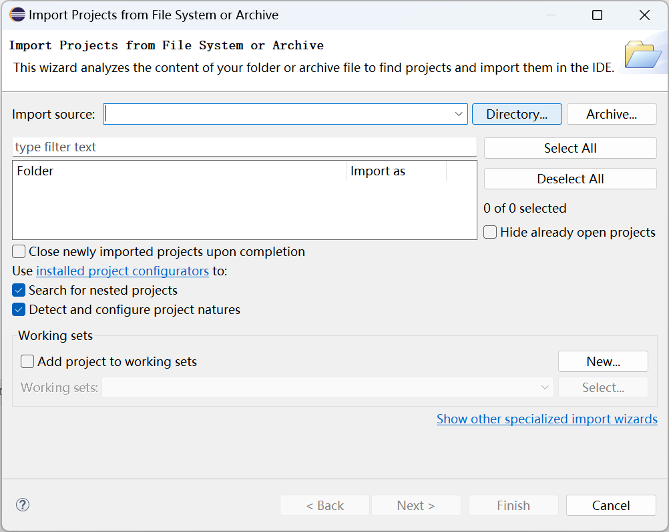

Select the folder extracted from Modeling.zip. In our manual, it is the tool folder under the root directory of Disk E.

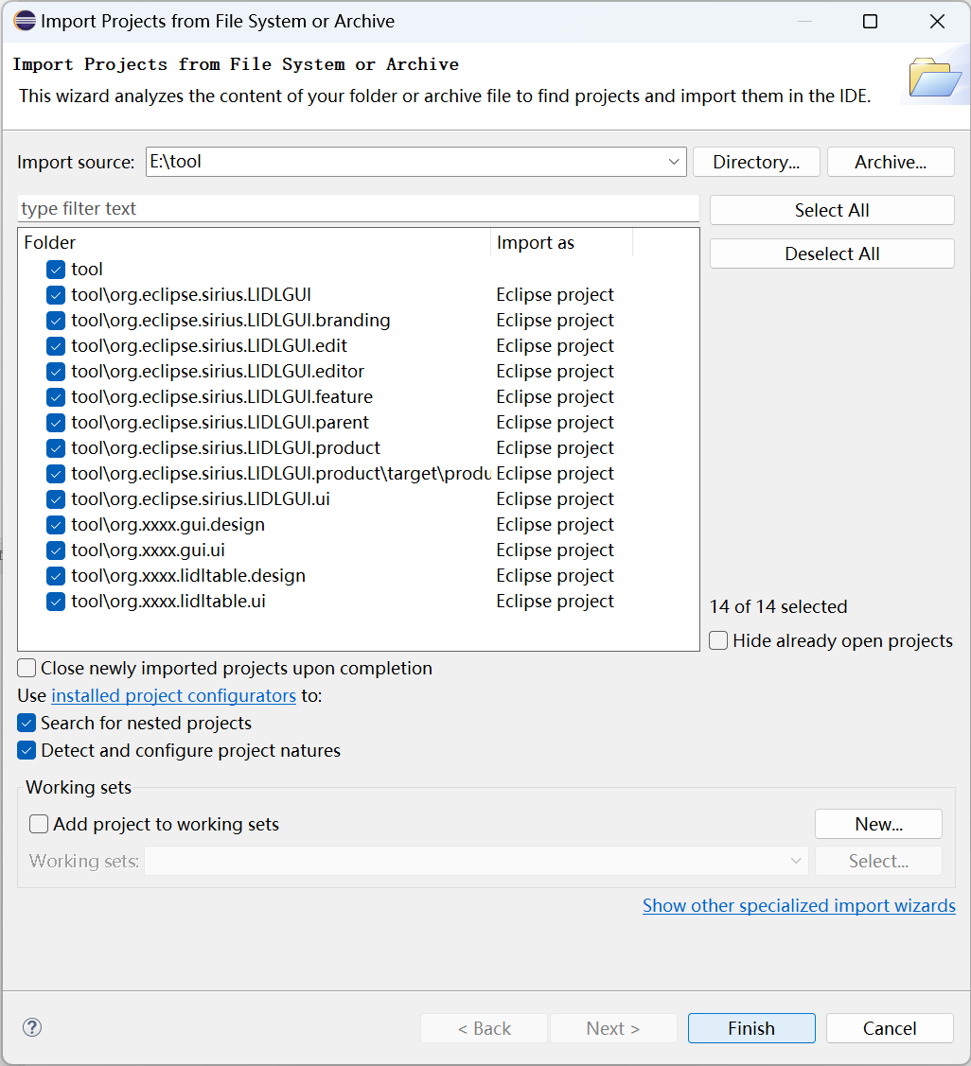

Eclipse will automatically check all Eclipse projects under Folder, and click Finish here.

After the software import is completed, the following window will pop up, prompting that the IDE lacks nature, and suggesting that you use the Eclipse Marketplace to install extensions.

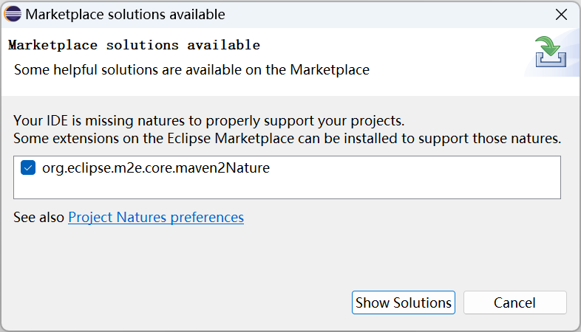

Click Show Solutions to jump to the Eclipse Marketplace and display Eclipse m2e – Maven support in Eclipse IDE Latest.

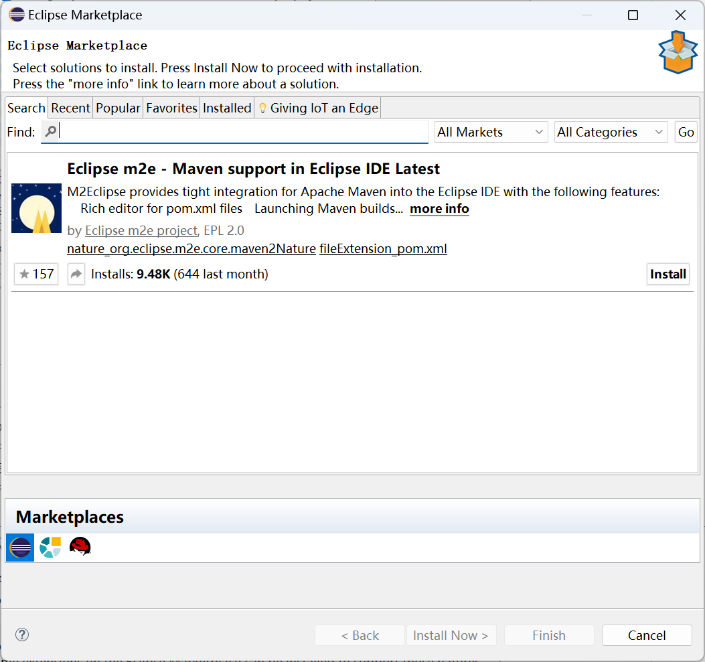

According to our experience, not installing this extension will not affect the next building and running of the source code of modeling tools. Therefore, you can **not install this extension**, just close the pop-up Eclipse Marketplace window and Marketplace solutions available window.

After importing the software project, You can see Warnings (100 of 214 items) in the Problems View below Eclipse. According to our experience, you can ignore these Warnings.

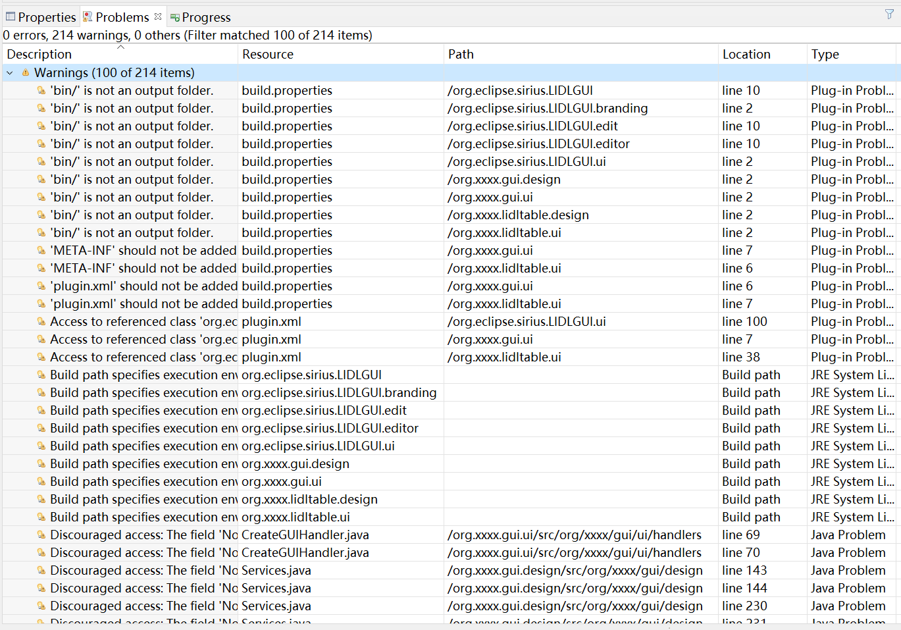

### First time running the project

Double click org.eclipse.sirius.LIDLGUI.product in the left Model Explorer.

Double click LIDLGUI Product, the following interface appears, and click Launch an Eclipse application in the red box.

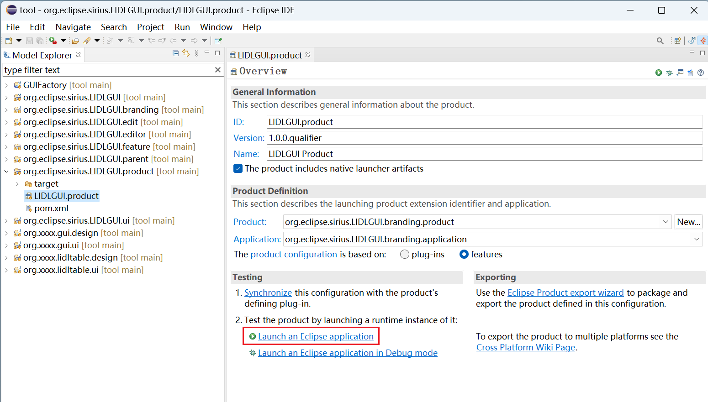

The Validation window pops up, click Continue.

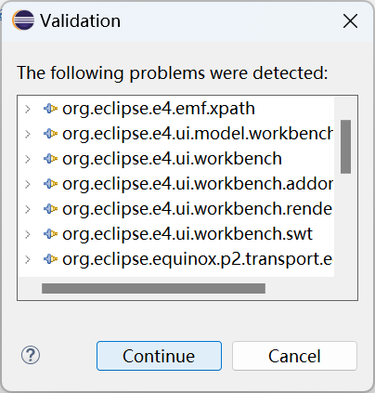

The prompt window of Launch Error appears. Click No to close it.

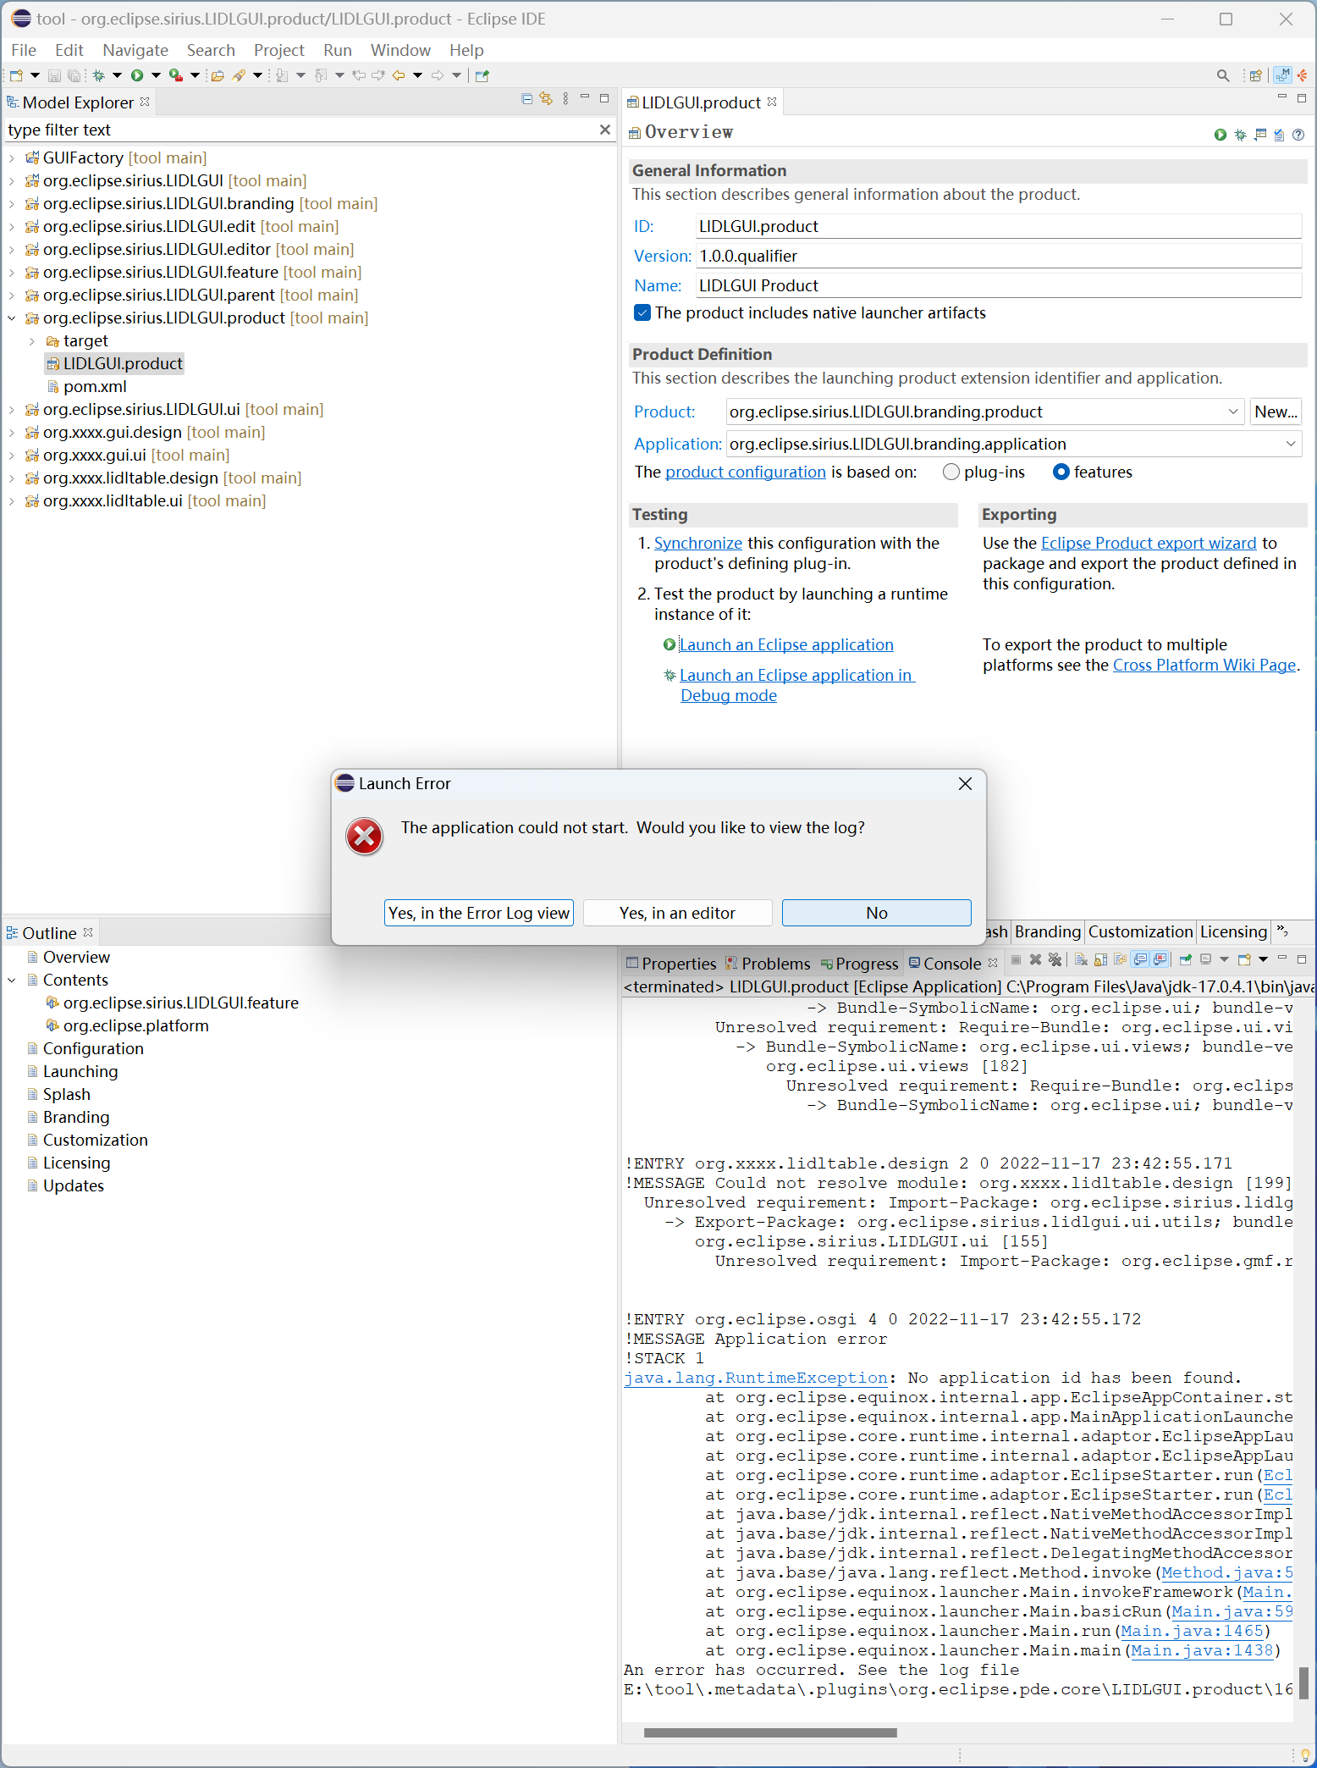

### Configure operation parameters and rerun items

Running the project for the first time is to facilitate the configuration of operation parameters. Next, configure the operation parameters.

In the top menu bar, select Run, and then click Run Configurations...

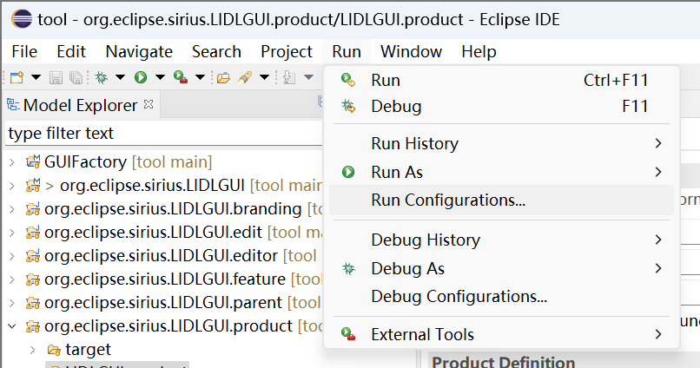

#### Check Main configurations

In the pop-up Run Configurations window, select the content in the red box, and then confirm the configurations of LIDLGUI.product in the main tab of the product are consistent with those in the screenshot. In particular, the execution environment is JavaSE-1.8.

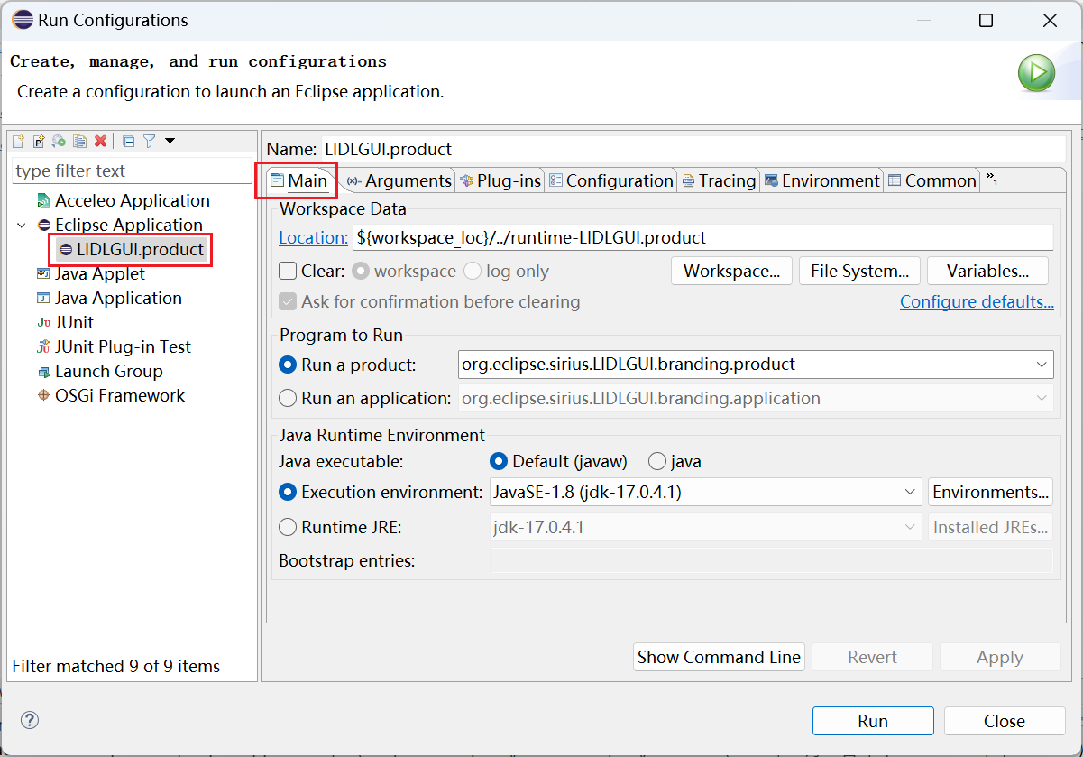

#### Configure Plug-ins

Select Plug-ins Tab, and configure Launch with “all workspace and enabled target plug-ins”.

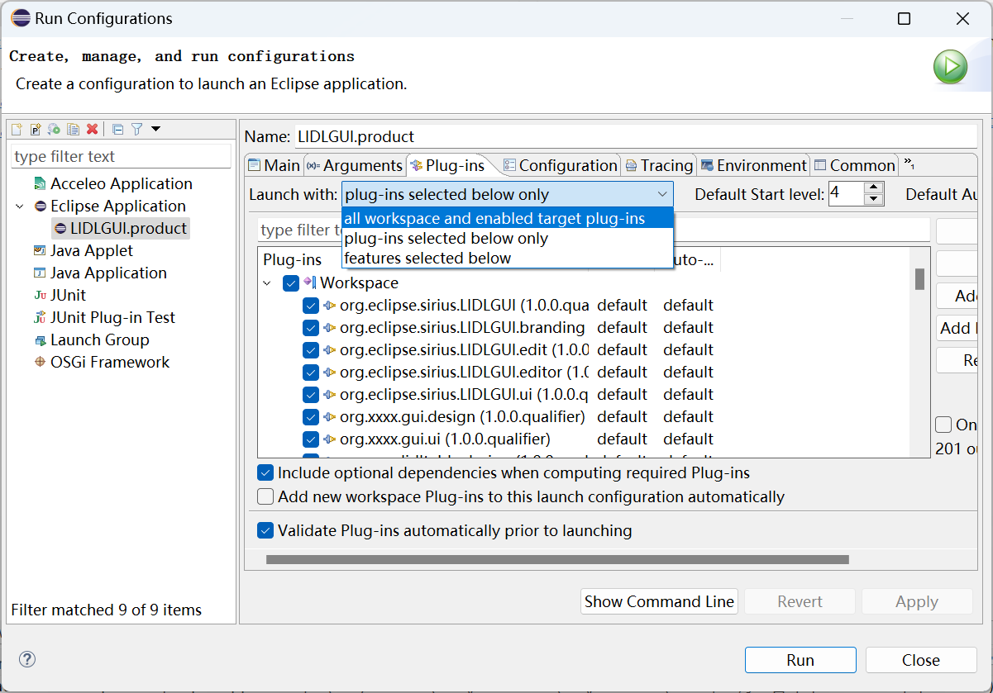

Click Apply.

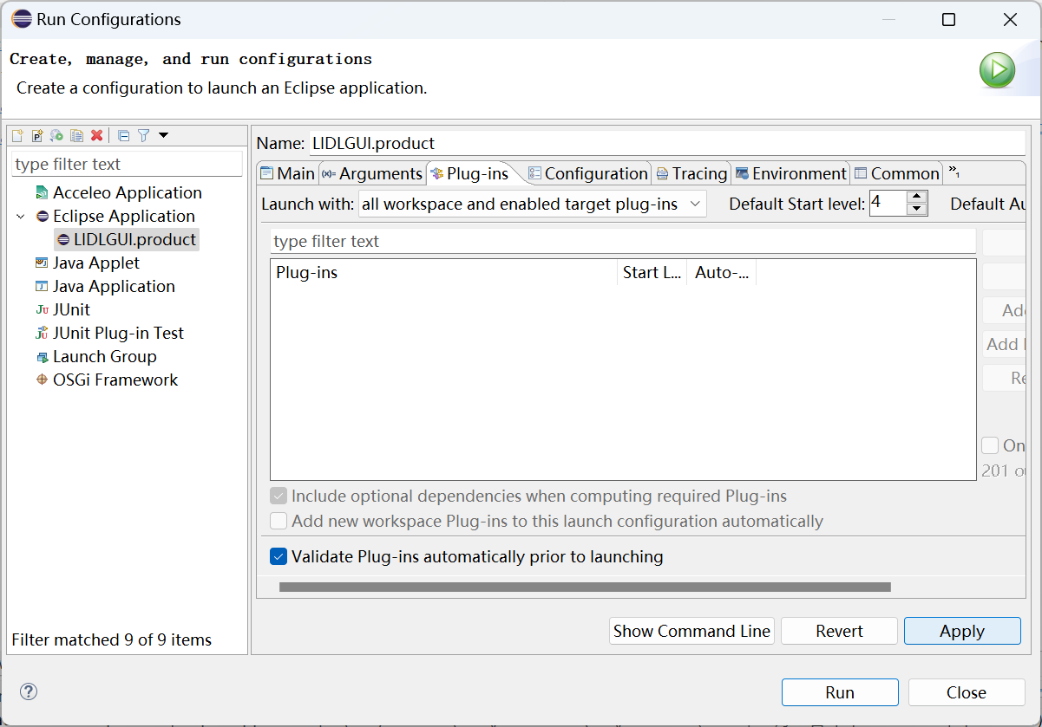

Click Run and click Continue in the pop-up Validation window.

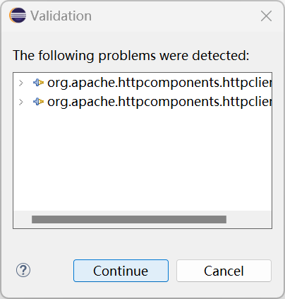

Wait for the project to run, and you should be able to see the following interface.

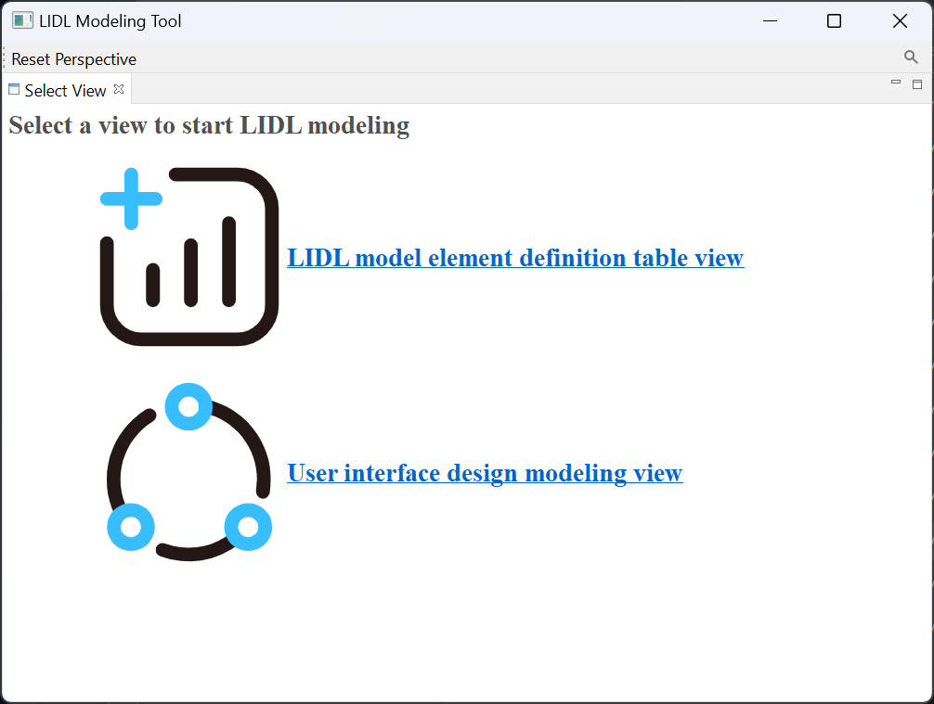

#### Configure Program arguments

If you want to return to the home page every time start the modeling tool, instead of the page when you left last time; At the same time, ensure that the data saved in the previous run is loaded successfully, then add the following to the Program arguments in the Arguments Tab of Run Configurations: **- clearPersistedState - persistState false**

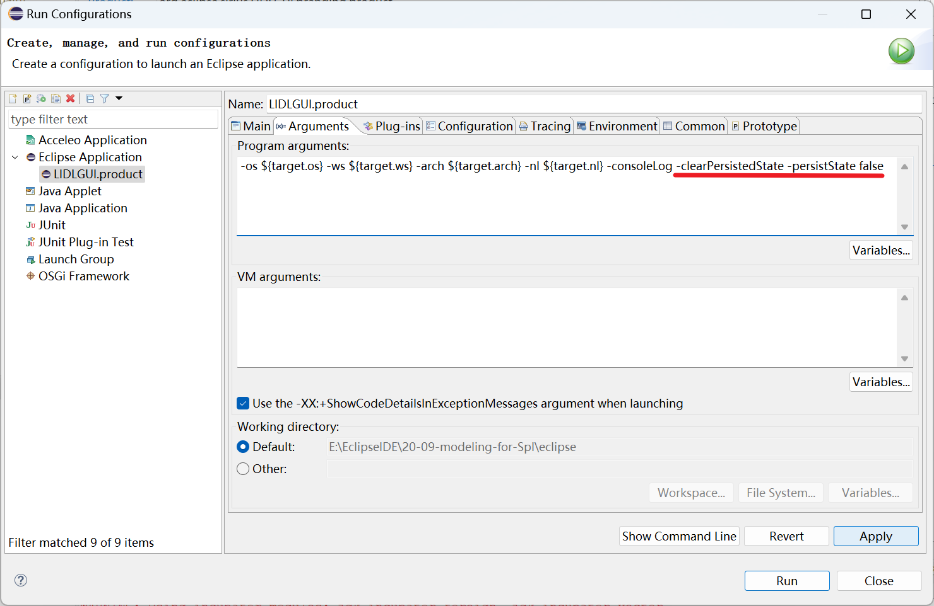

Click Apply, and click Run.

After configuring the above Program arguments, You can click the Run button at the top of the Eclipse IDE to run the program. If you still click Launch an Eclipse application in the product to run the program, the configured parameters in Program arguments will disappear.

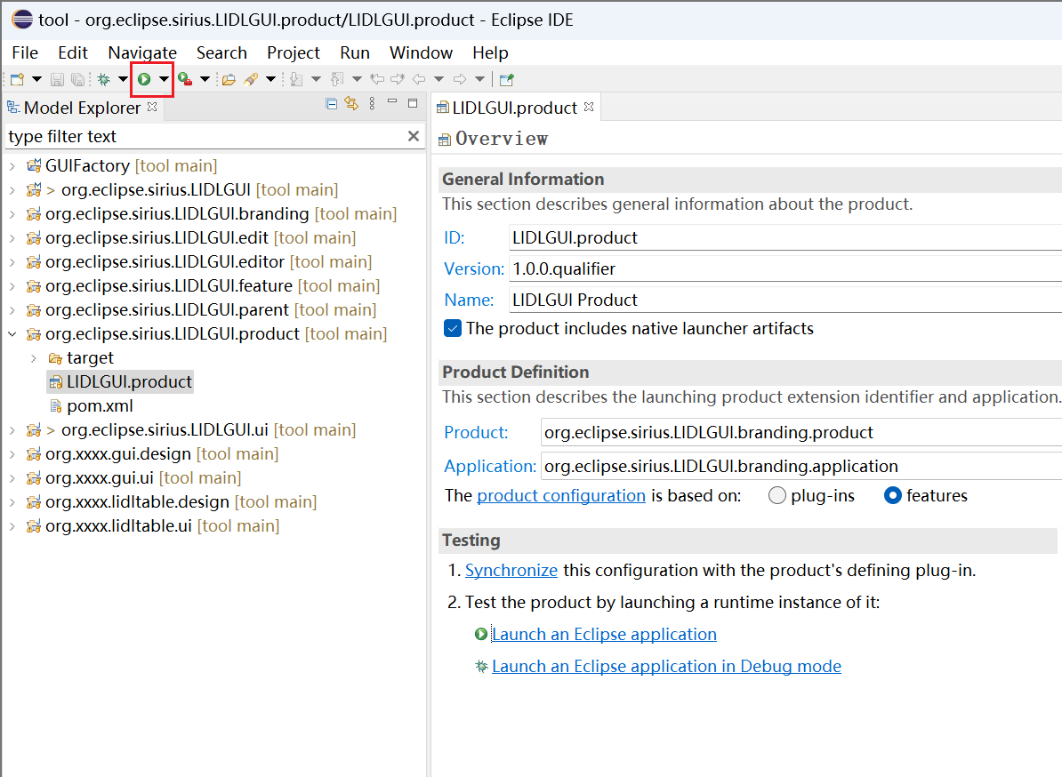

### Switch Perspective

In the upper right corner of the Eclipse IDE (in the red box below), you can switch Perspective, which is currently the default Modeling.

In the red box in the figure below, click the button on the left to open the "Open Perspective" window. You can see the currently open Perspectives on the right.

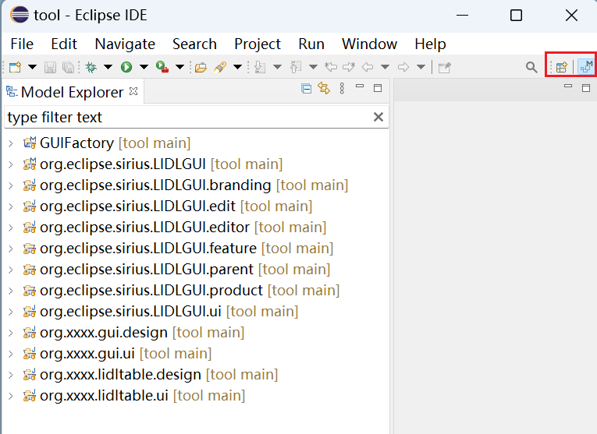

Click the "Open Perspective" button on the left of the red box in the figure above, select "Sirius" in the pop-up window and click Open.

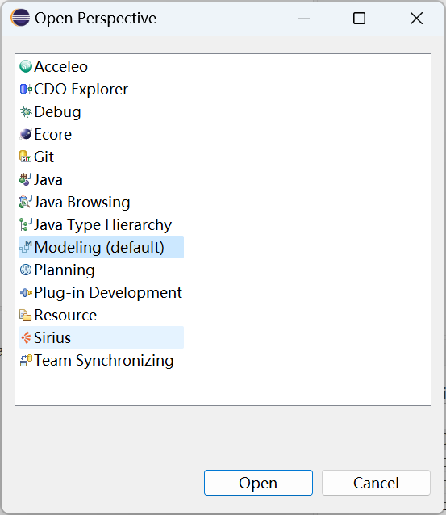

There is an icon of Sirius Perspective in the upper right corner of the Eclipse IDE.

We develop this project mainly from Sirius Perspective.

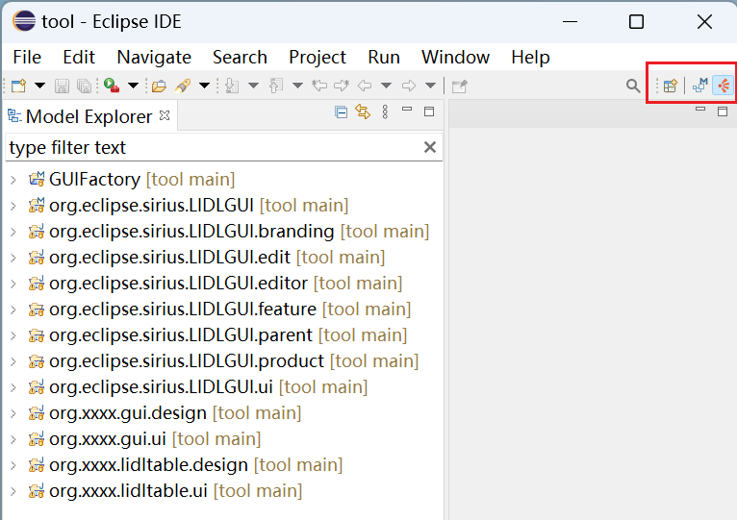

## Development manual guided by the graphical interface

### Launch Interface of Modeling Tool

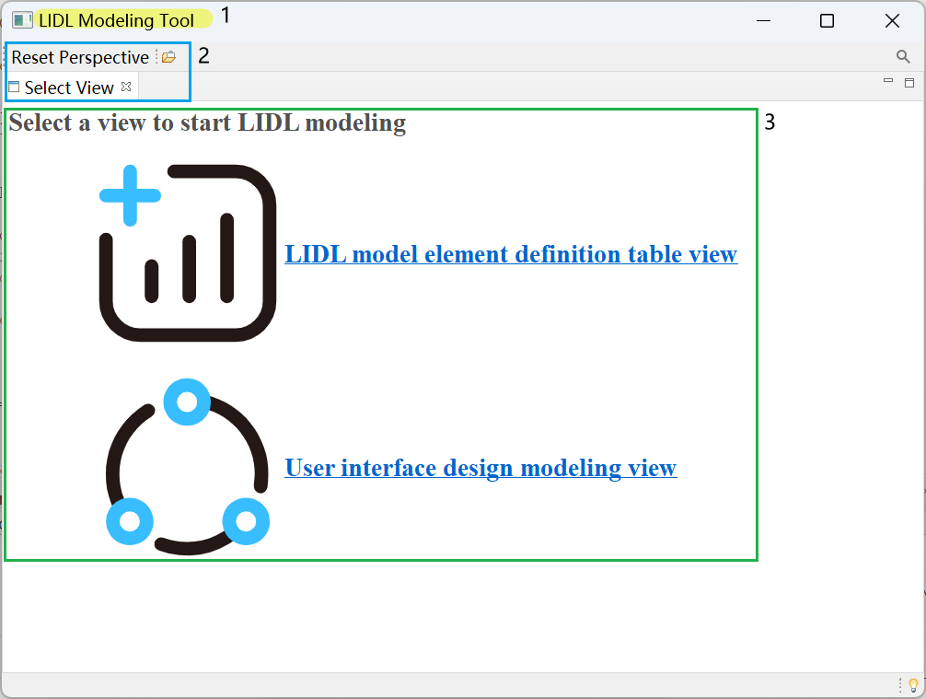

You can configure area 1 (window title) in the above figure in the File:

/tool/org.eclipse.sirius.LIDLGUI.branding/src/org/eclipse/Sirius/lidlgui/branding/ApplicationWorkbenchWindowAdvisor.java

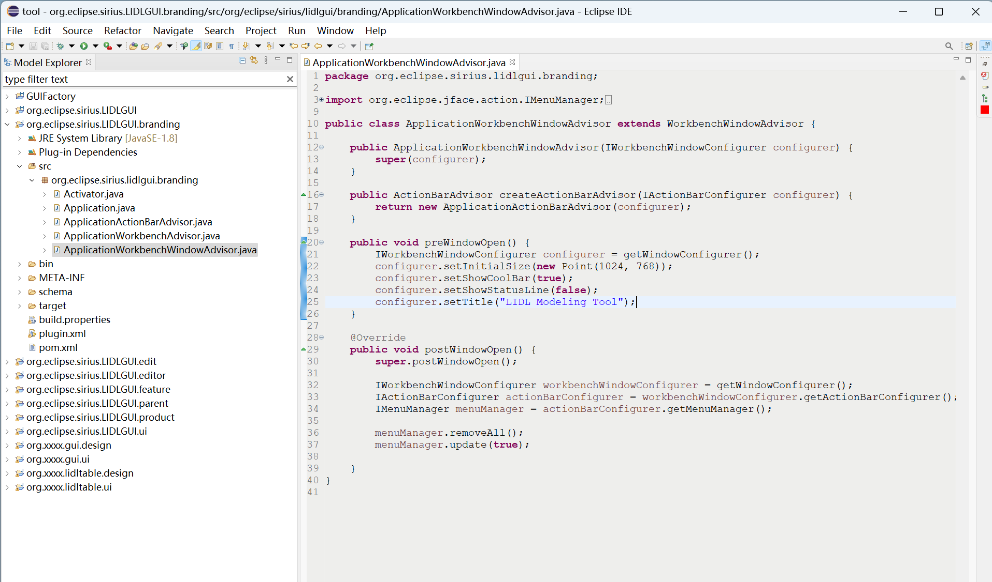

You can configure area 2 (top menu bar, tab) in the file:

/tool/org.eclipse.sirius.LIDLGUI.ui/plugin.xml

After opening, select in the following order to configure the text of the menu bar and tab at the top of the page.

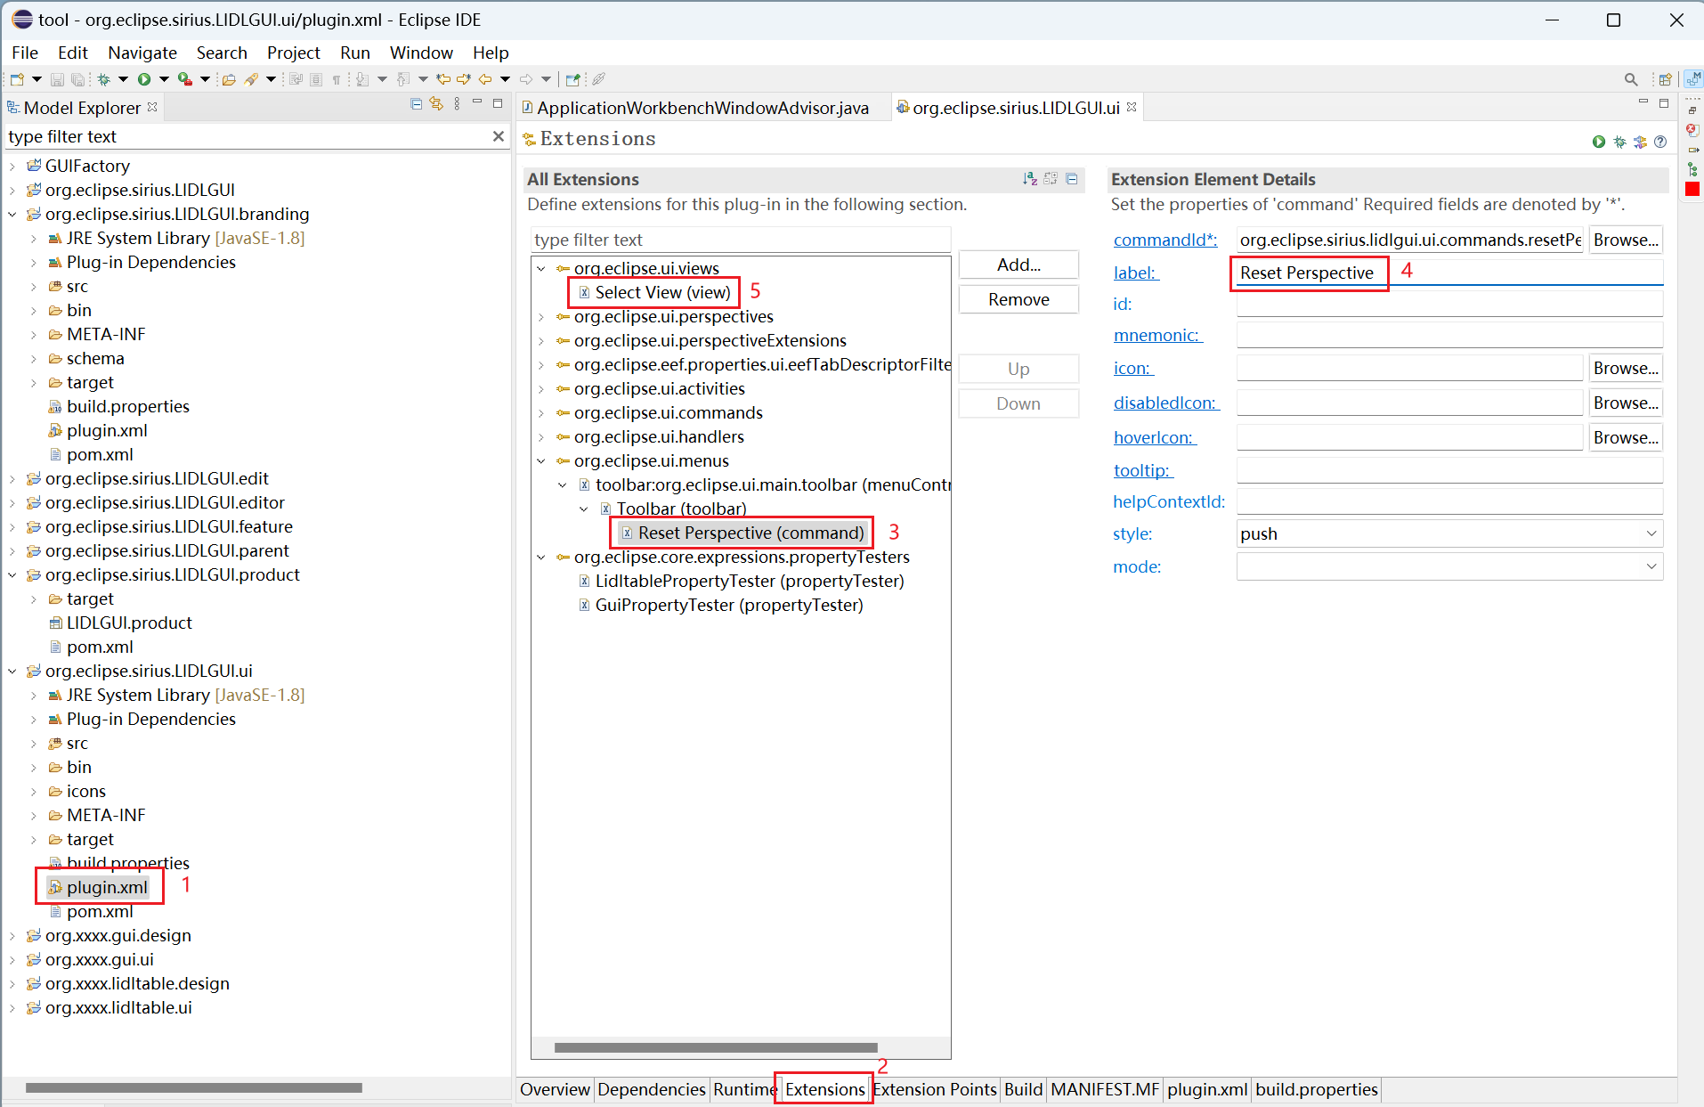

You can configure area 3 (Modeling view) in the file:

/tool/org.eclipse.sirius.LIDLGUI.ui/src/org/eclipse/sirius/lidlgui/ui/views/DashboardView.java

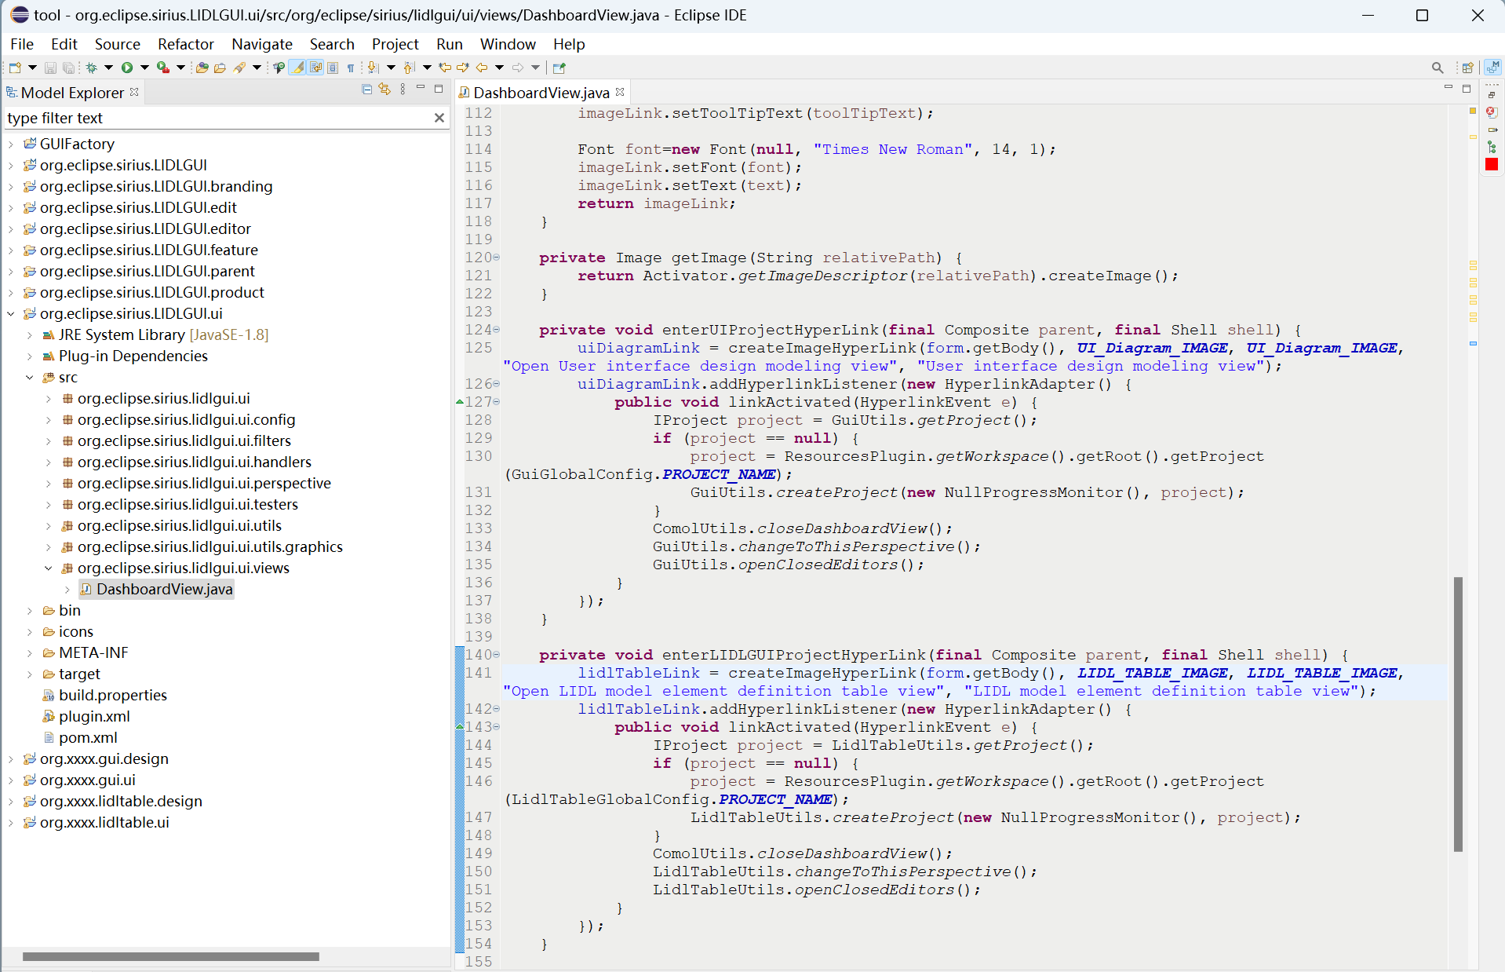

### Definition table view

Click "LIDL model element definition table view" in the tool launch interface to enter the definition table view as shown below.

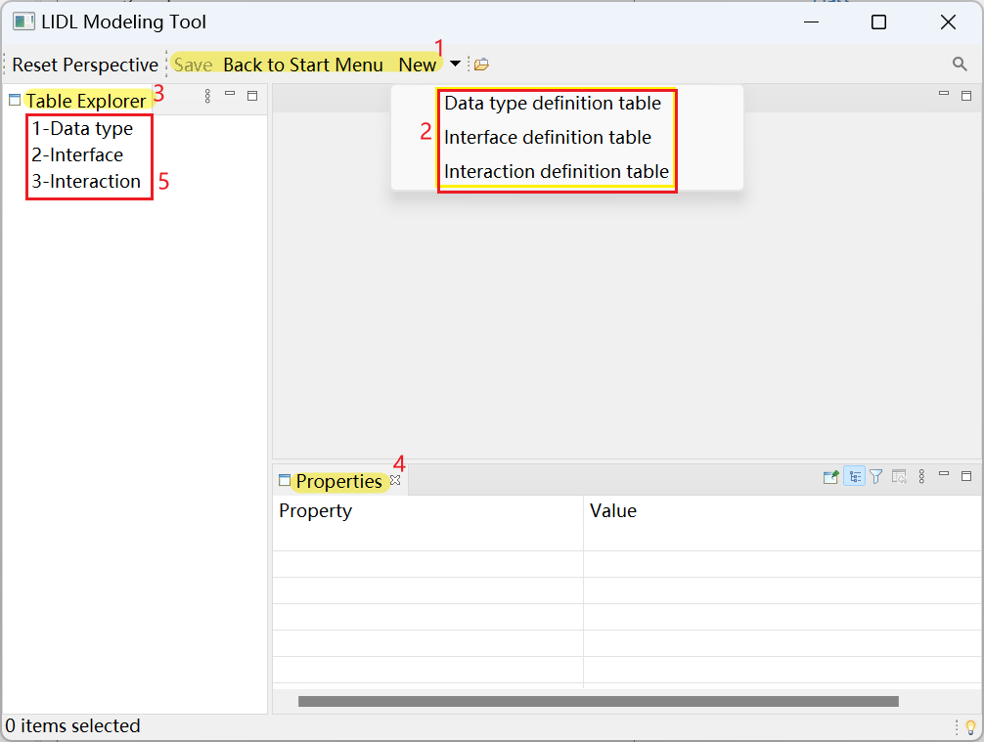

You can configure areas 1, 2, 3, and 4 in the Extensions interface of the file /tool/org.xxxx.lidltable.ui/plugin.xml

, as shown in the figure below.

Specifically:

Configure 1 in the above figure at 3 in the following figure,

Configure 2 in the above figure at 4 in the following figure,

Configure 3 in the above figure at 5 and 6 in the following figure,

Configure 4 in the above figure at 7 in the following figure.

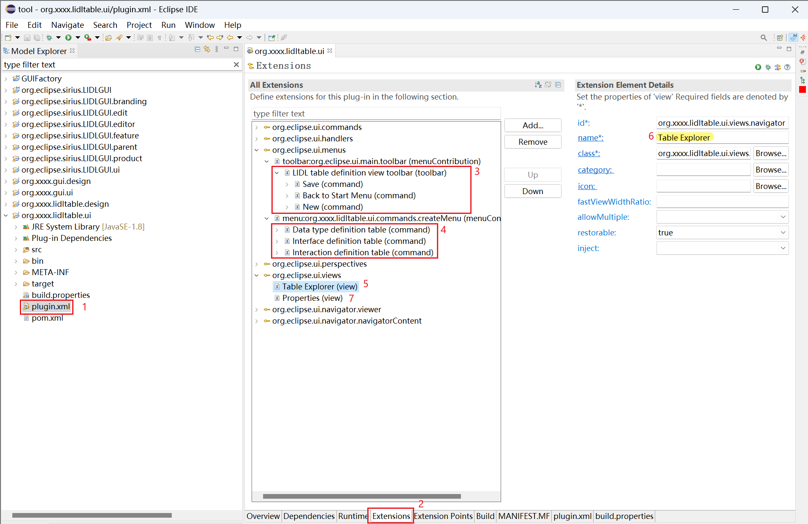

You can define the 5 (Navigator) in the Definition table view in：

/tool/org.xxxx.lidltable.ui/src/org/xxxx/lidltable/ui/views/navigator/LidltableNavigatorRoot.java

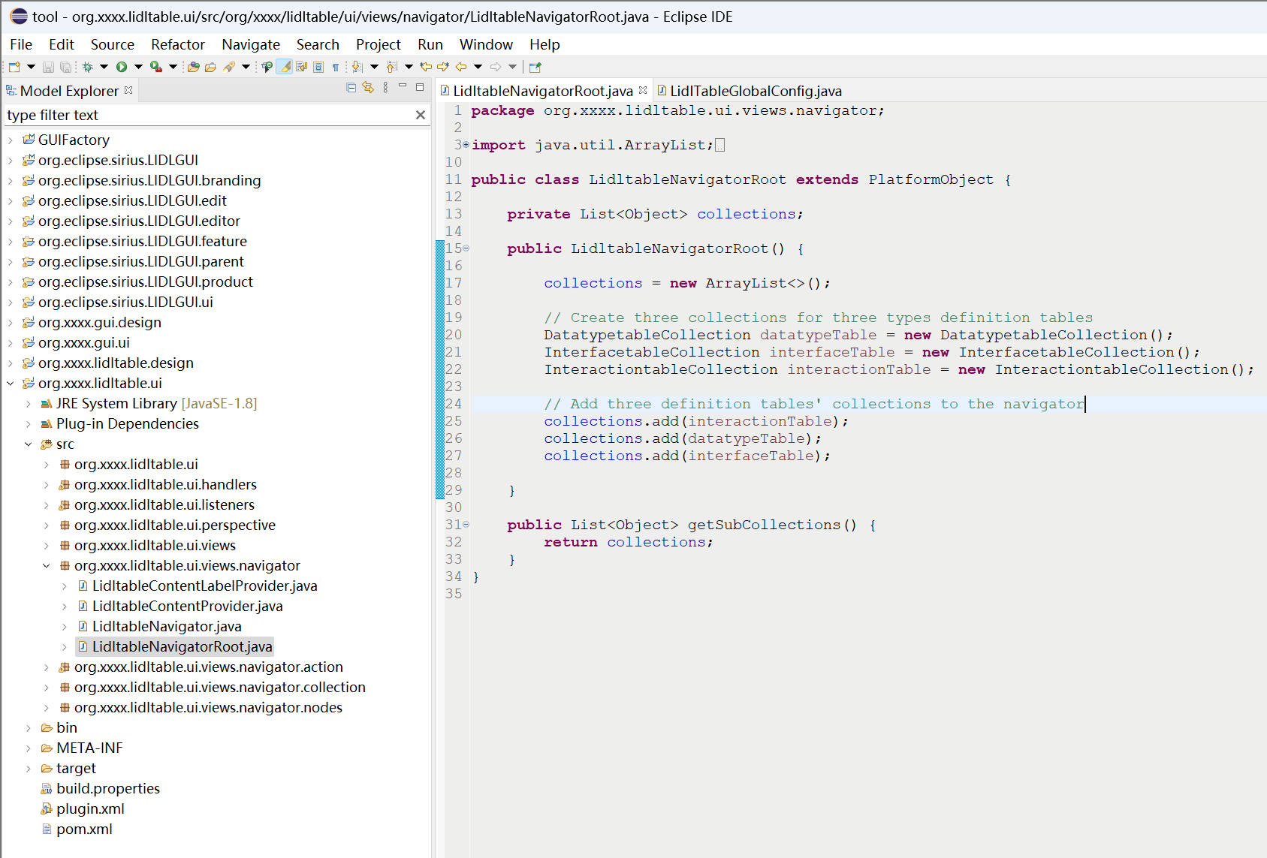

You can define the specific items in the Navigator in

**public** **static** **final** String ***DATATYPE_TABLE_IDENTIFIER***

**public** **static** **final** String ***INTERFACE_TABLE_IDENTIFIER***

**public** **static** **final** String ***INTERACTION_TABLE_IDENTIFIER***

of the file:

/tool/org.eclipse.sirius.LIDLGUI.ui/src/org/eclipse/sirius/lidlgui/ui/config/LidlTableGlobalConfig.java

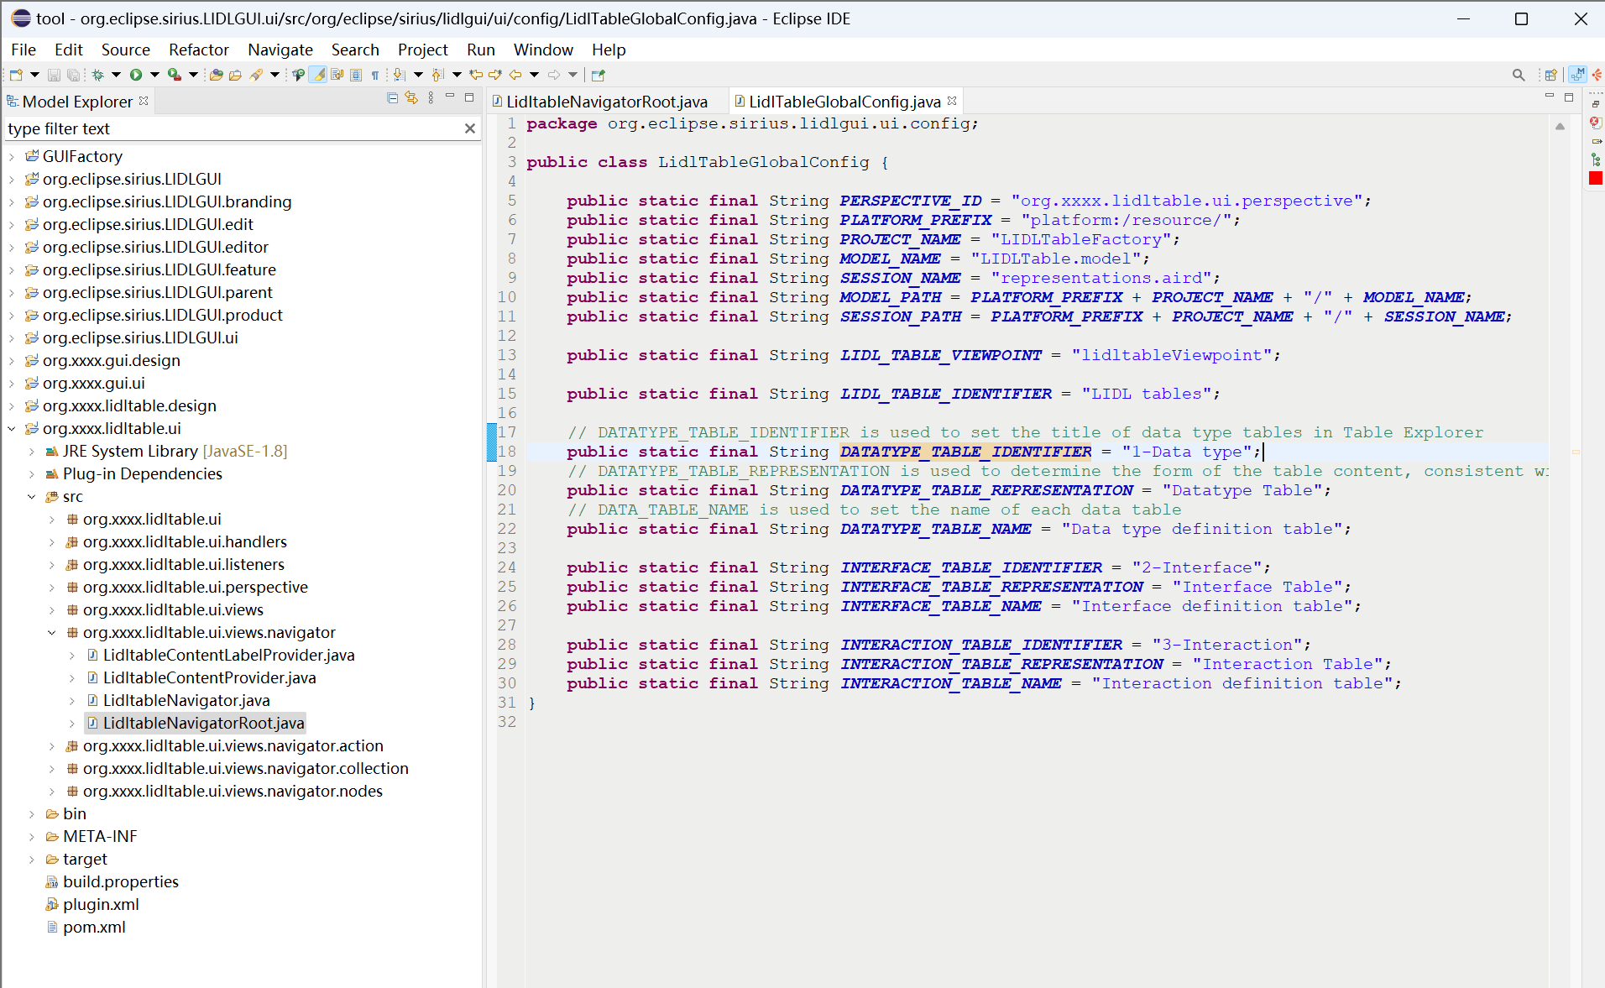

### Definition tables

After entering the Definition table view, click New, and then click Data type definition table.

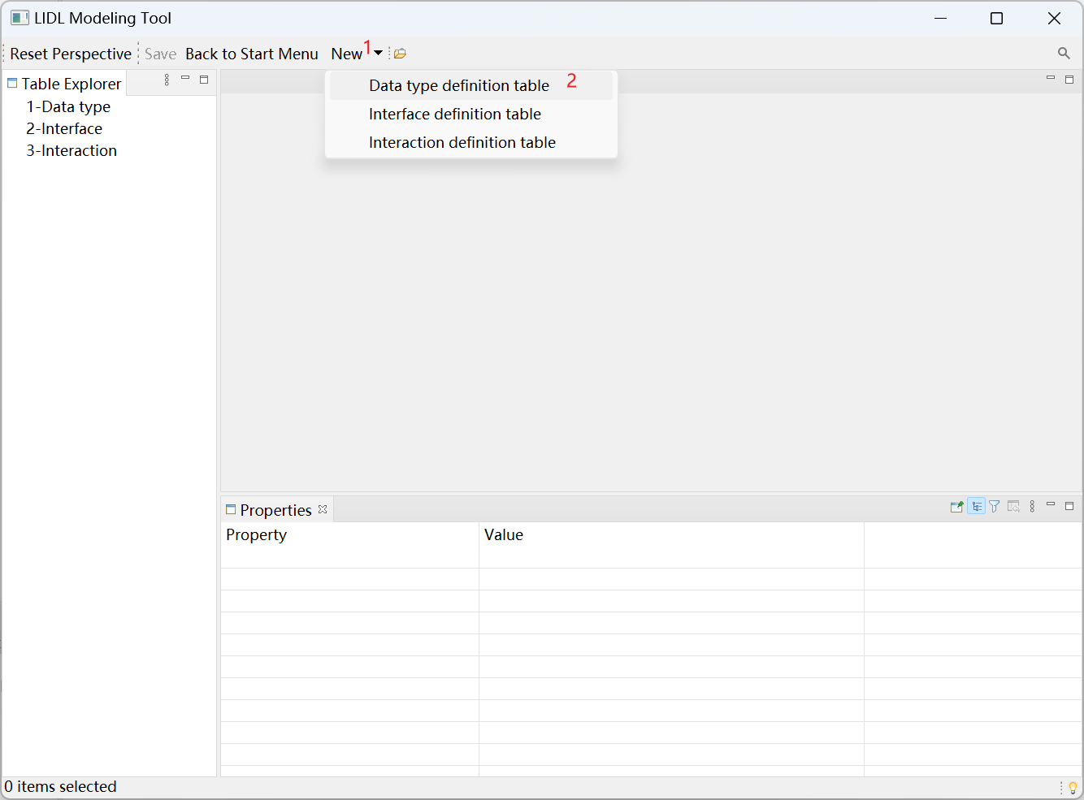

Automatically create Data type definition table 1.

Click the Data type definition table cell, and click New a composite data type in the Properties view below.

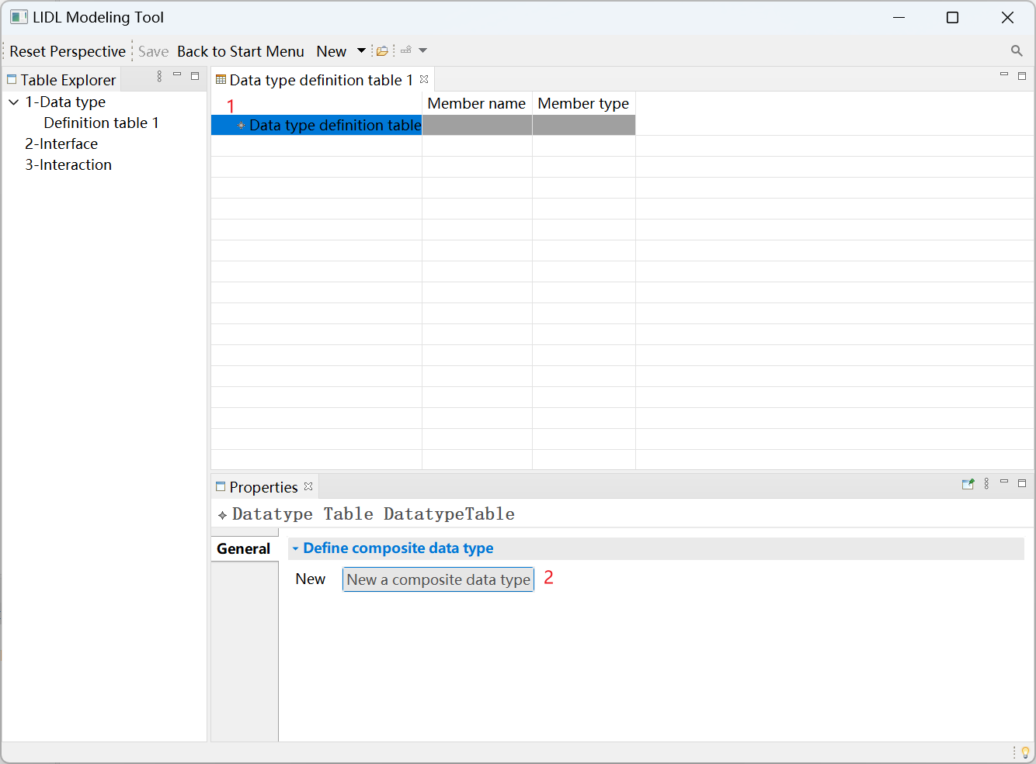

Click the newly created Composite data type: Data type name@1.

In the Properties view below, edit the newly created data type name and name it Point2D.

Click New a member datatype to add members to the newly created composite data type.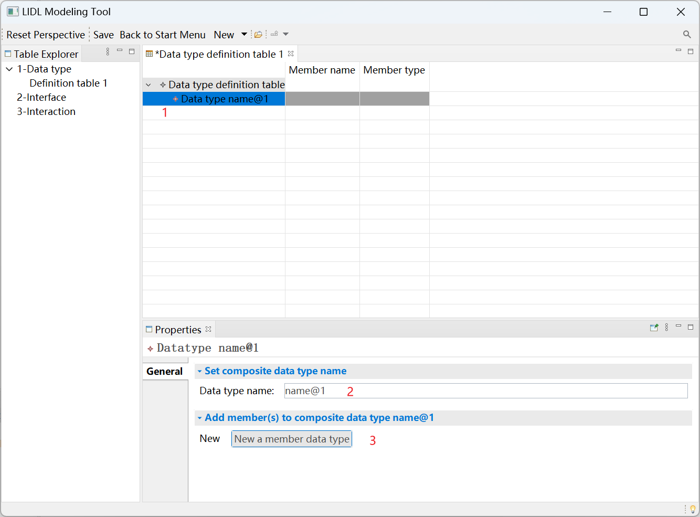

Click the new member.

Edit the member name as x in the Properties view below.

Select member type as Number.

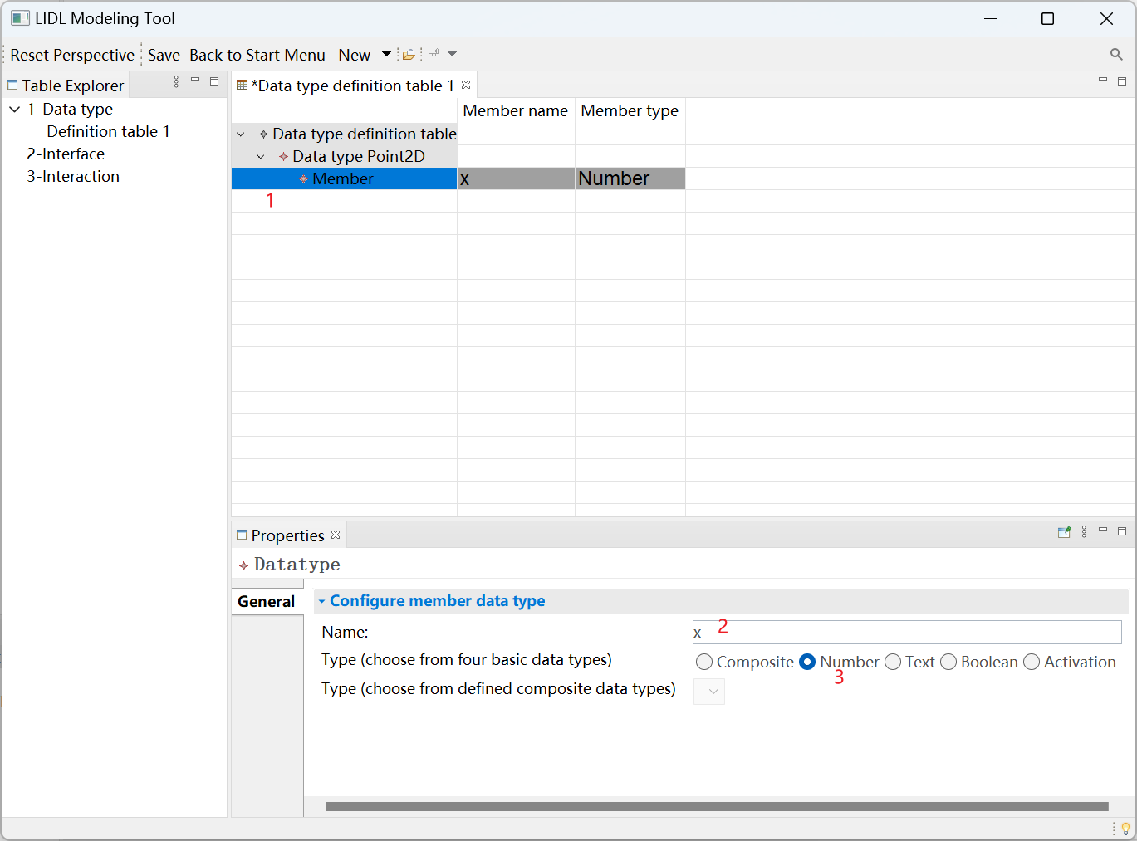

Click Data type Point2D again, and then click New a member data type to continue adding members.

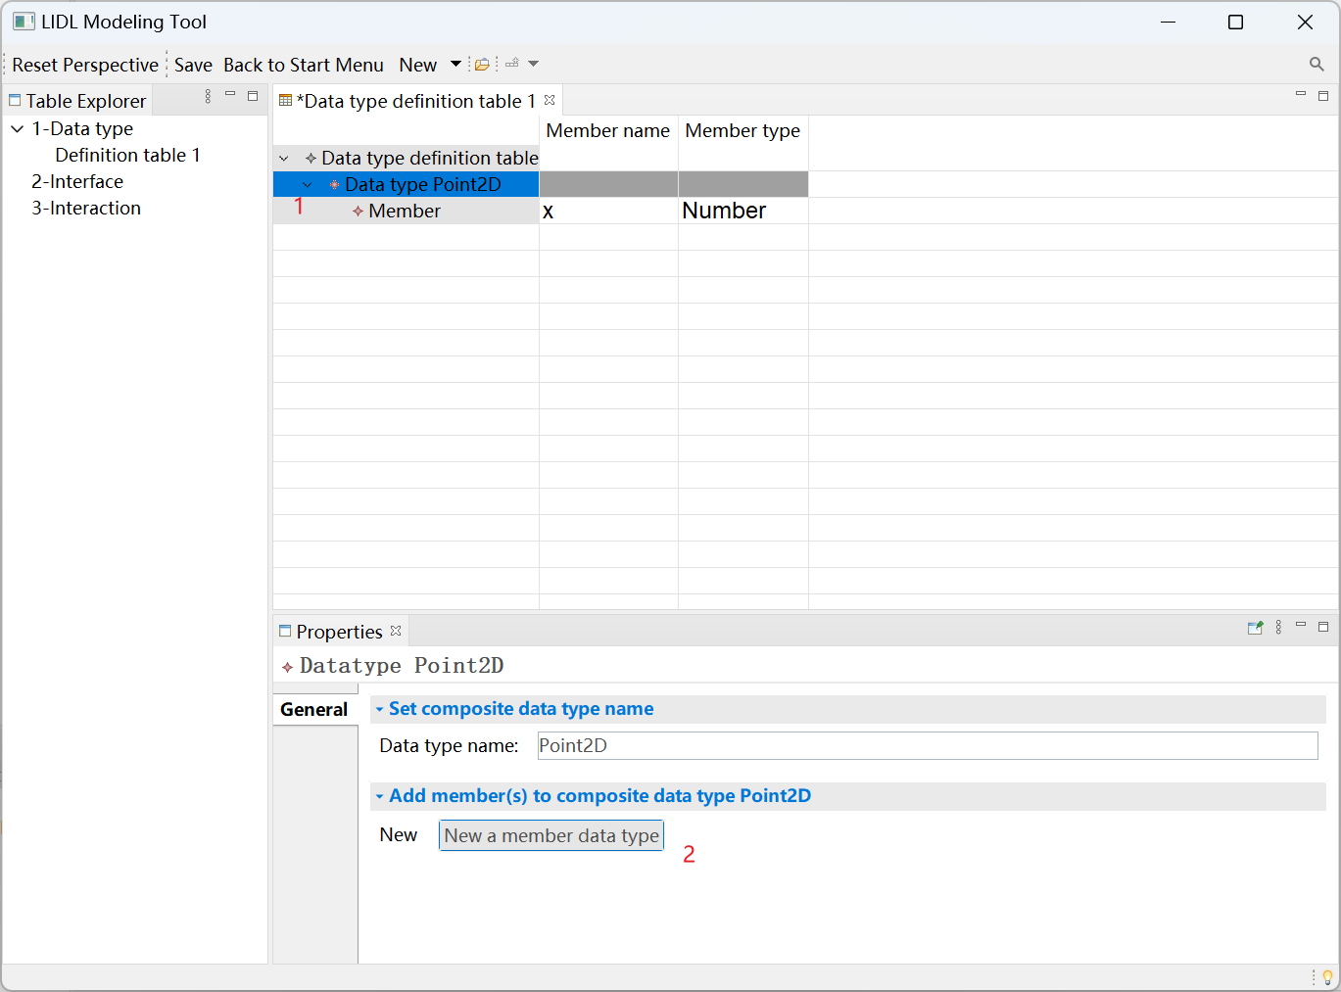

Name the newly added member y, and select the type as Number.

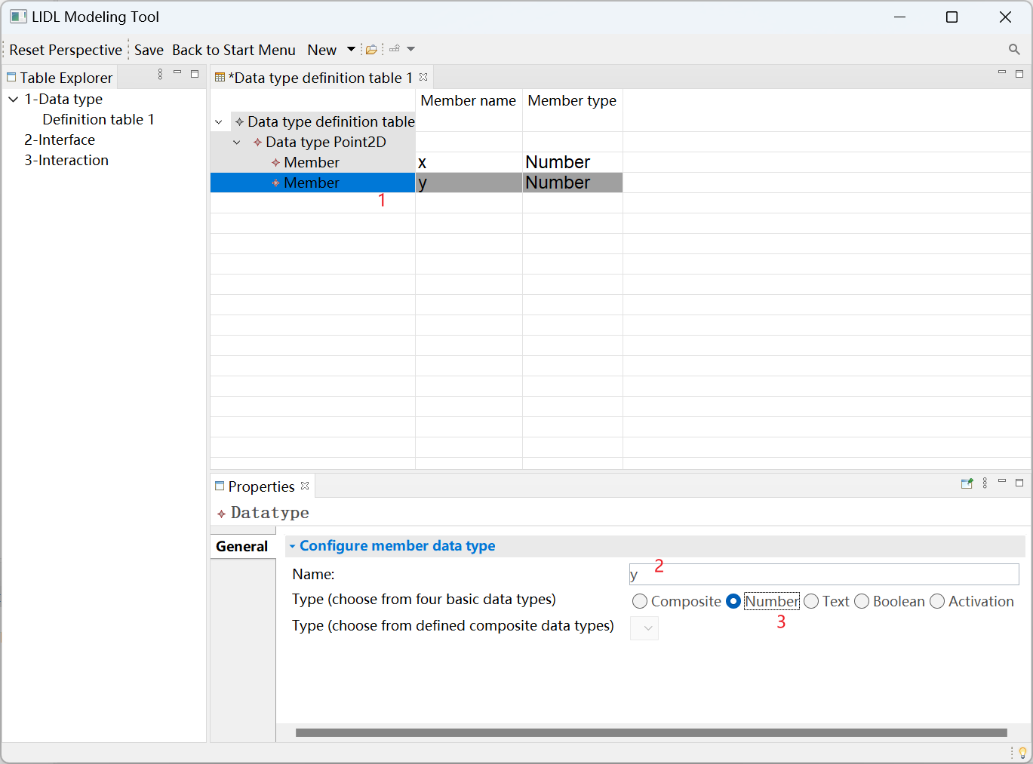

Continue to click the Data type definition table, and click New a composite data type to add a new composite data type.

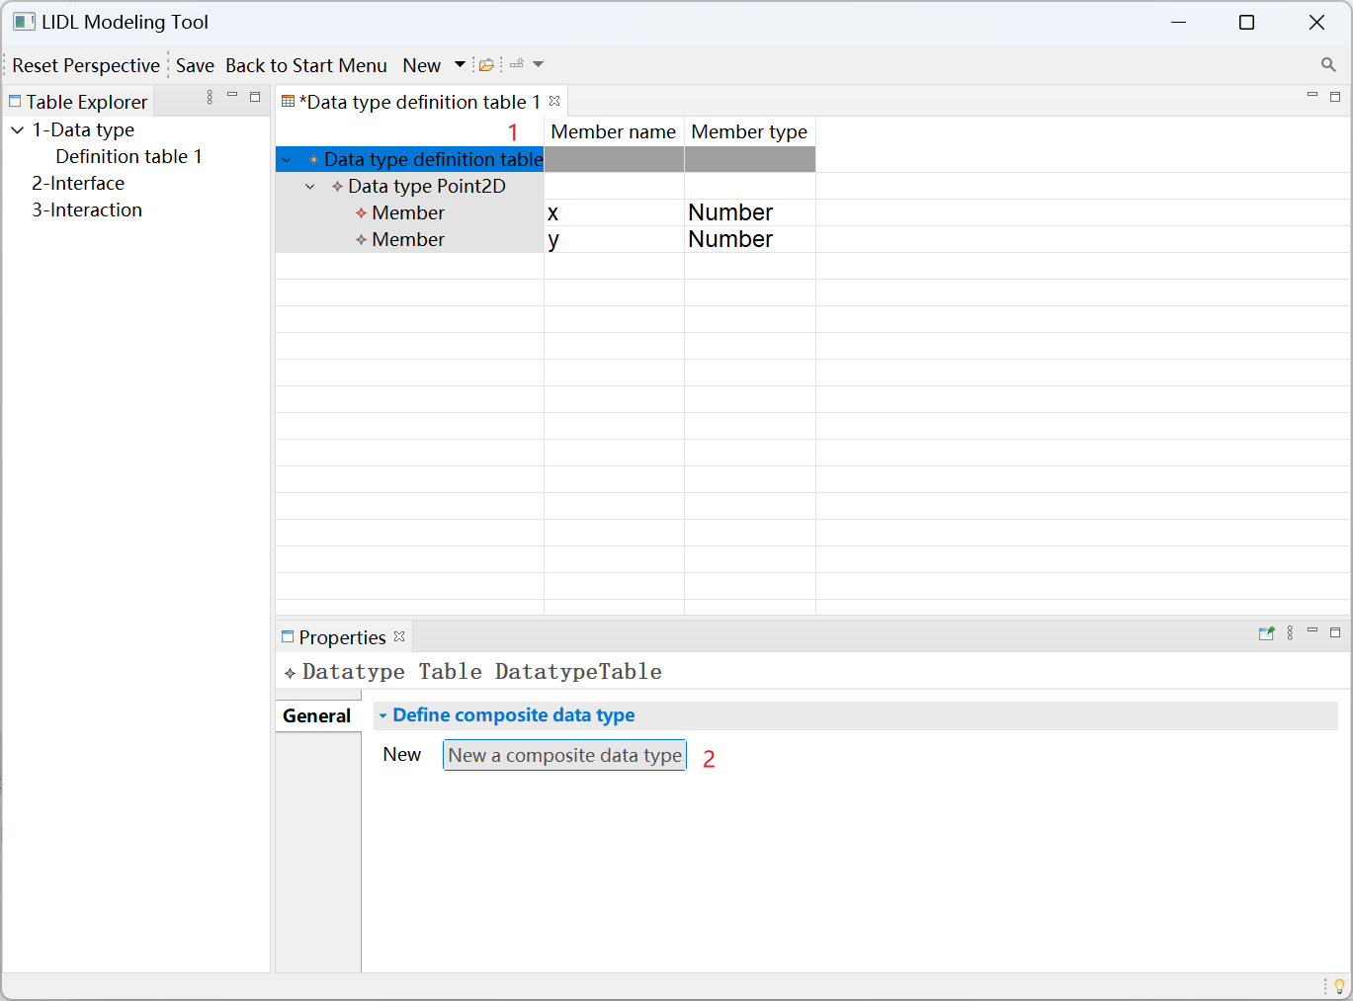

Click the newly created data type name@2, name it Line, and click New a member data type to add a member.

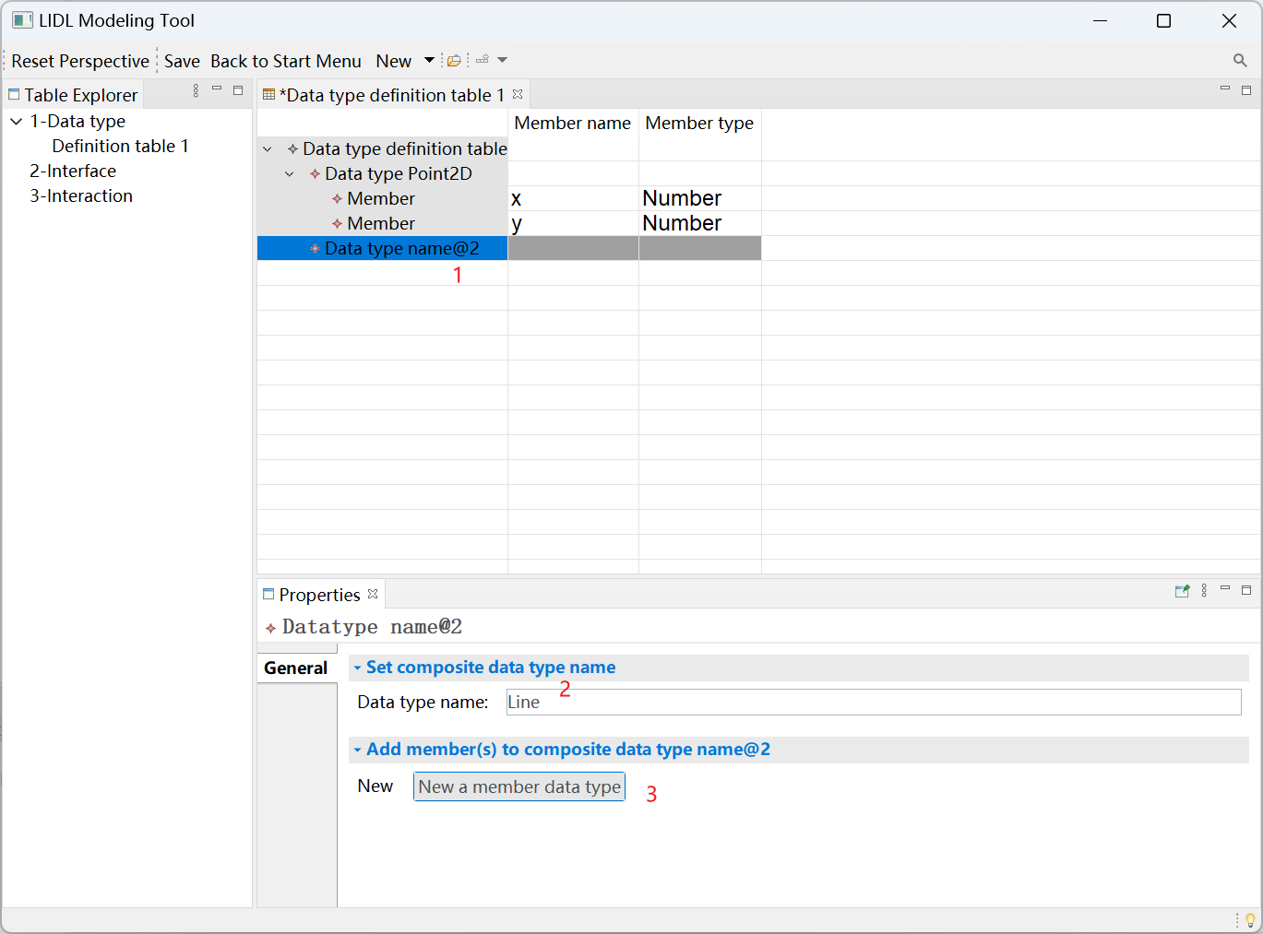

Name the member start, select the type as Composite, and then select Point2D just defined.

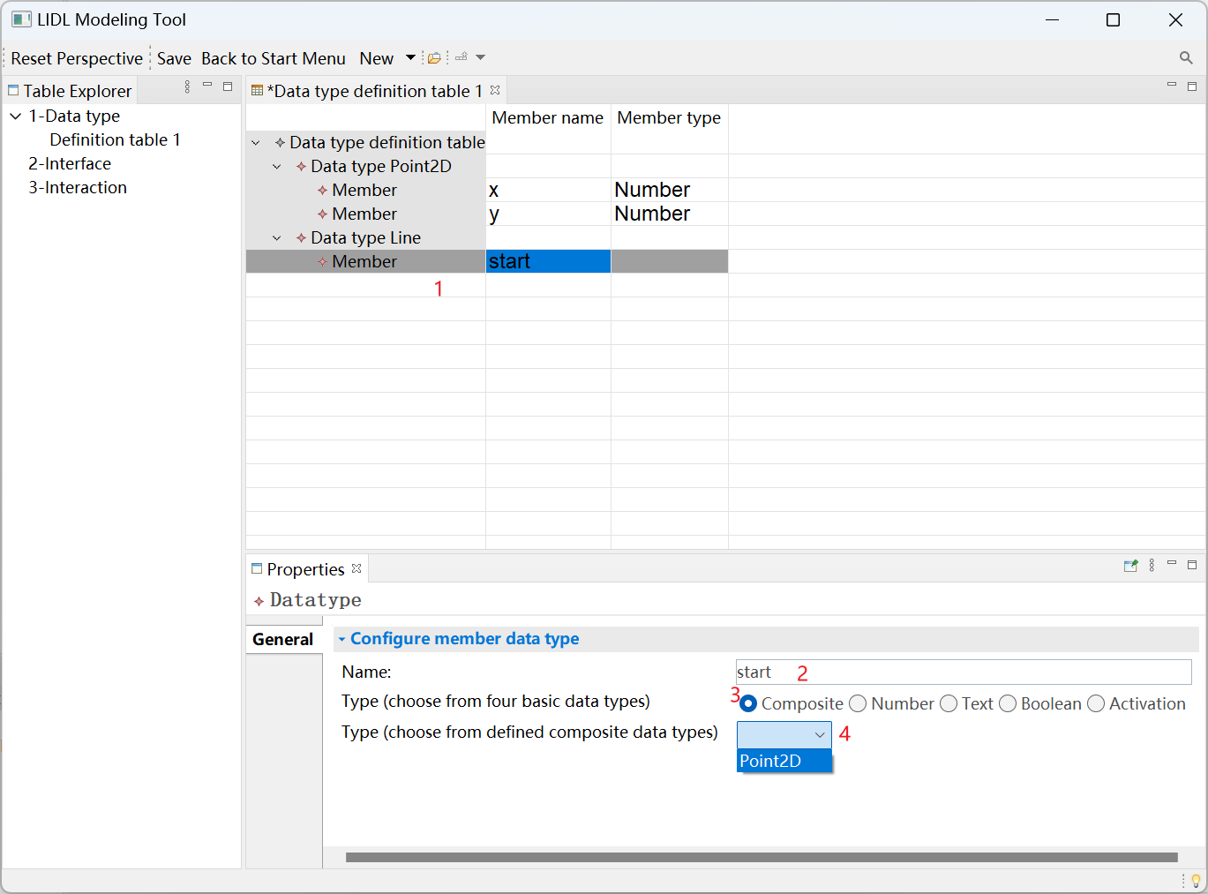

Continue to add member data type for Data type Line.

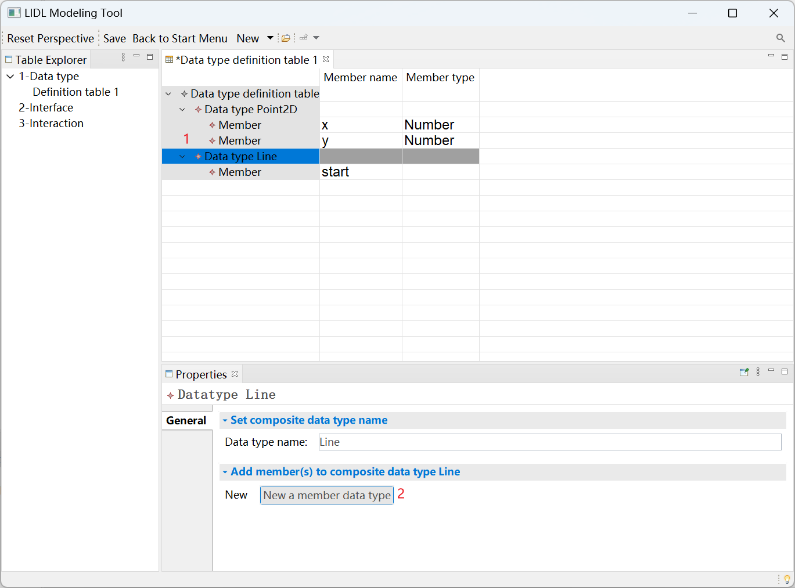

Add a Member with the name end and the type Point2D.

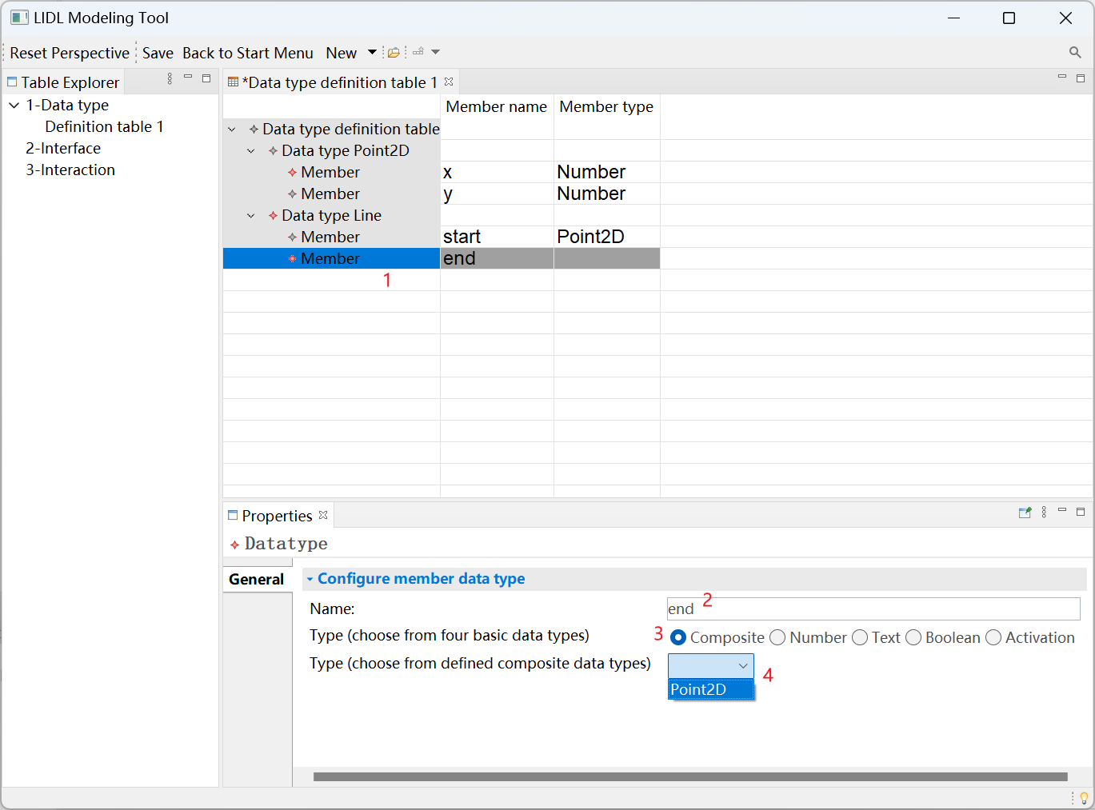

Finally, press Ctrl + s to save the Data type definition table 1.

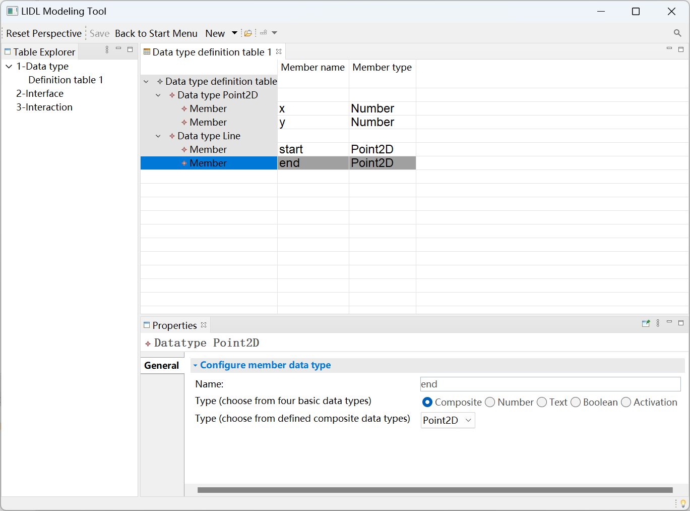

The above modeling process demonstrates the Data type definition table in detail. There are two definition tables not shown here, namely, the Interface definition table and the Interaction definition table.

You can see the usage of the other two definition tables in the user manual. These three tables have similar structures and usage.

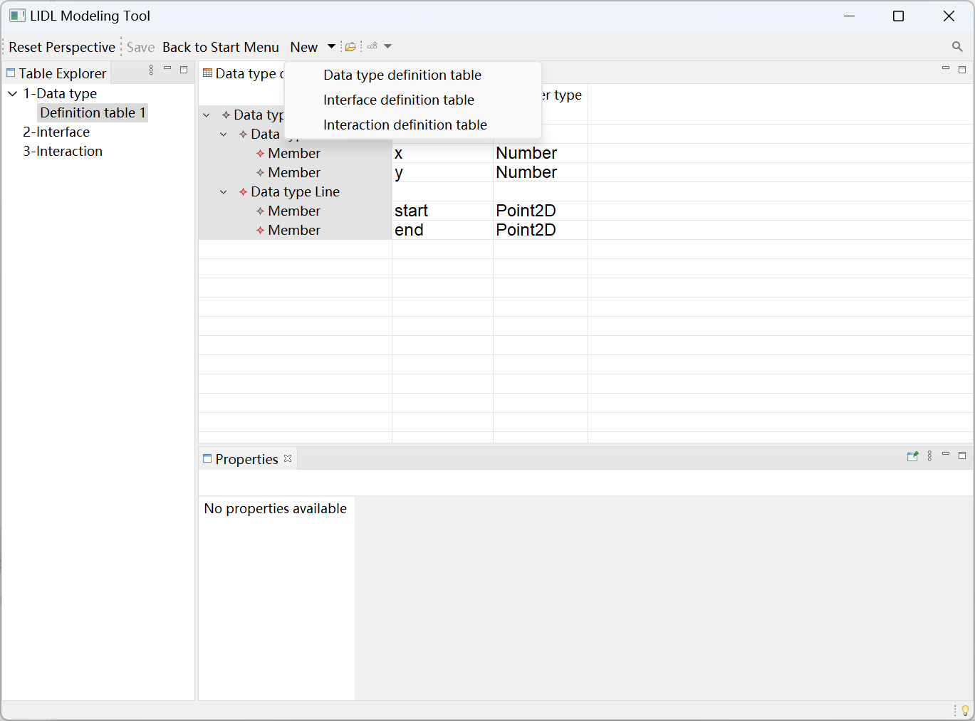

The row, column, and style of the tables in the upper part of the three definition tables, and the interactive functions supported in the Properties view in the lower part are all configured in the lidltable.odesign. The odesign file is a configuration file provided by Eclipse Sirius project[1] Our software is developed based on the Eclipse Sirius project. For the basic usage of the Eclipse Sirius project, see its Tutorial[2]和doucument[3].

The contents, styles, and functions of the three definition tables are all configured in the file lidltable.odesign. The path of the file is:

/tool/org. xxxx. lidltable.design/description/lidltable.odesign

You can see the relationships between the lidltable.odesign file and the LIDL Modeling Tool interface are in the figure below.

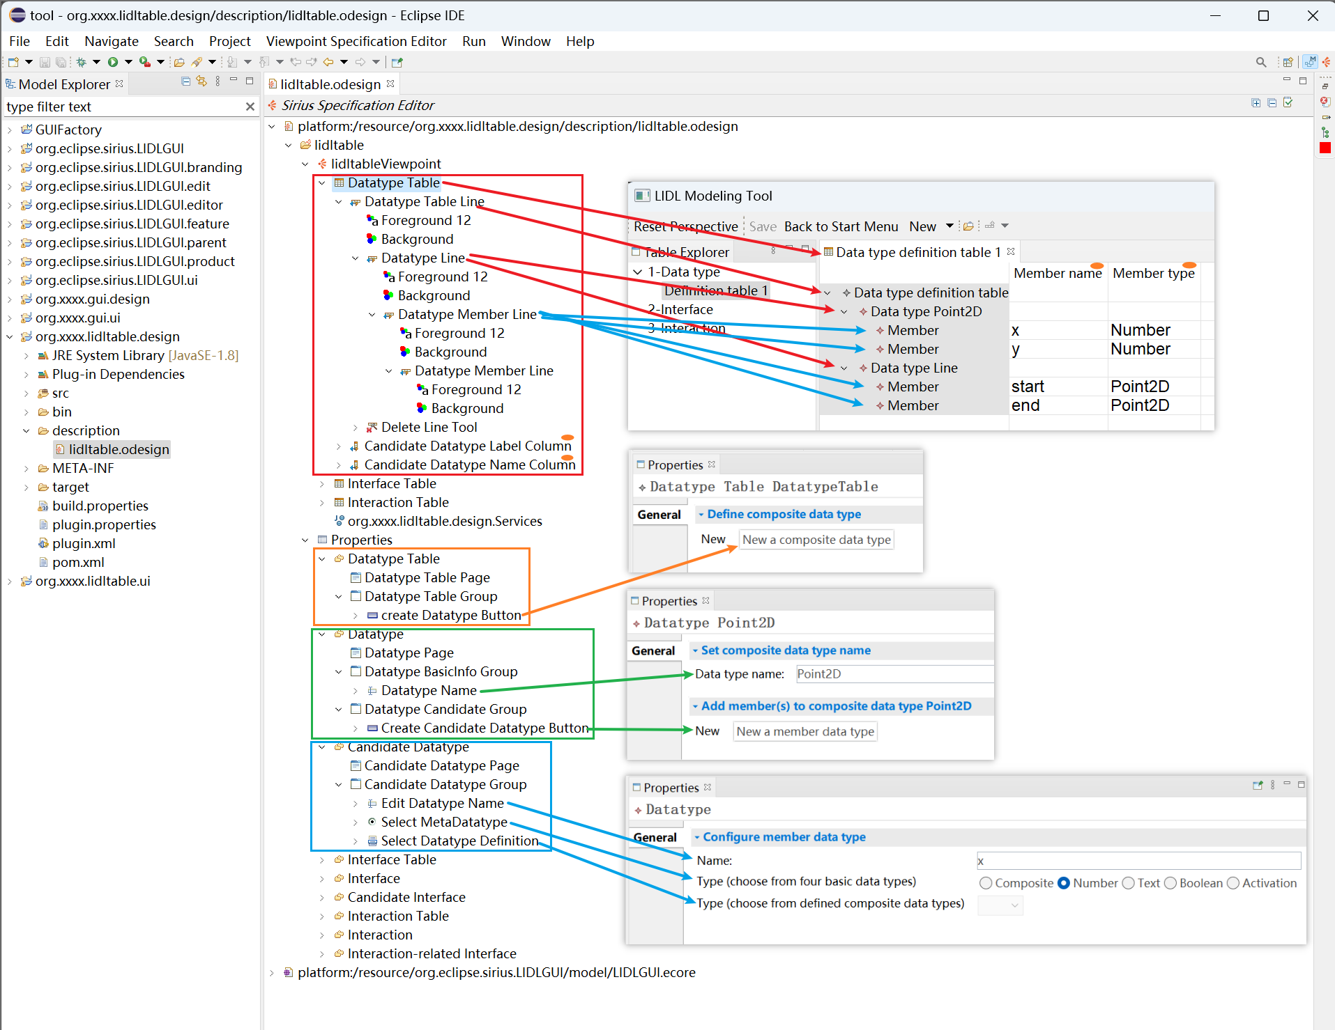

In the lidltableViewpoint, the Datatype table Line corresponds to each row in the Data type definition table, and the Candidate Datatype Label Column and the Candidate Datatype Name Column correspond to two columns in the Data type definition Table. Configure the content and style displayed in the table in this part of the odesign file.

In the Data type definition table, there are three different types of rows: Datatype Table, Datatype, and Candidate Datatype. Each type of row has a different Properties window in the lower part of the Definition Table View. Specifically, in the Data type definition table 1 shown, the Data type definition table is a Datatype Table row, the Data type Point2D, and Data type Line are Datatype rows, and the remaining Member Lines are Candidate Datatype rows.

You can set the different Properties windows of different categories of lines in the corresponding line directory under the Properties directory of the odesign file, and you can see the corresponding relationship in the figure.

Taking Datatype Line as an example, we use the AQL language in the Properties window to set the label of this line by aql: 'Data type'+self.name. In the Data type definition table 1, the corresponding line displays the label we set.

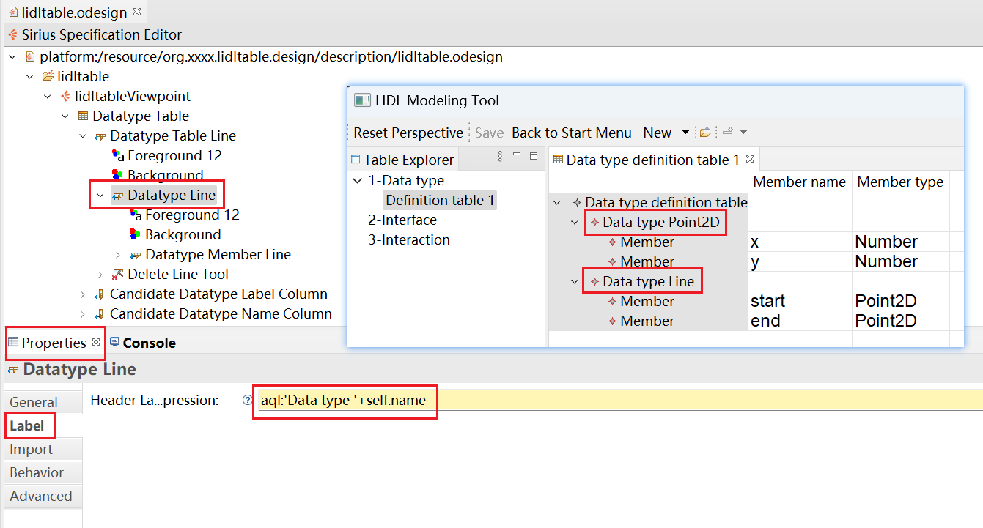

Take the Properties View of Datatype Table Line as an example. Configure the New a composite data type button in the Create Datatype Button of the Datatype Table Group of the Datatype Table in the Properties directory of the odesign file. Configure the Button Label as "New a composite data type". Configure the Is Enabled Expression using the **isDatatypeTableItem()** method in service. Service corresponds to **org.xxxx. lidtable.design.Services**, which is a Java file. Press alt and F3 on the keyboard and click service: isDatatypeTableItem() to automatically jump to the code in Services.

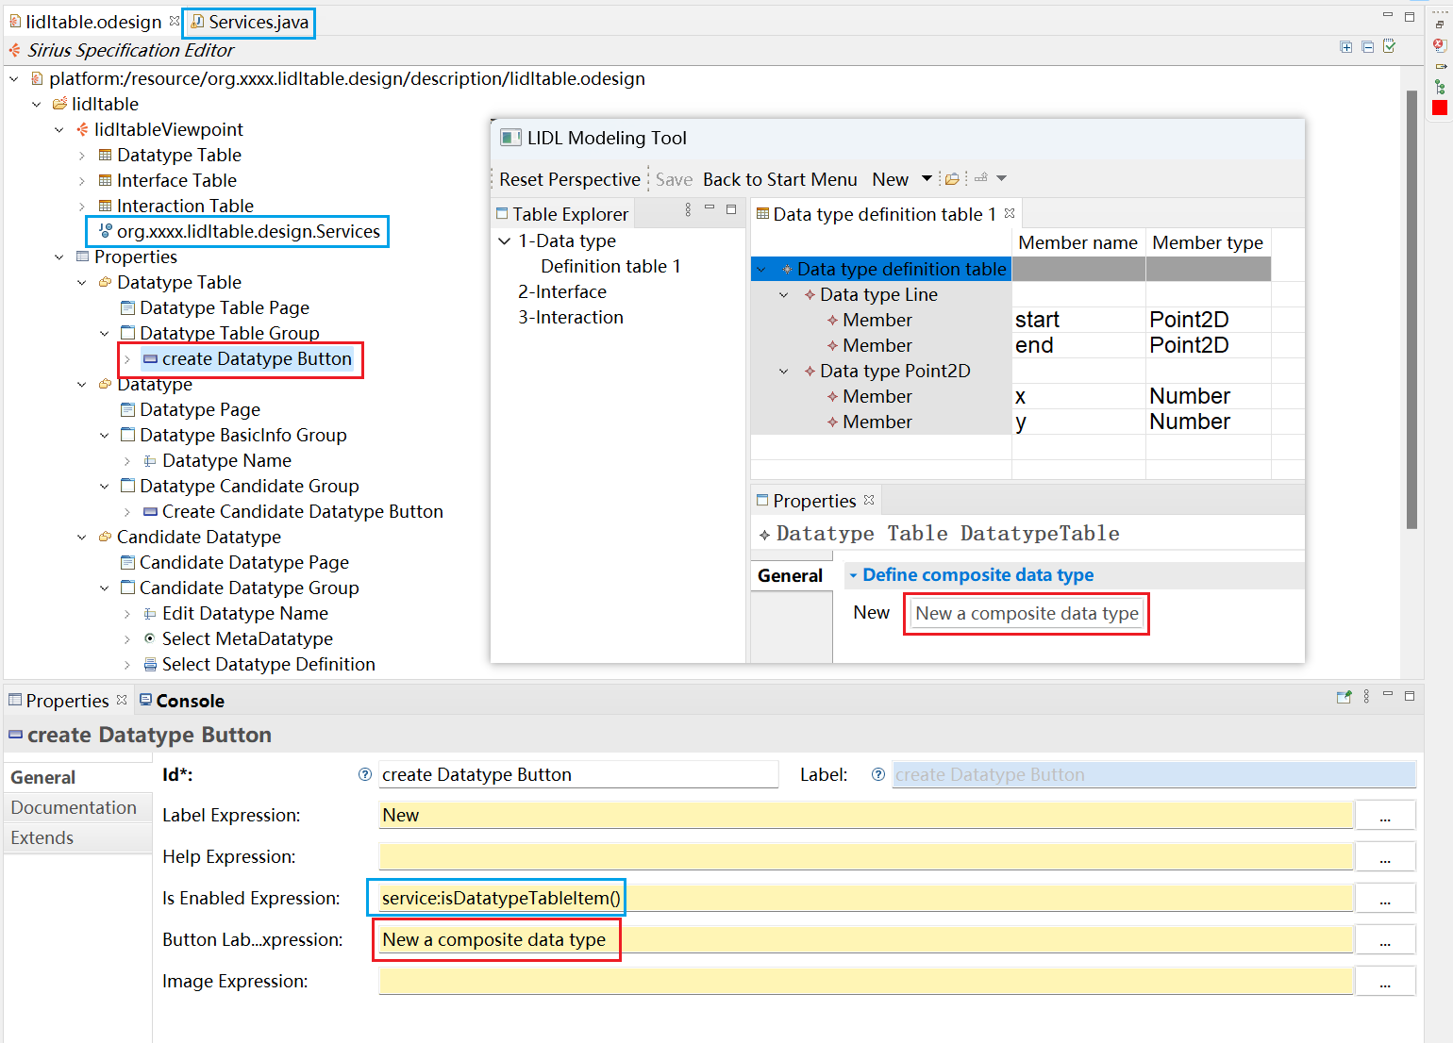

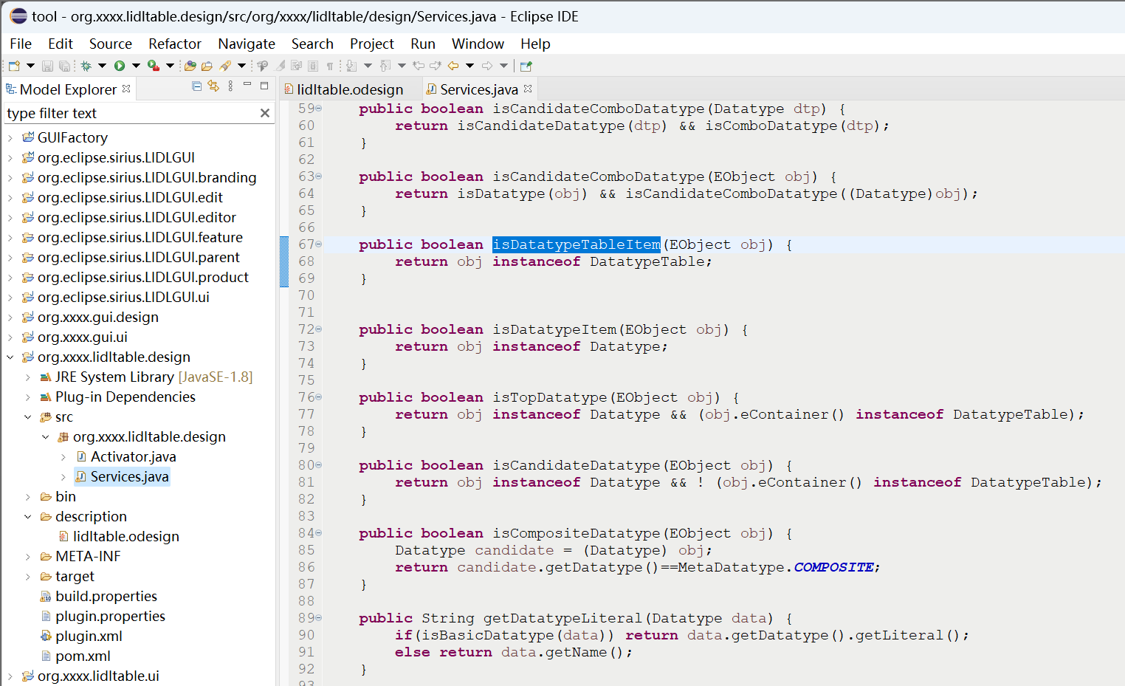

### Design modeling view

Click "User interface design modeling view" in the tool launch interface to enter the Design modeling view as shown below.

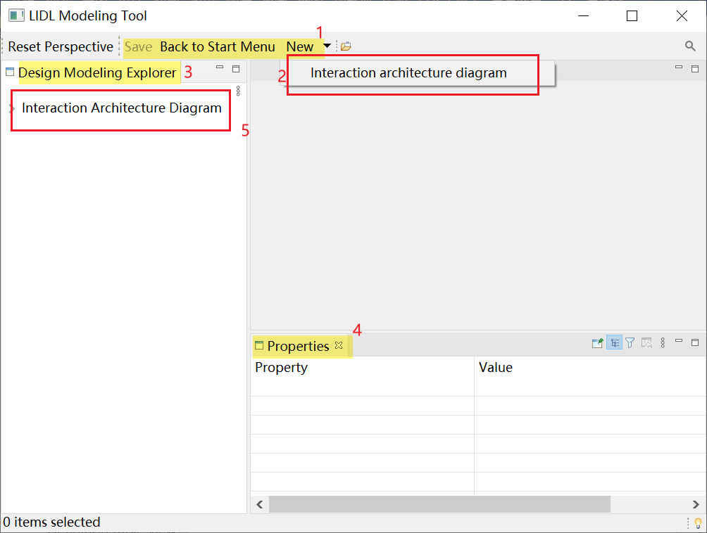

Configure areas 1, 2, 3, and 4 in the Extensions interface of the file /tool/org.xxxx.gui.ui/plugin.xml

, as shown in the figure below.

Specifically:

Configure 1 in the above figure at 3 in the following figure,

Configure 2 in the above figure at 4 in the following figure,

Configure 3 in the above figure at 5 in the following figure,

Configure 4 in the above figure at 7 in the following figure.

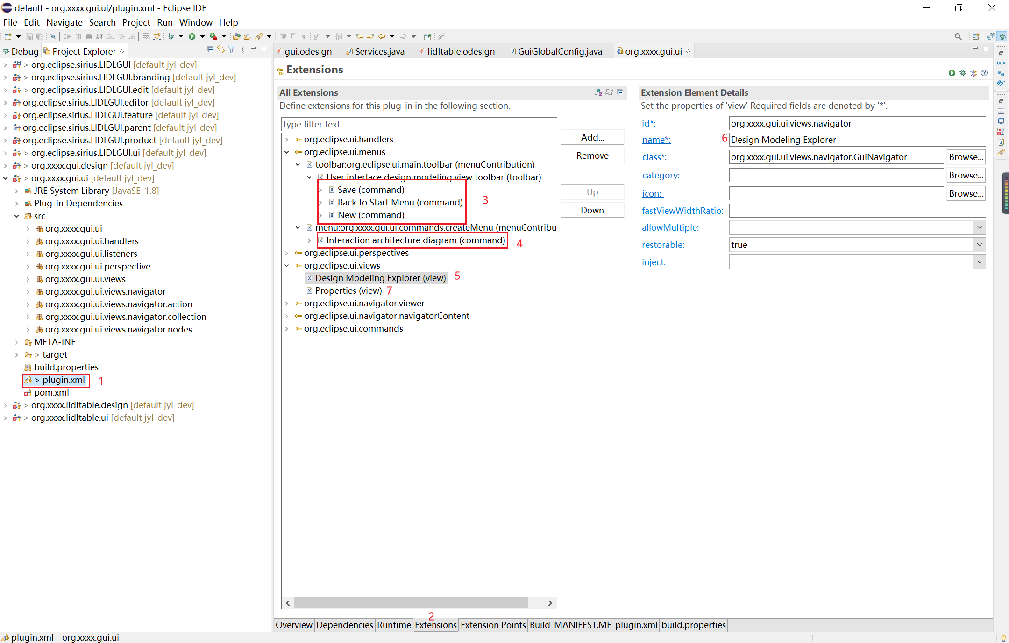

Define area 5 in the Design modeling view in

/tool/org.xxxx.gui.ui/src/org/xxxx/gui/ui/views/navigator/GUINavigatorRoot.java

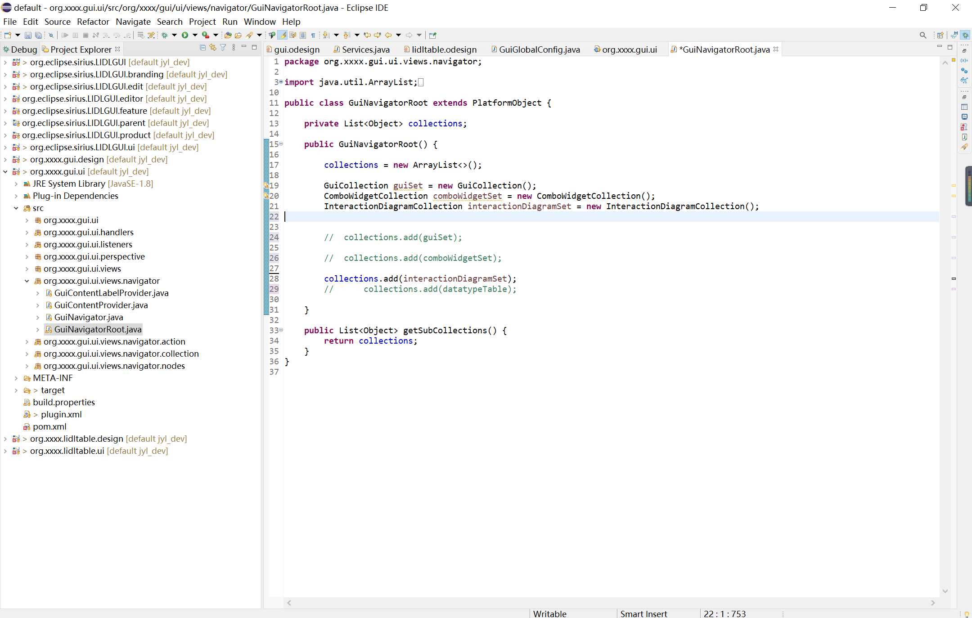

Define the specific items in the Navigator in

**public** **static** **final** String ***Interaction_Diagram_IDENTIFIER***

of the file:

/tool/org.eclipse.sirius.LIDLGUI.ui/src/org/eclipse/sirius/lidlgui/ui/config/GuiGlobalConfig.java

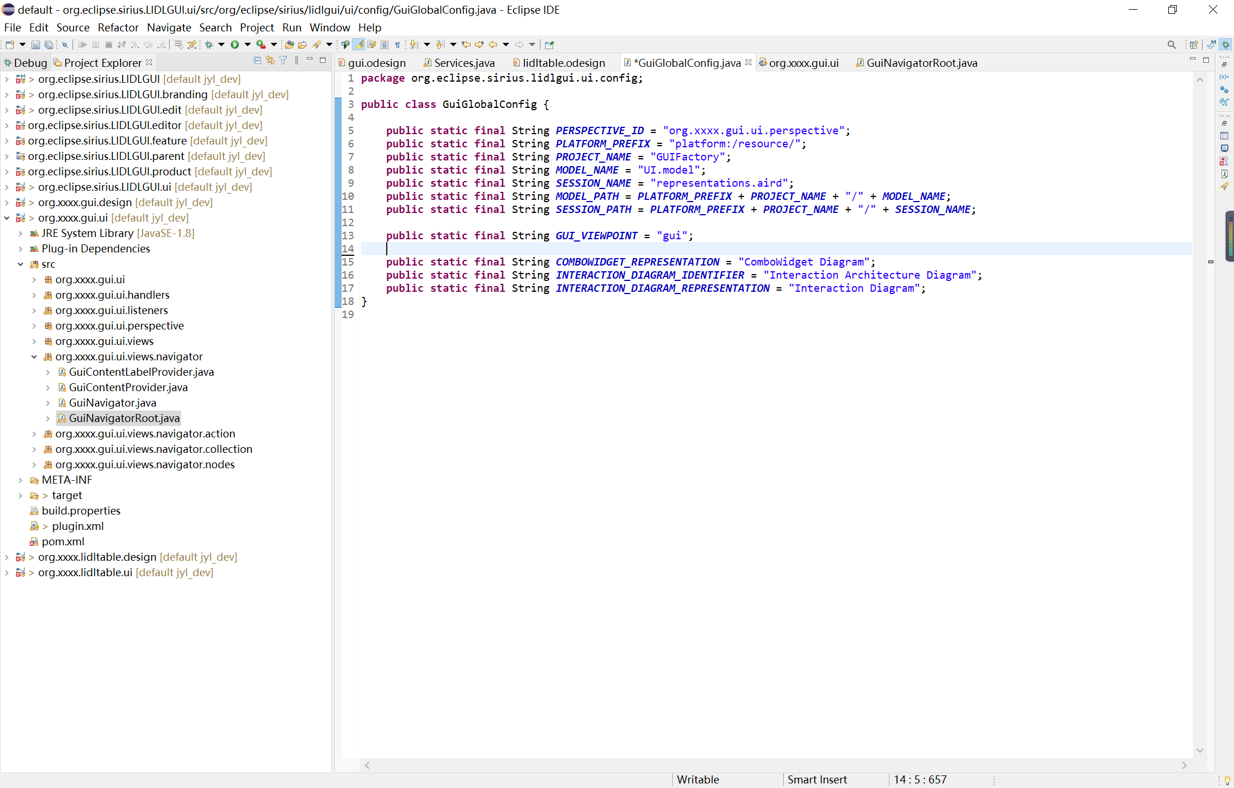

### Design Modeling

After entering the Design Modeling view, click New, and then click the Interaction architecture diagram.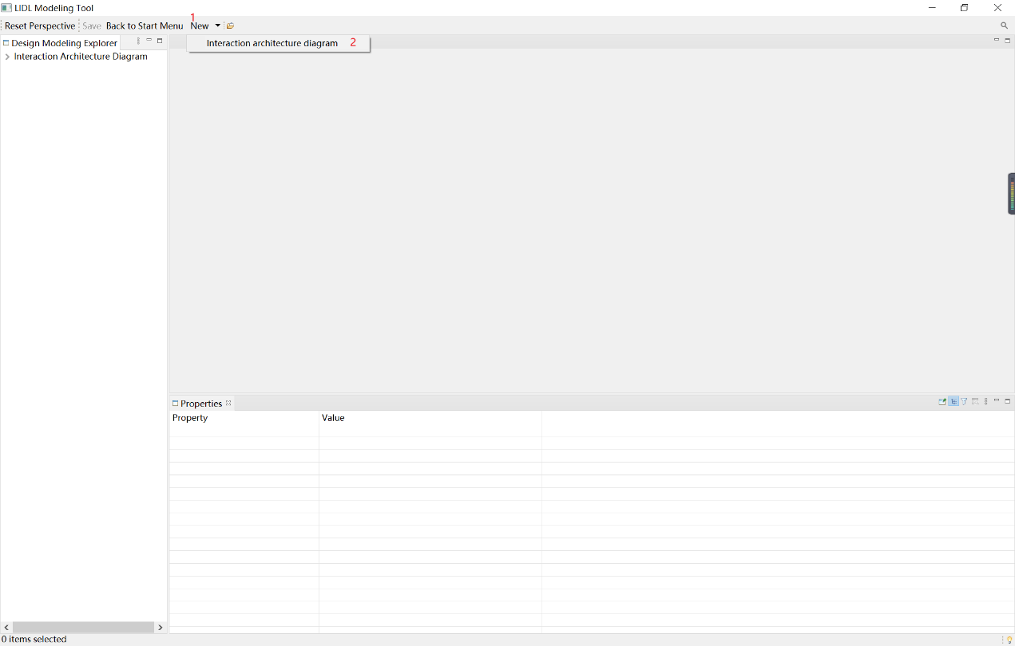

Since we have created an Interaction architecture diagram, the new Interaction architecture diagram is Interaction architecture diagram 2. The new Interaction Architecture diagram comes with a Main Interaction.

Place the mouse on the edge of the Main Interaction rectangle to adjust the size of the Main Interaction.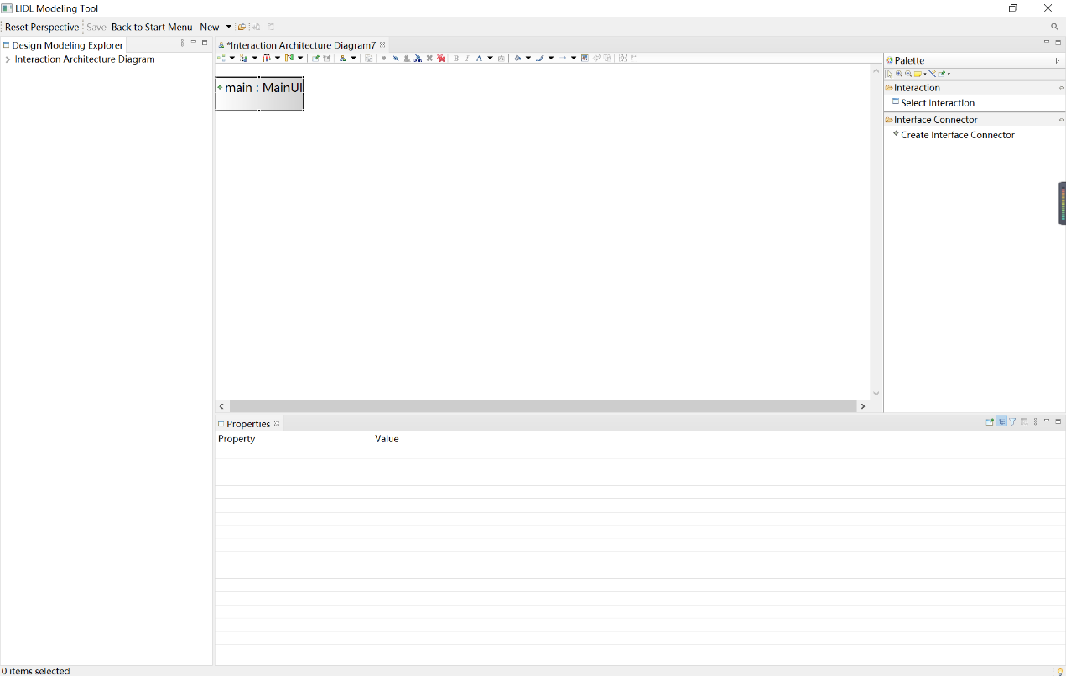

Click Select Interaction in the right toolbar, and then click on the Main Interaction to bring up the selection wizard as shown below.

You can select interactions to add to the Main Interaction in the selection wizard.

Specifically, click on an interaction and then click the Finish button to complete the addition.

Note: Only interactions that have been defined in the Interaction definition table in the Definition table view will be displayed in the selection wizard list here.

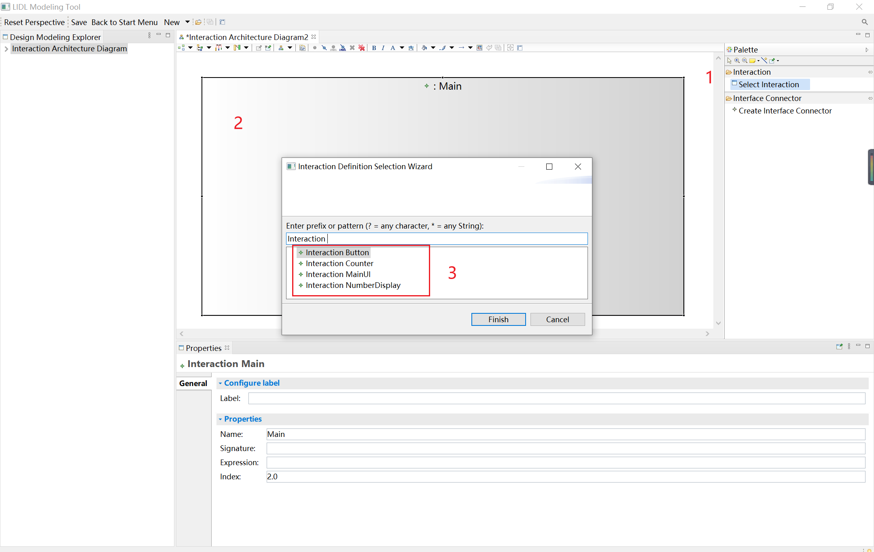

Click the interaction in the diagram, and you can see the properties of the interaction in the Properties view below. It contains configurable interactive labels in the diagram after configuration.

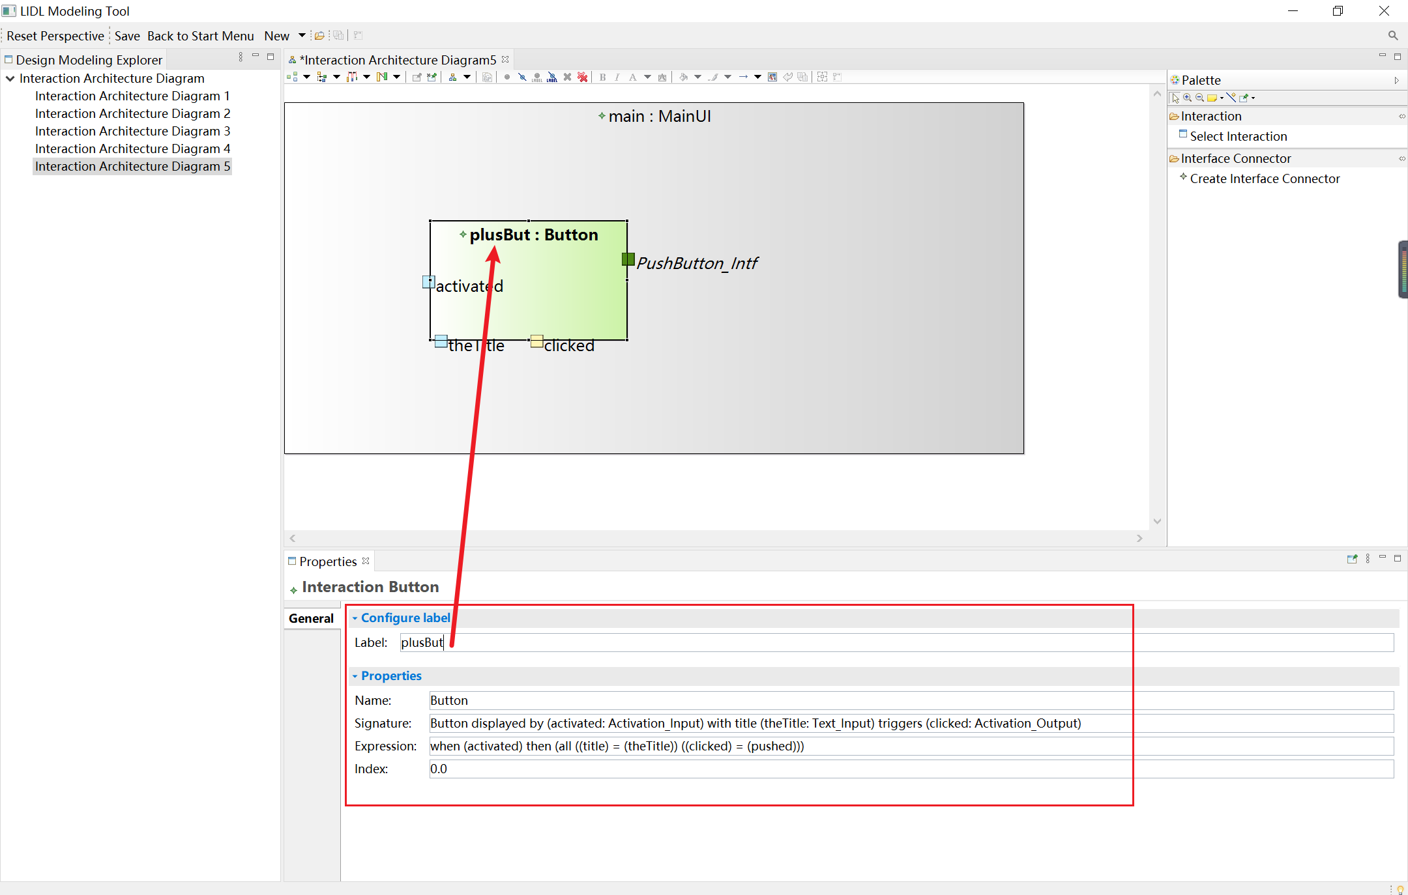

You can see the interface of the interaction on the edge of the interaction. The tool uses different colors to distinguish between different interface directions, specifically, green for io-type interfaces, blue for in-type interfaces, and yellow for out-type interfaces.

Clicking on an interface node will display the interface properties in the Properties View section below

The interface properties include three parts.

2 in the following figures include the configurable actual parameters.

3 in the figure below shows the read-only properties of the interface.

4 in the figure below shows the relationship of an interface to other interfaces. Currently, there are no relationships, so No relationships are shown.

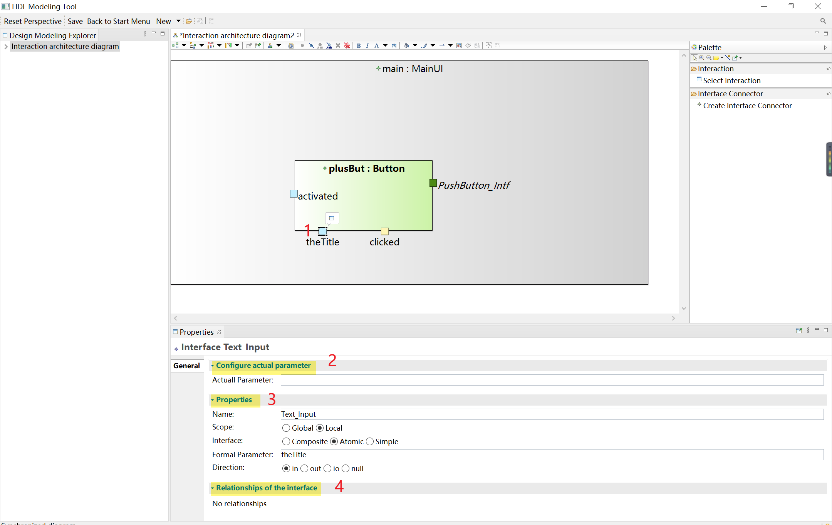

Enter "+" in the Actual Parameter input box and save (you can press Ctrl and S to save), as you can see in the interactive architecture diagram the interface shows the actual parameters entered. When the actual parameter is not configured, the parameter interface (the interface with the range Local) displays the formal parameter.

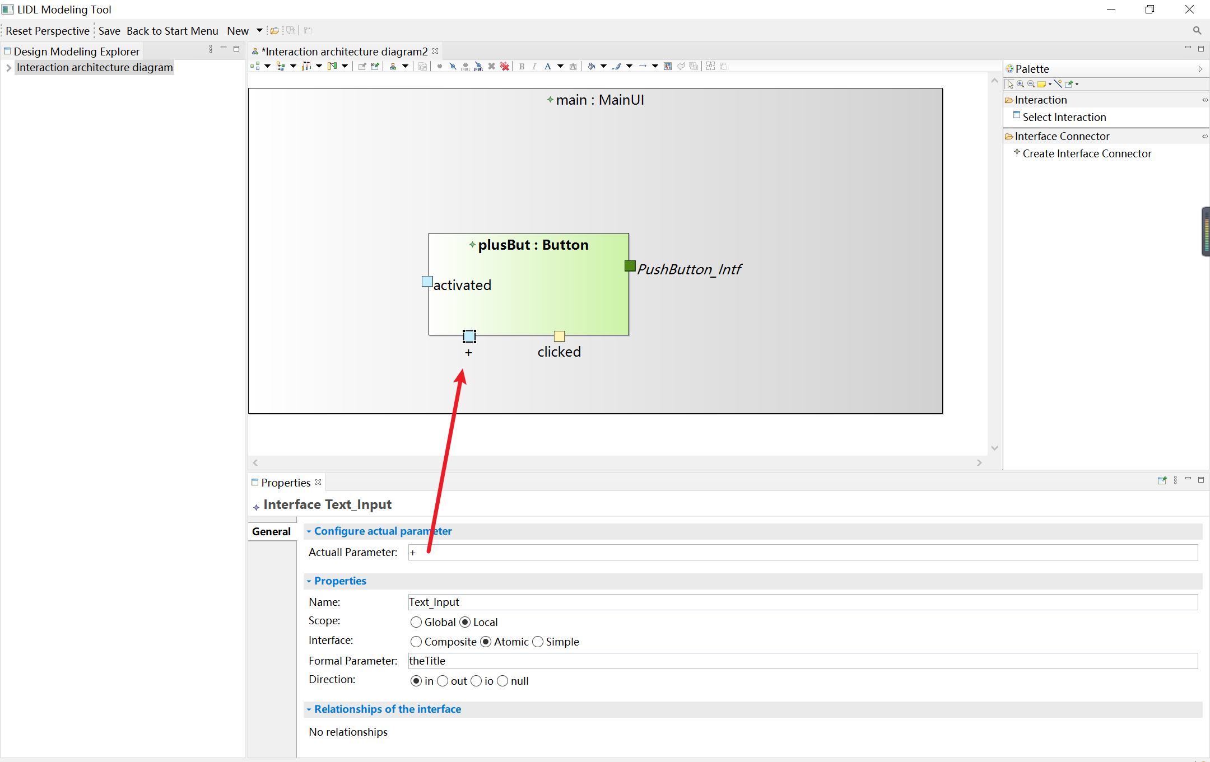

Click Create Interface Connector, then click the clicked interface of plusBut and finally click the btnSignal interface of counter to connect these two interfaces.

Click on the Interface Connector and the Properties View below will show its Source and Target.

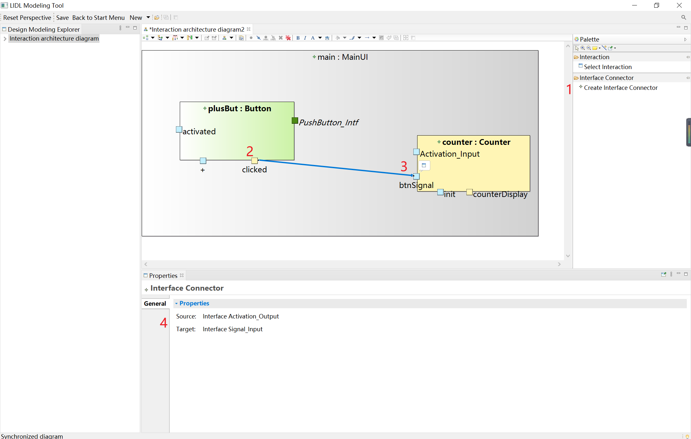

Now click the clicked interface again, and you can see its Relationships area shows the relationship that exists between the clicked interface. You can see Target:btnSignal. It means there is a connector between clicked and btnSignal.

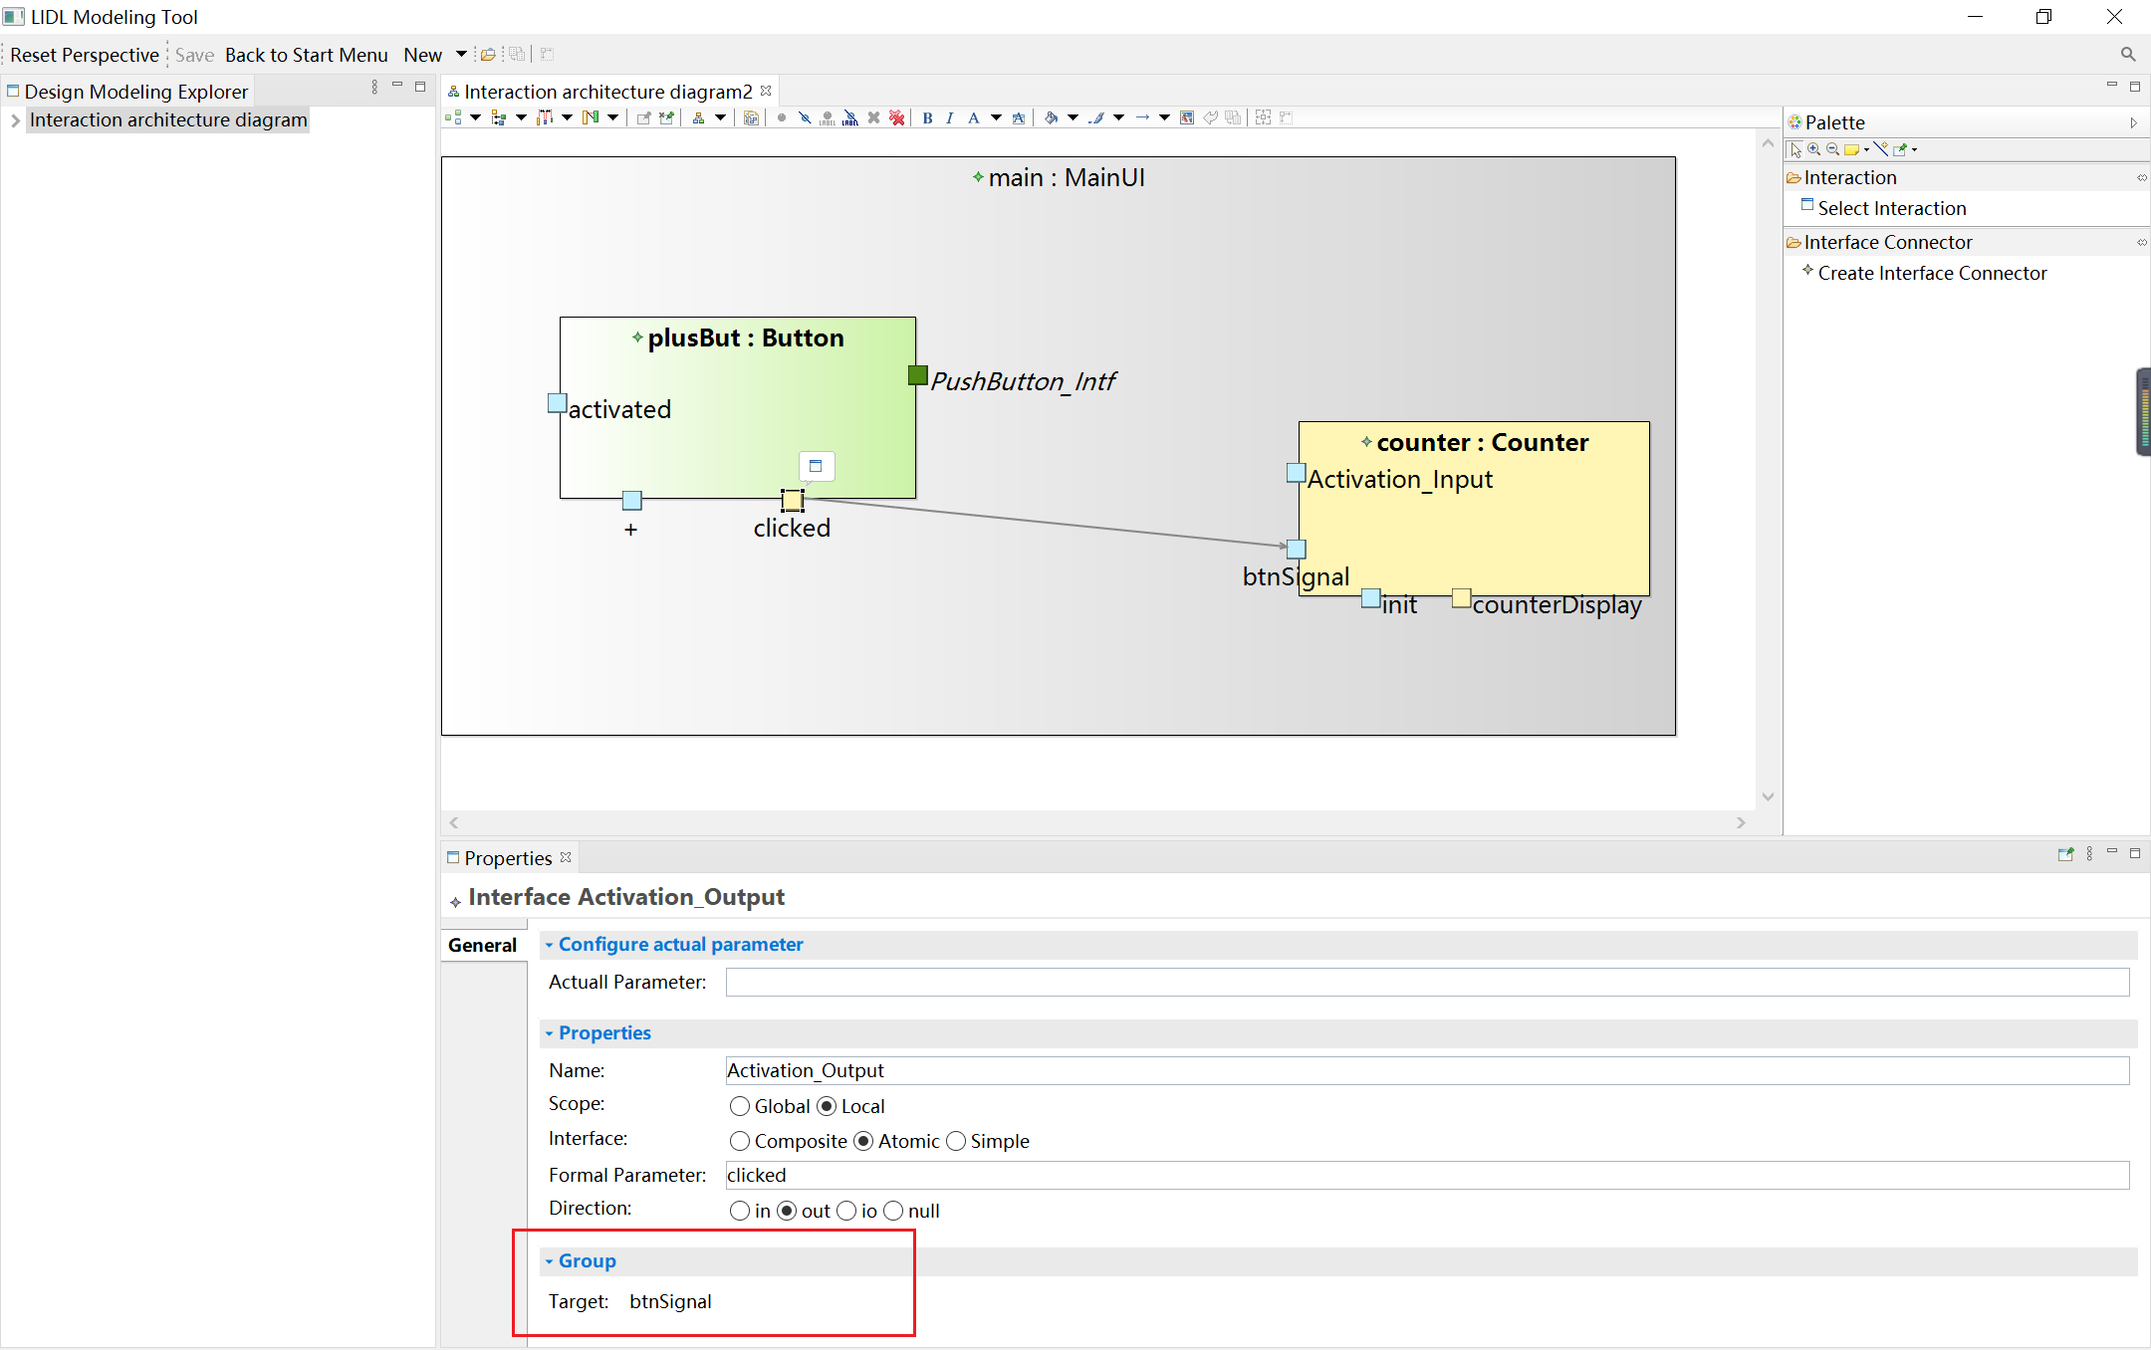

The main interaction, interaction, and interface nodes in the interaction diagram, the toolbar on the right, and the interaction functions supported in the Properties view in the lower part are all configured in the lidlgui.odesign. The odesign file is a configuration file provided by the Eclipse Sirius project[4]. The software is developed based on the Eclipse Sirius project. For the basic usage of the Eclipse Sirius project, you can see the Tutorial[5] and documentation[6].

The contents, styles, and functions of the Interaction Diagram are all configured in the file lidlgui.odesign. The path of the file is:

/tool/org. xxxx. lidlgui. design/description/lidlgui. odesign

You can see the relationships between the lidlgui.odesign file and the Design modeling view interface in LIDL Modeling Tool are in the following figure.

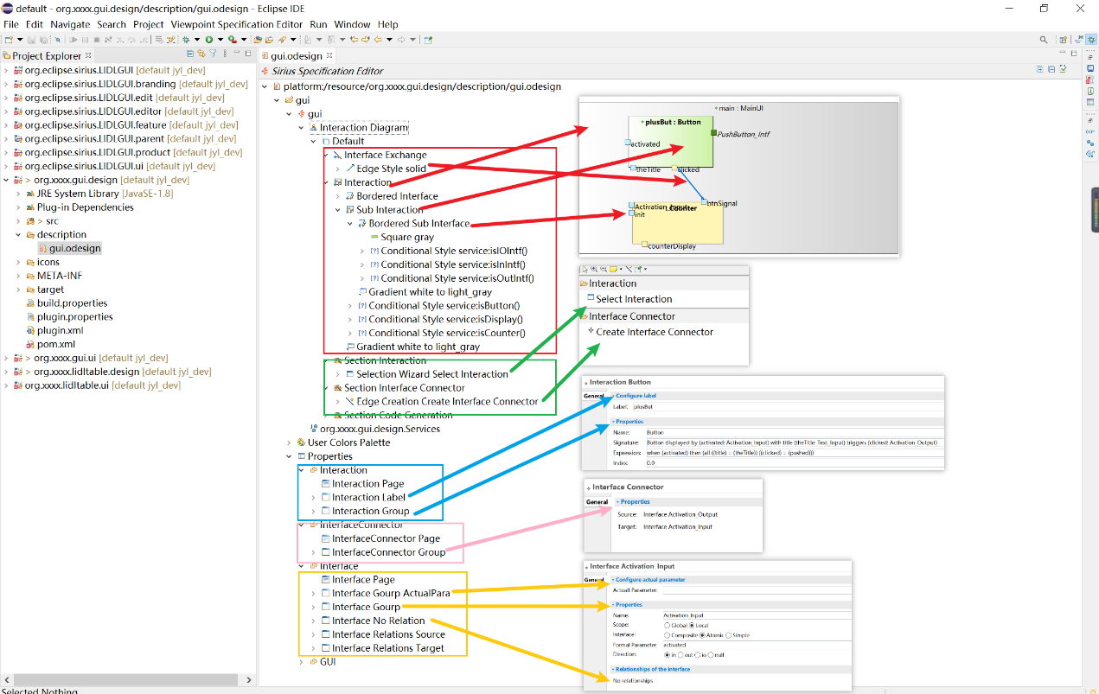

In the gui.odesign file the Interaction Diagram corresponds to the interaction architecture diagram in the modeling tool, the Interface Exchange in its default layer corresponds to the connector of the interface in the diagram, the Interaction corresponds to the Main Interaction in the diagram, the Sub Interaction corresponds to the Interaction contained in the Main Interaction, and the Bordered Interface corresponds to the interface node on the border of the interaction node in the diagram. And you can configure the style of the node by Style.

The function correspondence of the toolbar is as follows: the Selection Wizard Select Interaction in Section Interaction corresponds to the function of creating interaction in the toolbar, and the Edge Creation Create Interface Connector corresponds to the function of creating new a interface connector.

Different nodes have different Properties windows, and you can configure them in the corresponding directory under the Properties directory of the odesign file. The corresponding relationship is shown in the figure.

Take Create Interface Connector in the toolbar as an example. To achieve this function, add Edge Creation Create Interface Connector to Section Interface Connector in the odesign file, and add service: createInterfaceConnector(source, target).

Service corresponds to the org.xxxx.lidlgui.design.Services Java file. Press keyboard alt and F3, and click service:createInterfaceConnector(source, target) can automatically jump.

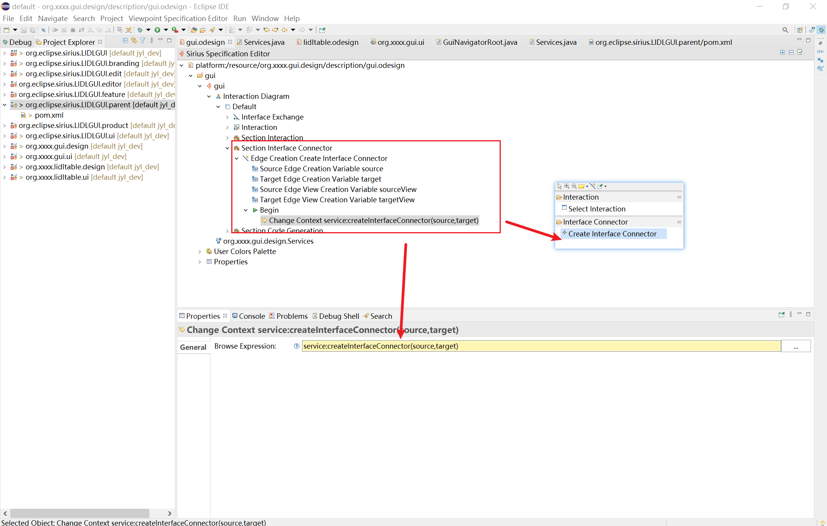

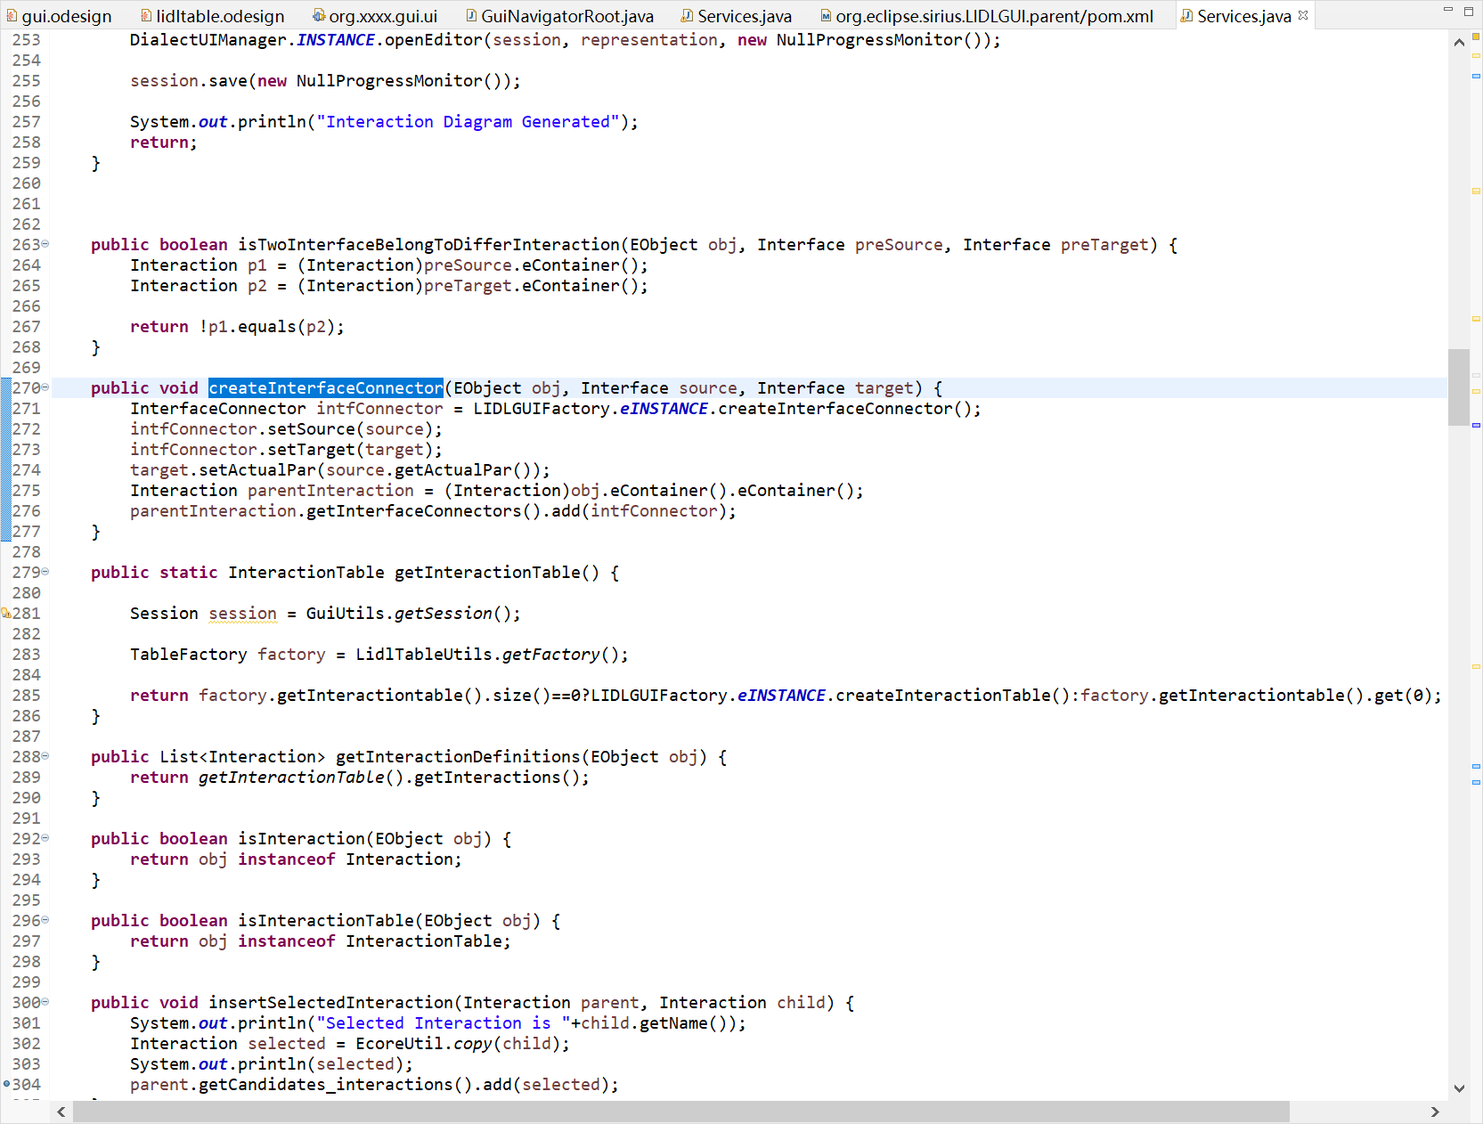

### Package and Publish Project

To ensure that the packaged project runs with the workspace saved correctly and always opens with the main interface, you need to add parameters in the org.eclipse.sirius.LIDLGUI.product.LIDLGUI.product file, click Launching, and add the parameter **-clearPersistedState -persistState false** to the Program Arguments.

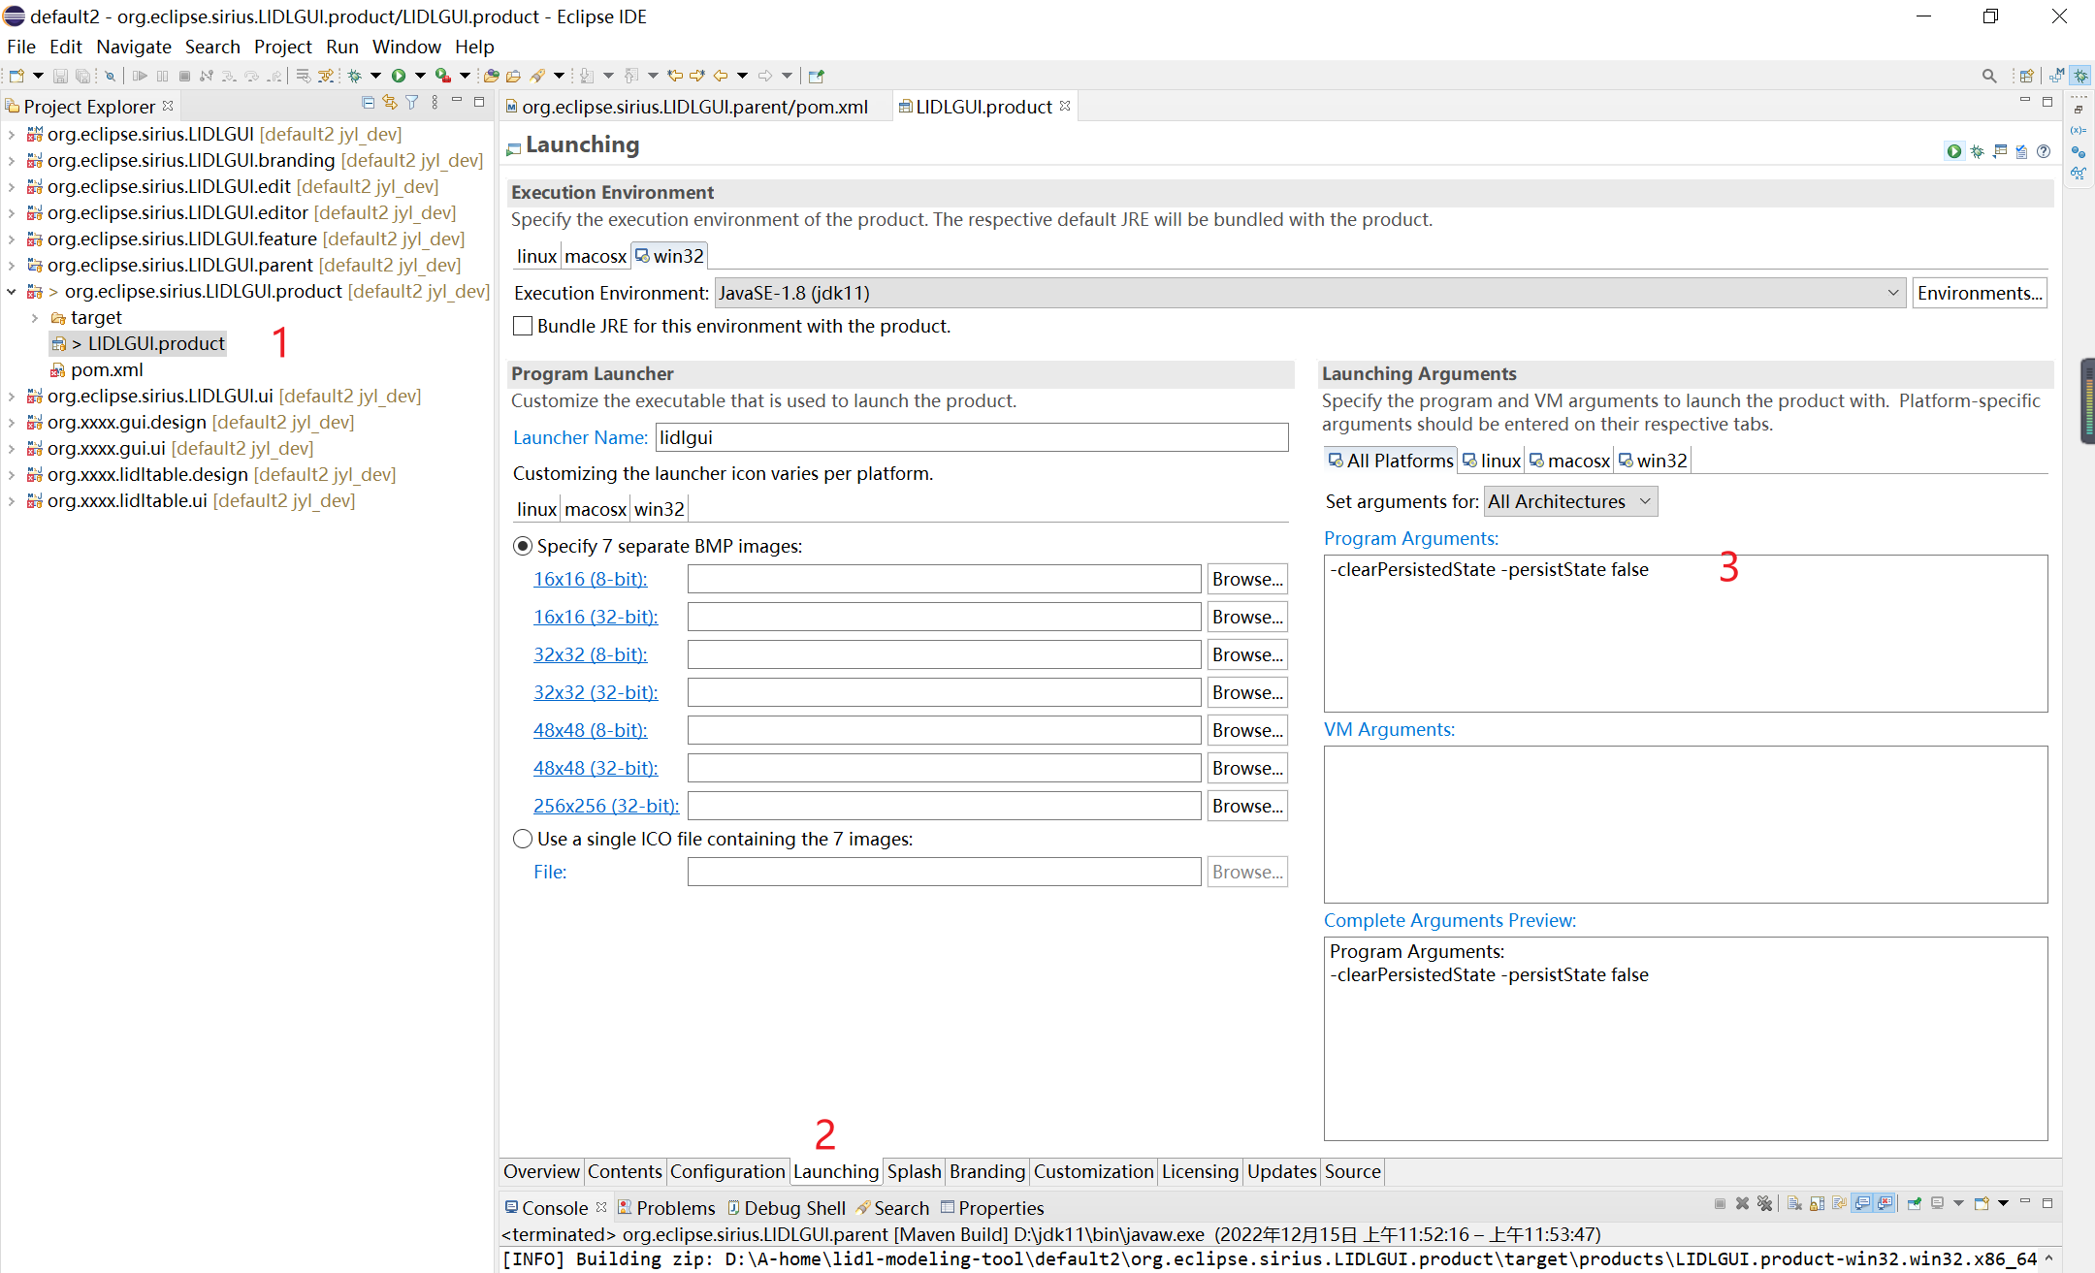

Configure the corresponding platform of the program you want to publish in

org.eclipse.sirius.LIDLGUI.parent/pom.xml

As shown in the figure below,

Area 1 is for the Windows platform, and area 2 is for the Linux platform.

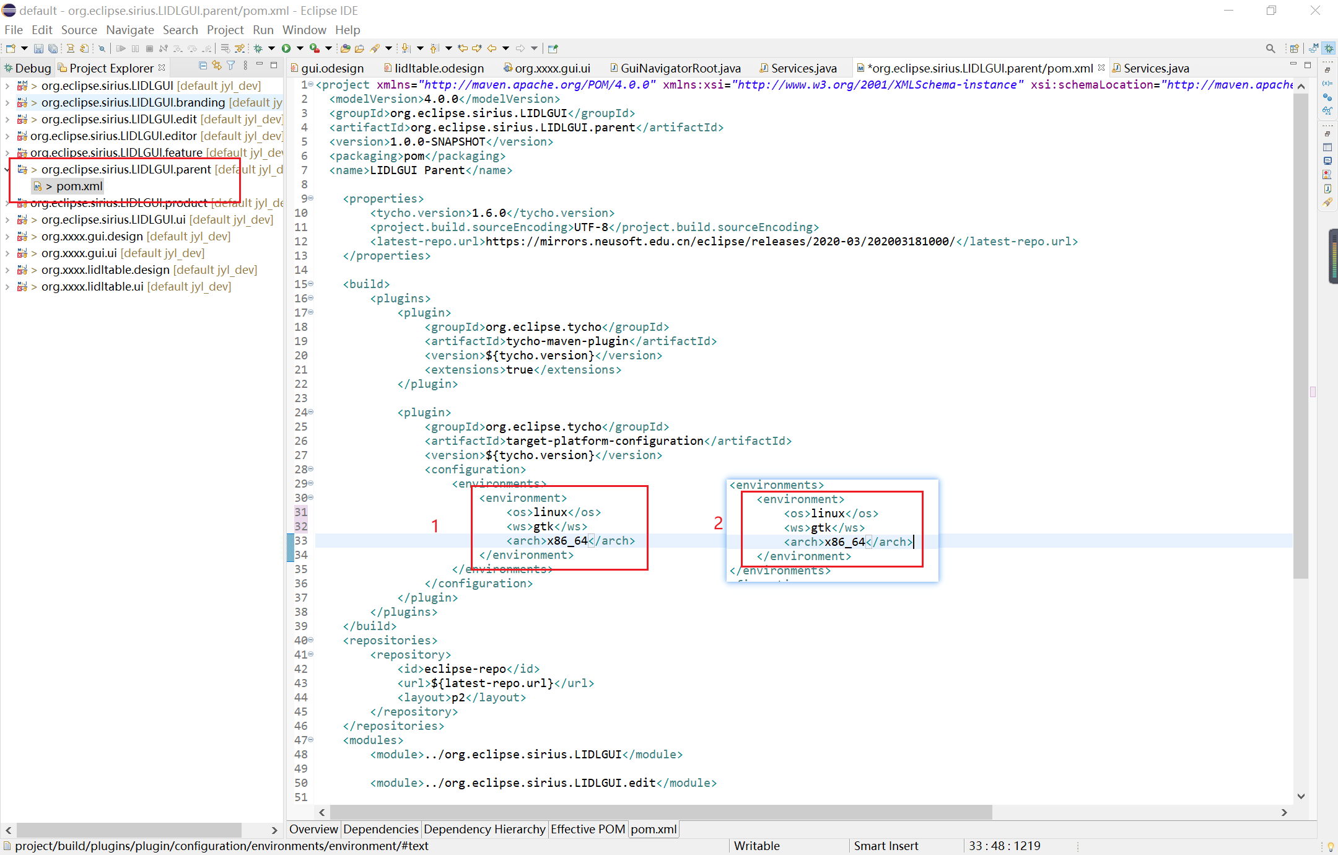

After configuration, right-click org. eclipse. sirius. LIDLGUI.parent, select Run As and 1 Maven build. Add clean install to the configuration item Goals, and click Run after the configuration.

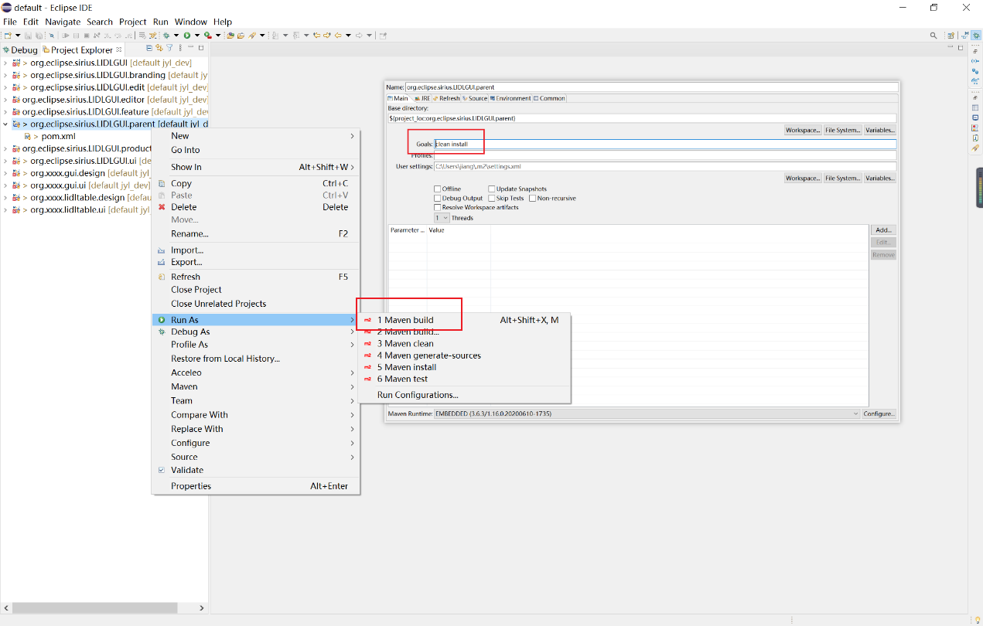

Start the project packaging program as follows:

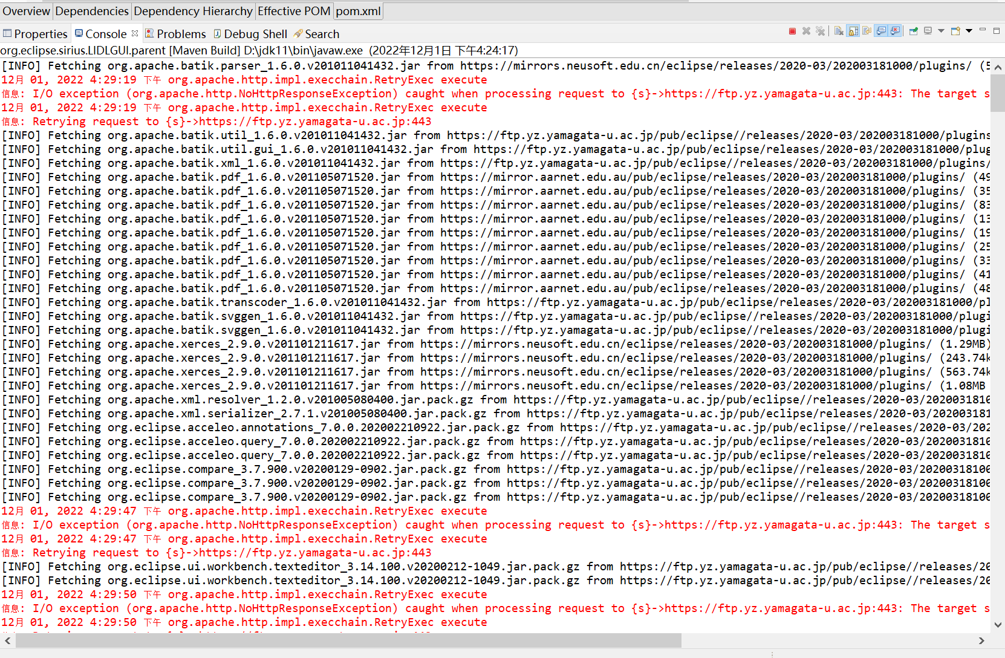

After packaging successfully, you can get the compressed zip LIDLGUI.product-win32.win32.x86.zip in ...\org.eclipse.sirius.LIDLGUI.product\target\products, decompress the compressed package, and it will generate the executable file: lidlgui.exe.

Double-click it to run.

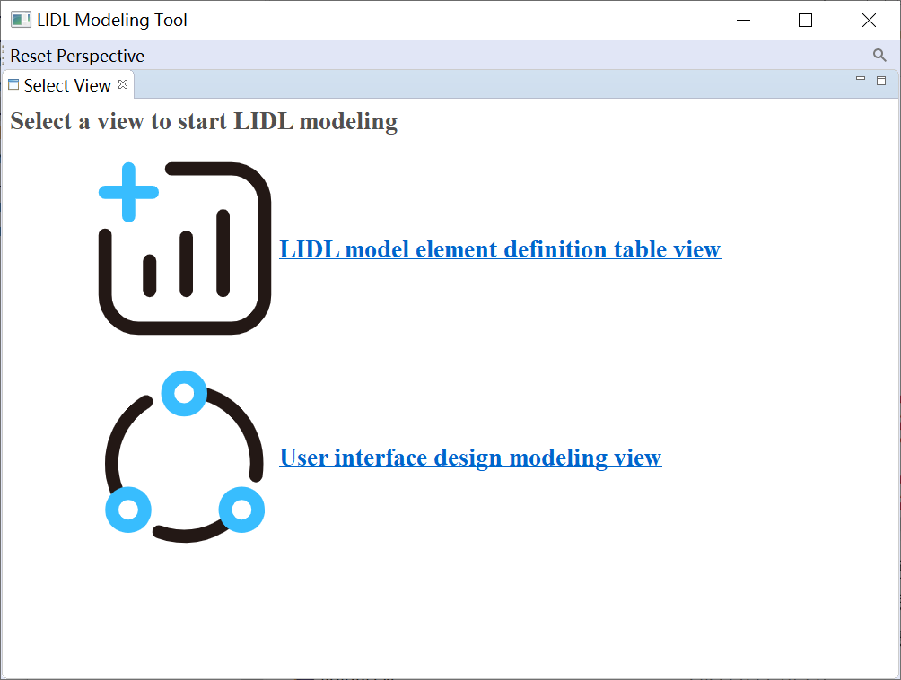

1. [Sirius | Overview (eclipse.org)](https://www.eclipse.org/sirius/overview.html)
2. [Sirius/Tutorials/StarterTutorial - Eclipsepedia](https://wiki.eclipse.org/Sirius/Tutorials/StarterTutorial)
3. [Eclipse Sirius Documentation](https://www.eclipse.org/sirius/doc/)
4. [Sirius | Overview (eclipse.org)](https://www.eclipse.org/sirius/overview.html)
5. [Sirius/Tutorials/StarterTutorial - Eclipsepedia](https://wiki.eclipse.org/Sirius/Tutorials/StarterTutorial)
6. [Eclipse Sirius Documentation](https://www.eclipse.org/sirius/doc/)